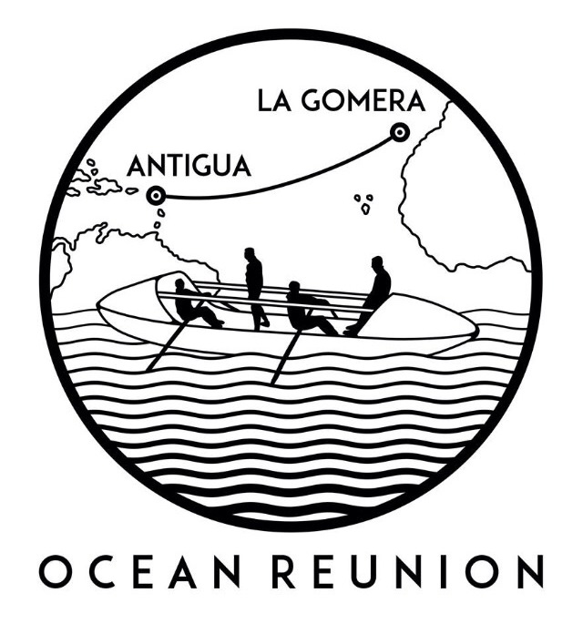
PRESS RELEASE
For release 12th May 2015

Ocean Reunion to row the world’s second largest ocean with Crewsaver safety equipment aboard including lifejackets and liferafts.
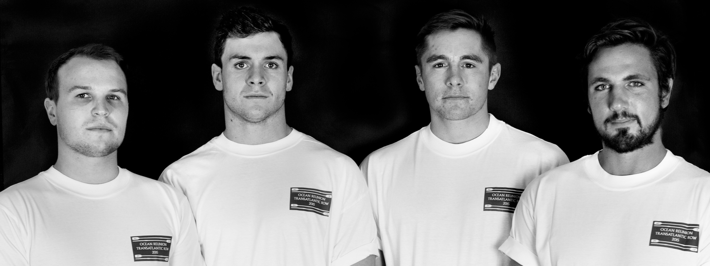
Ocean Reunion will row
3,000 nautical miles across the world’s second largest ocean, heading west from the Canary Islands to Antigua. The team, which reunites four old school friends, are competing in “The world’s toughest race”. They could face 50ft waves, hurricane strength winds, and 40-degree heat.

Thanks to Crewsaver, the team will have all the necessary safety equipment aboard during the row including a 6-man, over 24 hour Crewsaver ISO Ocean liferaft, custom made Crewsaver Fusion 3D lifejackets tailored specifically for the team’s needs, as well as numerous safety accessories including safety knifes, electronics and throw bags.

Prior to the challenge the team will participate in an intense training day at Crewsaver HQ to make sure they are able to look after their safety equipment when out at sea. This will include general care and maintenance of all products, how to repack and rearm their lifejackets, and a better understanding of how their products work.

‘We are dead excited to be working with Crewsaver, tailored lifejackets are exactly what we need to ensure we have something that we can comfortably wear for the duration of the row and that is going to keep us as safe as possible should we fall in.’ - Angus Collins, team member.

The row will begin December this year; the team will be rowing for two charities, Cystic Fibrosis Trust and Teenage Cancer Trust. Visit their website to donate.

Click here to watch Ocean Reunion’s video and find out more about the challenge!

Ends//

Notes to editors

About Crewsaver
Crewsaver is a world-leading manufacturer of marine safety equipment and clothing for the commercial and leisure marine industries. Based in Gosport, Hampshire, the company designs and manufactures bespoke safety equipment for several countries’ special forces, the UK government’s Environment Agency and the aviation and oil industries. Crewsaver is part of the Survitec Group.
www.crewsaver.com

For media information, hi-res images or product tests please contact:

Crewsaver
Hannah Burywood, Marketing Dept
T +44 (0) 1329 820024
E Hannah.Burywood@survitecgroup.com

