Press Release
9th January 2015
Crewsaver’s Revolutionary Fusion 3D Range Now Available
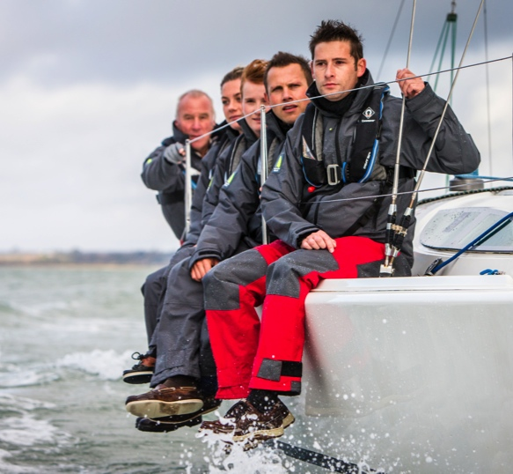
Comfort. Style. Performance
Crewsaver are proud to announce that the newly launched, complete range of 3D lifejackets will be on sale to the public for the very first time at the CWM FX London Boat Show 2015. By using the same advanced Fusion 3D technology developed in the hugely successful ErgoFit range, Crewsaver is moulding the future of leisure lifejackets – whatever your level there is now a Crewsaver lifejacket to suit.

As a manufacturer of integral safety equipment, Crewsaver has taken on the challenge to reduce the number of people that simply do not wear a lifejacket by producing a complete range focused on, Comfort. Style. Performance. All of which are key considerations when choosing your lifejacket.

“We are delighted to be offering this revolutionary new 3D lifejacket range for all to view and purchase during the CWM FX London Boat Show”, says Crewsaver’s Managing Director, Ross Wilkinson. “Our Fusion 3D technology encapsulates Crewsaver’s passion for designing high performance lifejackets at all levels.”

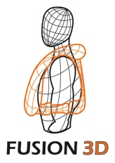
What is Fusion 3D?
The innovative Fusion 3D technology moulds to the shape of your body and sits off the neck giving the user total freedom of movement – it’s so comfortable you will forget you are wearing it.

The new Crewfit Pro, Crewfit Sport and the Crewfit Junior are the lifejackets which complete the 3D range. Not only do these lifejackets look and feel great, they have increased key safety features for vital in-water performance. The Crewfit range provides a comfortable and safe option for every kind of recreational boater.

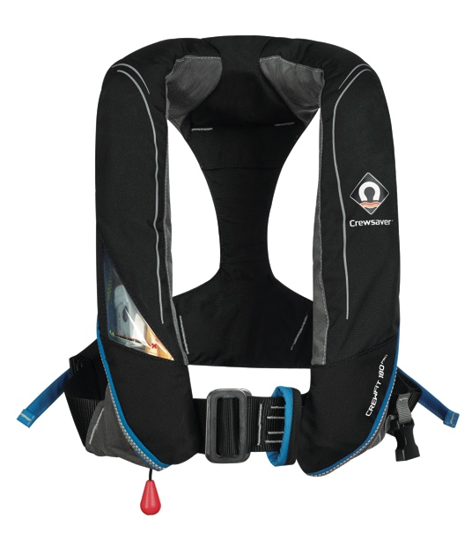
Crewfit 180N Pro

The first of its kind, this is an everyday boating lifejacket designed for sailors and powerboaters alike. Successful integration of a high volume shaped bladder design, a peninsular chin support and increased buoyancy to 180N provides you with maximum in-water performance.

- Peninsular chin support
- YKK quick burst zip
- Waist adjusters with quick release pull tabs allow for easy adjustment
- UML pro-sensor with Indicator window
- Exceptional bladder design providing exceptional turning speeds
- A fun, stylish, 3D shaped and super comfortable cover
- AIS S20 compactable, automatic activation on inflation
- Harness and non-harness versions
- Universal one size fits all

From £80.00 RRP Inc. VAT

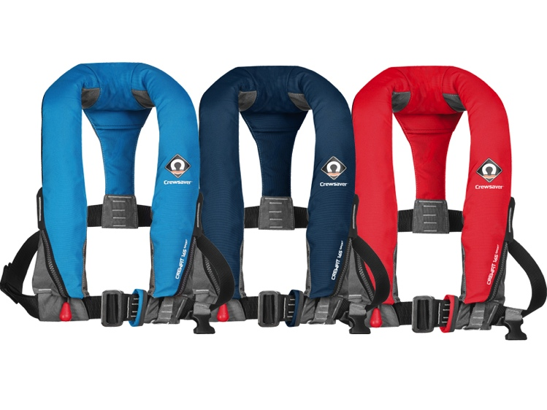
Crewfit 165N Sport

Entry level to the 3D range, the Crewfit 165N Sport has the essential features to ensure the recreational user remains safe when out on the water.

- Inflatable chin support
- YKK quick burst zip
- Exceptional bladder design providing exceptional turning speeds
- A fun, stylish, 3D shaped and super comfortable cover
- Harness and non-harness versions for sailors and power boaters alike
- Universal one size fits all
- Available in Diva Blue, Dress Blue and Fiery Red.

From £60.00 RRP Inc VAT

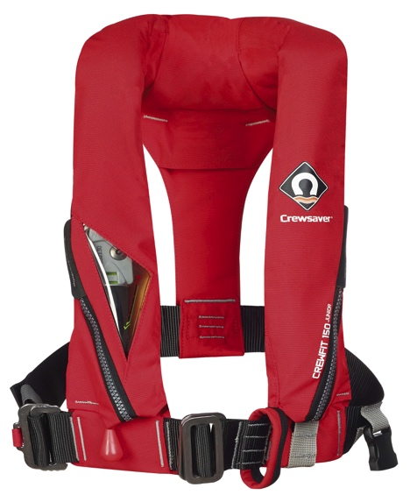
Crewfit 150N Junior

The first 3D designed lifejacket for juniors, helping to ensure your little ones remain as comfortable as possible when out on the water. Safety is paramount on the Crewfit 150N Junior, a unique bladder design with a peninsular chin support offers the most advanced performance solutions available today.

- Peninsular chin support
- YKK quick burst zip
- UML pro-sensor with indicator window
- Exceptional bladder design providing exceptional turning speeds
- A fun, stylish, 3D shaped and super comfortable cover
- Universal one size fits all

From £80.00 RRP Inc. VAT
The new 3D lifejacket range will be available to purchase for the first time during the show from the following retailers:
Marine Superstore – Stand no. A032
Andark – Stand no. B022 & B023
TCS – Stand no. C044
Piplers of Poole – Stand no. A040
As well as being able to get your hands on these fantastic new Fusion 3D lifejackets, consumers will also be able to take advantage of the following offers exclusive to the show:
- FREE Crewsaver Surface Light worth over £19 with any Crewfit 180N Pro lifejacket purchase*
- FREE Rearming pack and ErgoFit Safety Knife worth up to £46 with any ErgoFit Automatic lifejacket purchase*
- FREE McMurdo Fast Find 220 PLB worth £270 with every Crewsaver ISO Ocean Liferaft purchase*

CWM FX London Boat Show – Excel, London: 9th–18th January 2015

*T&C’s apply, E&OE

For media information, hi-res images or product tests please contact:

Crewsaver
Hannah Burywood, Marketing Dept
T +44 (0) 1329 820024
E hannah.burywood@survitecgroup.com

Or

Alison Willis – Marine Advertising Agency Ltd
T +44 (0) 23 9252 2044
E Alison@marineadagency.com

Notes to Editors

Crewsaver is a world-leading manufacturer of marine safety equipment and clothing for the commercial and leisure marine industries. Based in Gosport, Hampshire, the company designs and manufactures bespoke safety equipment for several countries’ Special Forces, the UK government’s Environment Agency and the aviation and oil industries. Crewsaver is part of the Survitec Group.
www.crewsaver.com

Survitec Group holds market-leading positions worldwide in marine, defence and aerospace survival technology. Headquartered in Southampton, the company employs 2000 people across 10 manufacturing sites and 50 service centres, operating through a network of a further 550 distributors and agents to bring its best-in-class products and services to a global customer base. With an extensive history spanning over 160 years and a portfolio of some of the most reputable brands in the safety and survival industry, Survitec is committed to product innovation, technological advancement and quality assurance.
Key products within Survitec’s portfolio include marine, defence and aviation Liferafts, world leading submarine escape technology, lifejackets for commercial airlines and the offshore industry as well as pilot flight equipment, including anti-g clothing used for the Eurofighter and JSF programmes. The Group also pioneered marine evacuation technology and today the unique MarinArk system is used on many major cruise ships across the globe.

www.survitecgroup.com

