PRESS RELEASE
For release 03th February 2015

Tom Bowker is appointed as Yak European Sales Manager
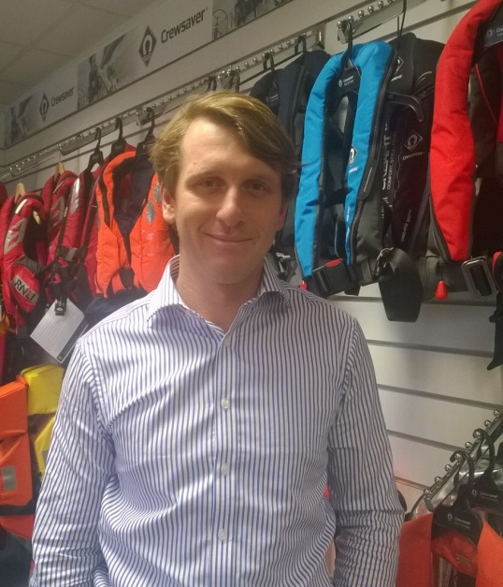
Yak is delighted to announce the new appointment of Tom Bowker as European Sales Manager. Tom has devoted his career to the marine industry and has a particularly strong sales and customer service focused background. Both his role as Area Sales Manager for SailLaser & LaserPerformance and as UK Training and Fleet Sales Manager for RS Sailing have been heavily focused on building on and developing business to business relationships.

With an enthusiasm for taking on new challenges, Tom’s main objective within his new role will be to develop and grow Yak’s European distributor network making the Yak product range more accessible throughout Europe.

Sales Director for Yak, David Duffin says ‘We are excited to welcome Tom and his experience in marine industry sales. He will be a key player in the development of the company and a great addition to the team.’

Tom says 'I am very excited to be joining Yak and am looking forward to meeting and working with the entire European distribution network.’

With the recent launch of Yak's new clothing and buoyancy aid range Tom couldn't have more exciting product to promote throughout Europe.

Ends//

For media information, hi-res images or product tests please contact:

Crewsaver
Hannah Burywood, Marketing Dept
T +44 (0) 1329 820024
E hannah.burywood@survitecgroup.com

Or

Alison Willis – Marine Advertising Agency Ltd
T +44 (0) 23 9252 2044
E Alison@marineadagency.com

Notes to Editors

Part of the Survitec Group which also owns Crewsaver, Yak, produces and manufactures products that are purposely designed for the whitewater, recreational and touring kayaking and canoe markets. A wide range of products suit all styles and experience, giving paddlers more choice and more opportunities to enjoy their sport with total peace of mind. Yak’s products include buoyancy aids, drysuits, cags, trousers, spray decks, gloves, footwear, headwear and buoyancy bags.

Together with Crewsaver, Yak has 50 years of experience manufacturing marine safety products that combine cutting edge technology with high performance and ultimate practicality.

