Press Release
20th April 2015

Crewsaver launches Fusion 3D lifejacket stockist programme!
Comfort. Style. Performance
Following the success of the recently launched Crewsaver Fusion 3D lifejacket range, Crewsaver is delighted to announce the Crewsaver Fusion 3D lifejacket stockist programme.
The Crewsaver Fusion 3D stockist’s scheme ensures that consumers are being given the best advice when choosing their lifejacket providing them with a better understanding on how it works, which could ultimately save their life.
All stockists will be have on display the entire range of Fusion 3D lifejackets, providing a solution for consumers at every level from recreational boating to extreme ocean racing.

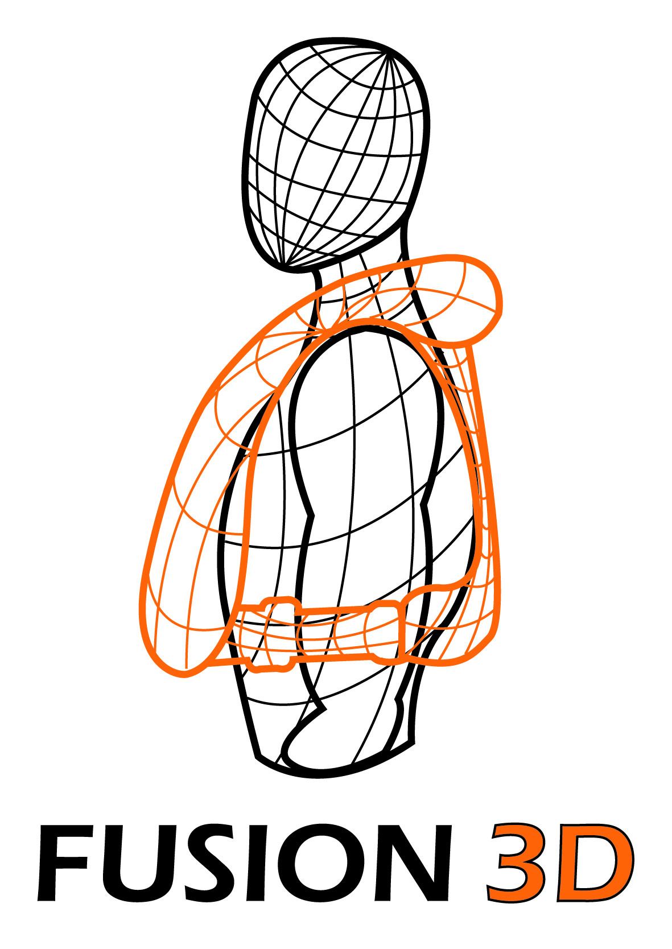
What is Fusion 3D?
Innovative Fusion 3D technology moulds to the shape of your body and sits off the neck giving the user total freedom of movement – it’s so comfortable you will forget you are wearing it.
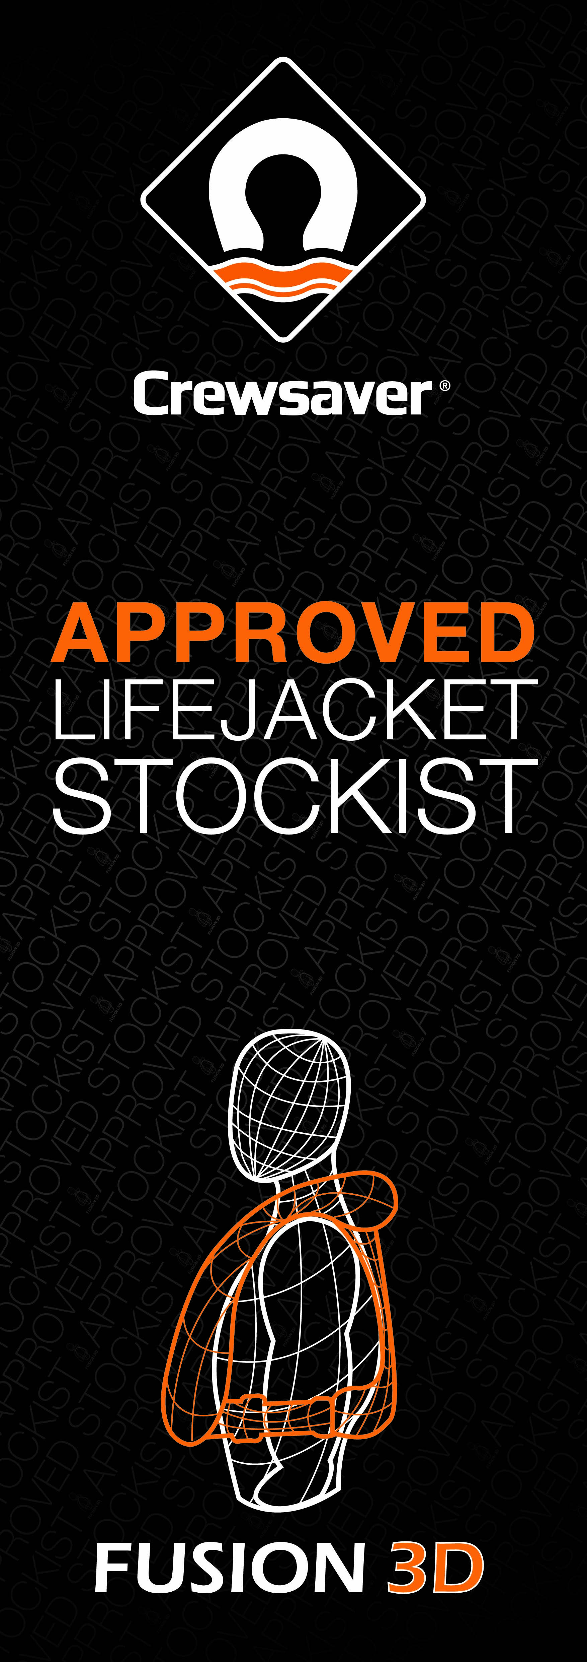
How to find a local stockist?
Consumers can locate their local Crewsaver Fusion 3D approved stockist by visiting the Crewsaver website; www.crewsaver.com
You will also find the Fusion 3D logo placed in the window of all approved stockists – to confirm their inclusion in the programme.

For media information, hi-res images or product tests please contact:

Crewsaver
Hannah Burywood, Marketing Dept
T +44 (0) 1329 820024
E hannah.burywood@survitecgroup.com

Or

Alison Willis – Marine Advertising Agency Ltd
T +44 (0) 23 9252 2044
E Alison@marineadagency.com

Notes to Editors

Crewsaver is a world-leading manufacturer of marine safety equipment and clothing for the commercial and leisure marine industries. Based in Gosport, Hampshire, the company designs and manufactures bespoke safety equipment for several countries’ Special Forces, the UK government’s Environment Agency and the aviation and oil industries. Crewsaver is part of the Survitec Group.

www.crewsaver.com

Survitec Group holds market-leading positions worldwide in marine, defence and aerospace survival technology. Headquartered in Southampton, the company employs 2000 people across 10 manufacturing sites and 50 service centres, operating through a network of a further 550 distributors and agents to bring its best-in-class products and services to a global customer base. With an extensive history spanning over 160 years and a portfolio of some of the most reputable brands in the safety and survival industry, Survitec is committed to product innovation, technological advancement and quality assurance.
Key products within Survitec’s portfolio include marine, defence and aviation Liferafts, world leading submarine escape technology, lifejackets for commercial airlines and the offshore industry as well as pilot flight equipment, including anti-g clothing used for the Eurofighter and JSF programmes. The Group also pioneered marine evacuation technology and today the unique MarinArk system is used on many major cruise ships across the globe.

www.survitecgroup.com

