PRESS RELEASE
For release 2nd July 2014

Coxless Crew to row Pacific Ocean with Crewsaver safety equipment aboard including lifejackets & liferafts

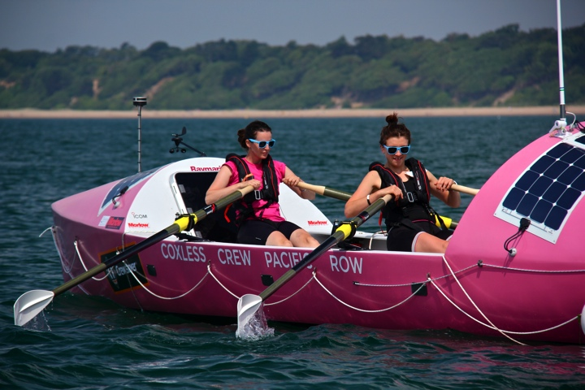
The Coxless Crew, four women who will be achieving a world first by rowing 8,446 miles unsupported across the Pacific Ocean in 2015, from America to Australia, and in the process aim to raise half a million pounds for their two charities Walking With the Wounded and Breast Cancer Care, are being backed by Crewsaver with donations of vital safety equipment.

During the row the girls will have all the necessary safety equipment aboard including a 6-man, over 24 hour Crewsaver ISO Ocean Liferaft and ErgoFit 290N lifejackets designed specifically for use offshore, as well as numerous safety accessories including safety knifes and throw bags.
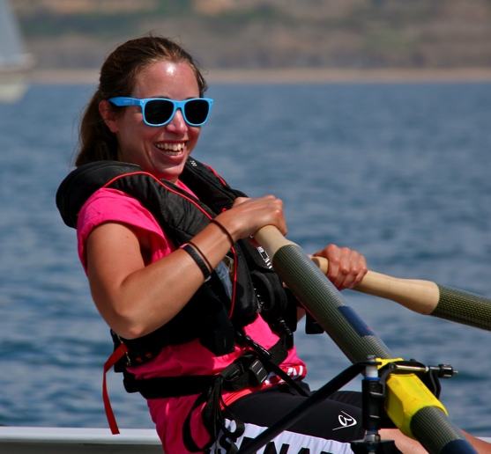
Prior to the challenge the girls will participate in some intense training days at Crewsaver HQ to make sure they are able to look after their safety equipment when out at sea. This will include general care and maintenance of all products, how to repack and rearm their lifejackets, and a better understanding of how their products work.

The girls have already started the adventure through their training to help them prepare for the challenge, most recently with a 9-hour row across the Solent to the Isle of Wight. This has given them a great opportunity to test out the new kit, 'Our ErgoFit lifejackets are super comfy and most certainly make us feel much safer when going offshore,' said Laura Penhaul, skipper of the crew.

More about the ErgoFit lifejacket

Key features designed into the ErgoFit lifejackets to help keep the Coxless Crew safe should they unexpectedly fall overboard include:

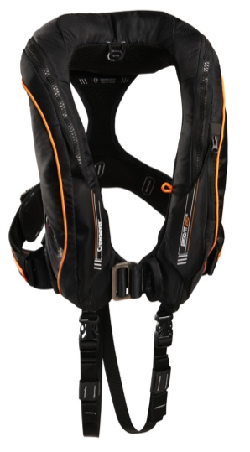
- Inflatable chin support, tilts your head back, keeps your airways clear and helps to stop water coming onto your face
- Slim line profile around the shoulders aiding manoeuvrability
- Unique buoyancy distribution, keeping you as high out of the water as possible and aiding turning speed

- Lifting beckets making it easy for the team to pull you back in to safety
- Numerous accessories including, light, spray hood and whistle

Ends//
Notes for editors
For more information and images please contact:
Hannah Burywood
Marketing Assistant
email hannah.burywood@survitecgroup.com
office +44 (0)1329 820024
mob +44 (0)7971142687
About Crewsaver
Crewsaver is a world-leading manufacturer of marine safety equipment and clothing based in Gosport, Hampshire. As well as specialising in sailing kit for dinghy and yacht racing the company supplies the lifejackets worn by all 4,600 of Britain’s RNLI lifeboat crew. It also designs and manufactures bespoke safety equipment for several countries’ special forces, the UK government’s Environment Agency and the aviation and oil industries. Crewsaver is part of the Survitec Group.
www.crewsaver.com
About Survitec Group

Survitec Group holds market-leading positions worldwide in marine, defence and aerospace survival technology. Headquartered in Southampton, the company employs 2000 people across 10 manufacturing sites and 50 service centres, operating through a network of a further 550 distributors and agents to bring its best-in-class products and services to a global customer base. With an extensive history spanning over 160 years and a portfolio of some of the most reputable brands in the safety and survival industry, Survitec is committed to product innovation, technological advancement and quality assurance.
Key products within Survitec’s portfolio include marine, defence and aviation Liferafts, world leading submarine escape technology, lifejackets for commercial airlines and the offshore industry as well as pilot flight equipment, including anti-g clothing used for the Eurofighter and JSF programmes. The Group also pioneered marine evacuation technology and today the unique MarinArk system is used on many major cruise ships across the globe.

www.survitecgroup.com

About the Coxless Crew Pacific Ocean Row

The Pacific Ocean is the world’s largest ocean, bounded by Australia in the west and the Americas in the east. At sixty-four million square miles, it covers one-third of Earth’s total surface area. The Coxless Crew row across the Pacific will be an unsupported three-stage row starting in Long Beach, California and finishing in Cairns, Australia. Stops will be made in Hawaii and Samoa and the entire expedition will cover 8,446 miles and take 5 to 6 months (weather dependent)! Stops will last for approximately seven days at a time to restock the boat, repair and replenish supplies and for the team to share their story with the local, national and international media. This route has only ever been completed by solo and pairs teams, never has it been done by a team of four and never has it been done as a continuous three stage row.

www.coxlesscrew.com

