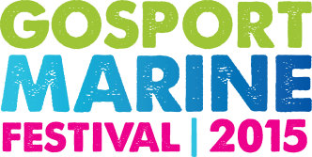
Press Release
For release 13th May 2015

Crewsaver backs Gosport Marine Festival with Crewsaver GoWaterSport

Crewsaver, the essential lifesaving equipment and clothing manufacturer, is delighted to announce its new key partnership with Gosport Marine Scene CIC starting with providing support to the very exciting Gosport Marine Festival to take place Saturday 13th June 2015.

The Crewsaver GoWaterSport element of the event provides over 1000 on the water sessions for local people to come and enjoy throughout the day, activities range from sailing, paddle boarding, harbour tours, rib rides and kayaking.

‘Gosport Marine Scene CIC is thrilled to announce that Gosport's largest marine employer, Crewsaver, has come onboard as a Gosport Marine Festival sponsor. This enables us to offer the Crewsaver GoWaterSport activities for FREE, enabling local families to safely experience the vast range of sailing and watersport activities available on the peninsula’ John Beavis MBE, Chairman of Gosport Marine Festival.

Crewsaver’s Managing Director Ross Wilkinson said, ‘Providing as much support as we possibly can to make getting on the water as accessible as possible is a key goal at Crewsaver, it is really exciting for us to be able to provide this support direct to our local community.’
Visitors to the event will not only be able to enjoy the on the water activities but a food festival, live music and lots of other exciting entertainment providing a great day out for all!
ENDS//

For media information, hi-res images or product tests please contact:

Crewsaver
Hannah Burywood, Marketing Dept
T +44 (0) 1329 820024
E hannah.burywood@survitecgroup.com

