PRESS RELEASE
For immediate release
30th June 2014

Crewsaver introduces Hamble Horseshoe Buoy Set into highly successful safety range
Following the success of the Crewsaver safety range, launched in January 2012, Crewsaver has taken the Horseshoe Buoy one step further with the introduction of the Hamble Horseshoe Buoy Set. The Hamble Horseshoe buoy, bracket and light set provides a high quality solution for anyone who requires the addition of a compact light to their rescue buoy. The compact light on the set comes complete with a lithium battery, which has a maximum five-year life.

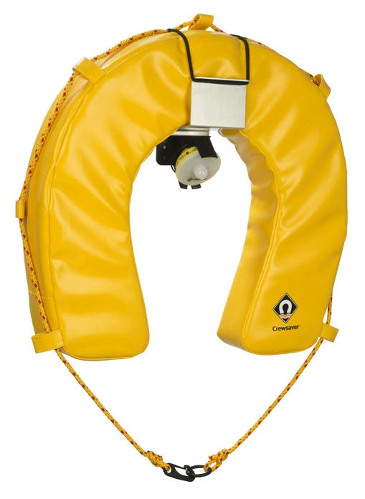
Hamble Horseshoe Buoy Set – RRP £60

The Hamble Horseshoe buoy, bracket and light set has one of the most compact lights on the market today. Constructed from
layered EPE foam and tough PVC material for durability, the set is ideal for both yachts and motorboats. This is an essential piece of equipment in case of a man overboard.
- Flashing, SOLAS approved LED light
- High visibility yellow
- Super soft foam
- Lithium battery for light with maximum 5 year life

Continues overleaf...

Items are also available individually to upgrade your existing lifebuoy.
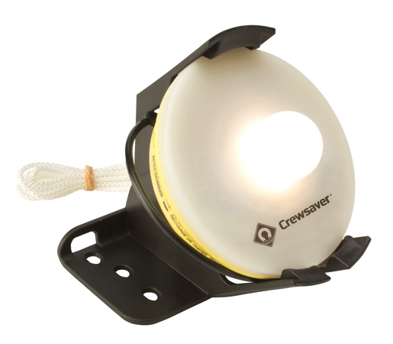
Hamble Light
The Hamble Horseshoe Light uses the latest LED technology featuring low energy consumption and enhanced reliability. A bright flashing light helps enhance visibility should a crew member fall overboard during the night.
- SOLAS Approved
- Maximum 5 Year life
- Over 30 metres drop height
- Lithium battery

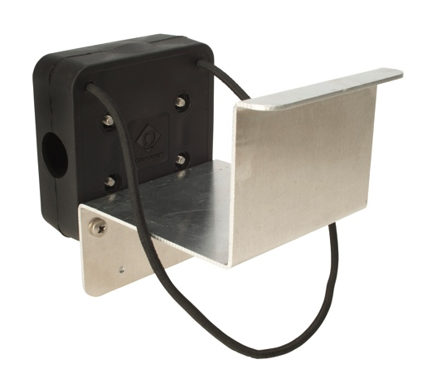
Hamble Bracket
Constructed from stainless steel the Hamble Horseshoe Bracket combined with the Hamble Horseshoe Light is the ideal solution for anyone looking to update their Crewsaver Horseshoe buoy to be suitable for use at night.
- Constructed from stainless steel
- Easy installation
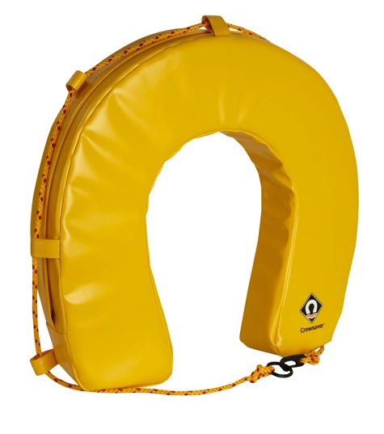
Horseshoe Buoy
Ideal for both yachts and motorboats, the Horseshoe Buoy is an essential piece of equipment in case of a man overboard.

- Layered EPE foam for the ultimate in buoyancy
- Tough outer PVC material to ensure longevity
- High visibility yellow

Continues overleaf...

Notes for editors
For more information and images please contact:
Hannah Burywood
Marketing Assistant
email hannah.burywood@survitecgroup.com
office +44 (0)1329 820024
mob +44 (0)7971142687
About Crewsaver
Crewsaver is a world-leading manufacturer of marine safety equipment and clothing based in Gosport, Hampshire. As well as specialising in sailing kit for dinghy and yacht racing the company supplies the lifejackets worn by all 4,600 of Britain’s RNLI lifeboat crew. It also designs and manufactures bespoke safety equipment for several countries’ special forces, the UK government’s Environment Agency and the aviation and oil industries. Crewsaver is part of the Survitec Group.
www.crewsaver.com
About Survitec Group

Survitec Group holds market-leading positions worldwide in marine, defence and aerospace survival technology. Headquartered in Southampton, the company employs 2000 people across 10 manufacturing sites and 50 service centres, operating through a network of a further 550 distributors and agents to bring its best-in-class products and services to a global customer base. With an extensive history spanning over 160 years and a portfolio of some of the most reputable brands in the safety and survival industry, Survitec is committed to product innovation, technological advancement and quality assurance.
Key products within Survitec’s portfolio include marine, defence and aviation Liferafts, world leading submarine escape technology, lifejackets for commercial airlines and the offshore industry as well as pilot flight equipment, including anti-g clothing used for the Eurofighter and JSF programmes. The Group also pioneered marine evacuation technology and today the unique MarinArk system is used on many major cruise ships across the globe.

www.survitecgroup.com

