PRESS RELEASE
For release 25th November 2014

Crewsaver announces two key appointments

Crewsaver has strengthened its senior management team with the appointment of David Duffin as the Sales Director. David will be managing the UK and Export Sales teams and working towards taking the Crewsaver brand global.

David has worked within the marine industry for 20 years, has a wealth of Sales Management experience and a proven track record leading successful sales teams and developing key relationships between businesses.

An infectious enthusiasm for taking on new changes, David’s main objective within his new role will be to develop and implement sales strategies that will take both new and existing products to new countries and markets.

Managing Director for Crewsaver, Ross Wilkinson says ‘We are excited to welcome David and his experience in marine safety sales. He will be key to the development of the company and a great addition to the team.’

David quotes 'I am very excited to be joining Crewsaver and am looking forward to working with the sales team and taking this well established brand global.'

Matthew Bridge has joined as Commercial Manager. Matt will take a lead role in the day to day management of sales and customer service of the business.
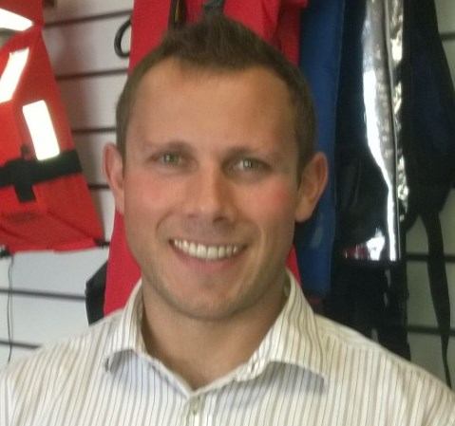
Matt comes from a strong consumer focused, industry background through both his role as Global Operations Manager for SailLaser & LaserPerformance and as Commercial Director for Oman Sail. Both roles have been heavily focused on developing the businesses and the business processes selling both service and product. Matt’s experience in managing teams and establishing robust systems to ensure excellent service, will be a strong addition to our team.

Matt says ‘I am very pleased to join the team at Crewsaver; I am very much looking forward to working with the sales office to ensure that we offer the best possible service to our customers.’

Ross Wilkinson, Managing Director for Crewsaver quotes ‘We are delighted to have these industry experts join our team. With their collective knowledge and experience we will continue to grow our success and establish high levels of customer service to all our customers.’

Ends//

For media information, hi-res images or product tests please contact:

Crewsaver
Hannah Burywood, Marketing Dept
T +44 (0) 1329 820024
E hannah.burywood@survitecgroup.com

Or

Alison Willis – Marine Advertising Agency Ltd
T +44 (0) 23 9252 2044
E Alison@marineadagency.com

Notes to Editors

Crewsaver is a world-leading manufacturer of marine safety equipment and clothing for the commercial and leisure marine industries. Based in Gosport, Hampshire, the company designs and manufactures bespoke safety equipment for several countries’ Special Forces, the UK government’s Environment Agency and the aviation and oil industries. Crewsaver is part of the Survitec Group.

www.crewsaver.com

Survitec Group holds market-leading positions worldwide in marine, defence and aerospace survival technology. Headquartered in Southampton, the company employs 2000 people across 10 manufacturing sites and 50 service centres, operating through a network of a further 550 distributors and agents to bring its best-in-class products and services to a global customer base. With an extensive history spanning over 160 years and a portfolio of some of the most reputable brands in the safety and survival industry, Survitec is committed to product innovation, technological advancement and quality assurance.
Key products within Survitec’s portfolio include marine, defence and aviation Liferafts, world leading submarine escape technology, lifejackets for commercial airlines and the offshore industry as well as pilot flight equipment, including anti-g clothing used for the Eurofighter and JSF programmes. The Group also pioneered marine evacuation technology and today the unique MarinArk system is used on many major cruise ships across the globe.

www.survitecgroup.com

