PRESS RELEASE
For immediate release
24th September 2014

Crewsaver celebrates 30 years of Crewfit with limited edition lifejacket box set giveaways at PSP Southampton Boat Show!

Crewsaver gave away 11 of 30 limited edition Crewfit lifejacket and accessory box sets worth over £500 to members of the general public in daily prize draws during the PSP Southampton Boat Show.

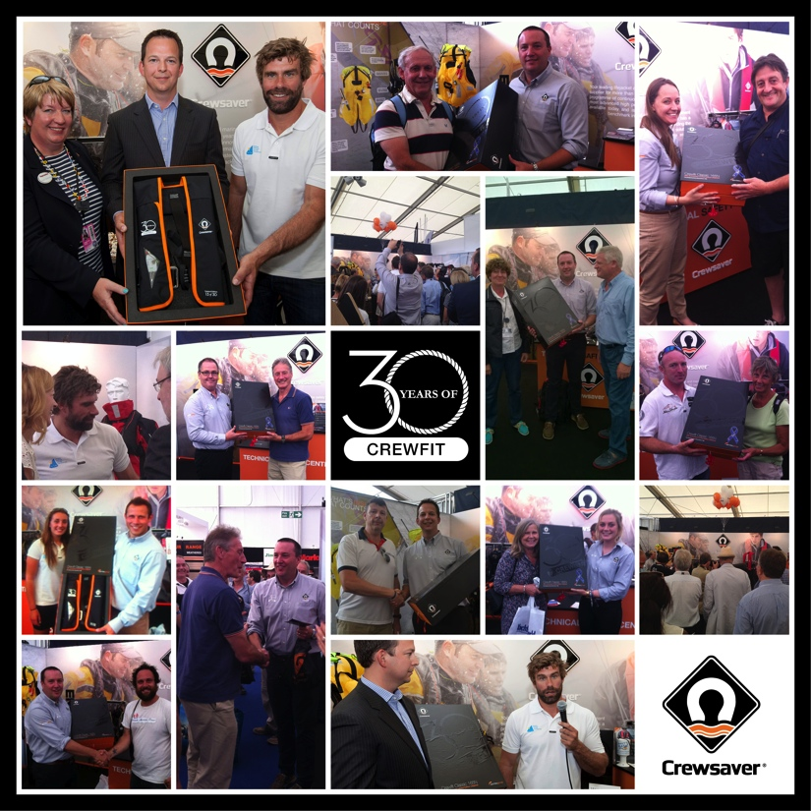
The competition was a major part of a celebration of the Crewfit inflatable lifejacket, which this year celebrates 30 successful years since it was first designed and manufactured.

Huge crowds gathered on the Crewsaver stand every day of the show with the final Saturday attracting 141 visitors for the draw. A total of over 850 visitors entered the competition during the course of the show.

The sets are packed with accessories including;
- Re-designed Crewfit lifejacket each in unique colour ways and individually numbered
- McMurdo Fastfind personal locator beacon
- Spray hood
- Safety line
- ErgoFit safety knife
- Crotch Straps
- Replacement Re-arming Kit
- Lifejacket light
- Lifetime’s free service
- Certificate of ownership

Thom Axon a winner of one of the limited edition lifejackets said; ‘I work at sea and have always relied on ships’ jackets. Now I have my own that I can take with me everywhere I go. I'm so proud to own this jacket. THANK YOU Crewsaver!!’

The remaining limited edition lifejackets will be donated to charity auctions, including the RNLI silent auction in December, and given to some key contributors to the marine industry including Fiona Pankhurst, President of the British Marine Federation, and Iain Percy OBE, Trustee of the Andrew Simpson Sailing Foundation, who were presented with their lifejacket box sets during the show.

To celebrate 30 years of the Crewfit inflatable lifejacket Crewsaver successfully launched the new Crewfit 165N a re-designed version of the original Crewfit lifejacket. This proved to be extremely popular during the show with strong sales through numerous Crewsaver retailers.

From 30 years of Crewfit to extreme ocean racing, Crewsaver also proudly launched the ErgoFit Extreme, designed with Abu Dhabi Ocean Racing for the extreme ocean racer. The lifejacket was very well received during the show. The option to purchase an ErgoFit Extreme with a McMurdo S20 AIS unit proved popular and had a high take-up. The ErgoFit Extreme is the latest addition to the ErgoFit lifejacket collection, which achieved record sales at the 2014 PSP Southampton Boat Show.

ENDS//

For media information, hi-res images or product tests please contact:
Hannah Burywood, Marketing Dept, Crewsaver
T +44 (0) 1329 820024
E hannah.burywood@survitecgroup.com
Press releases for the Crewfit 165 and ErgoFit Extreme lifejackets can be found in the Media Centre on the Marine Advertising Agency website:
www.marineadagency.com/media-centre

About Crewsaver
Crewsaver is a world-leading manufacturer of marine safety equipment and clothing for the commercial and leisure marine industries. Based in Gosport, Hampshire, the company designs and manufactures bespoke safety equipment for several countries’ special forces, the UK government’s Environment Agency and the aviation and oil industries. Crewsaver is part of the Survitec Group.
www.crewsaver.com
About Survitec Group
Survitec Group holds market-leading positions worldwide in marine, defence and aerospace survival technology. Headquartered in Southampton, the company employs 2000 people across 10 manufacturing sites and 50 service centres, operating through a network of a further 550 distributors and agents to bring its best-in-class products and services to a global customer base. With an extensive history spanning over 160 years and a portfolio of some of the most reputable brands in the safety and survival industry, Survitec is committed to product innovation, technological advancement and quality assurance.
www.survitecgroup.com

