New Release
For immediate release 15th May 2015

Flattens: Furling Battens designers follow up prestigious 2014 METS DAME nomination with plans for expanded range

Primrose Fry Technologies Ltd plans to grow the existing range of Flattens: Furling Battens with additional sizes following on from the product’s nomination for a prestigious 2014 DAME award at the Marine Equipment Trade Show (METS) last November. The plans to increase the range will see the additional sizes appearing in the near future.

The Flatten roller batten is a completely new concept in furling battens, designed in the UK by Primrose Fry Technologies Ltd (PFT). Flattens are the only battens that roll, rather than bend. The innovative, patented bi-stable tube from which they are made removes, for the first time, the need to compromise in the sail design and function. Flattens offers comparable performance to fixed battens when sailing, whilst furling as easily and neatly as a non-battened sail.

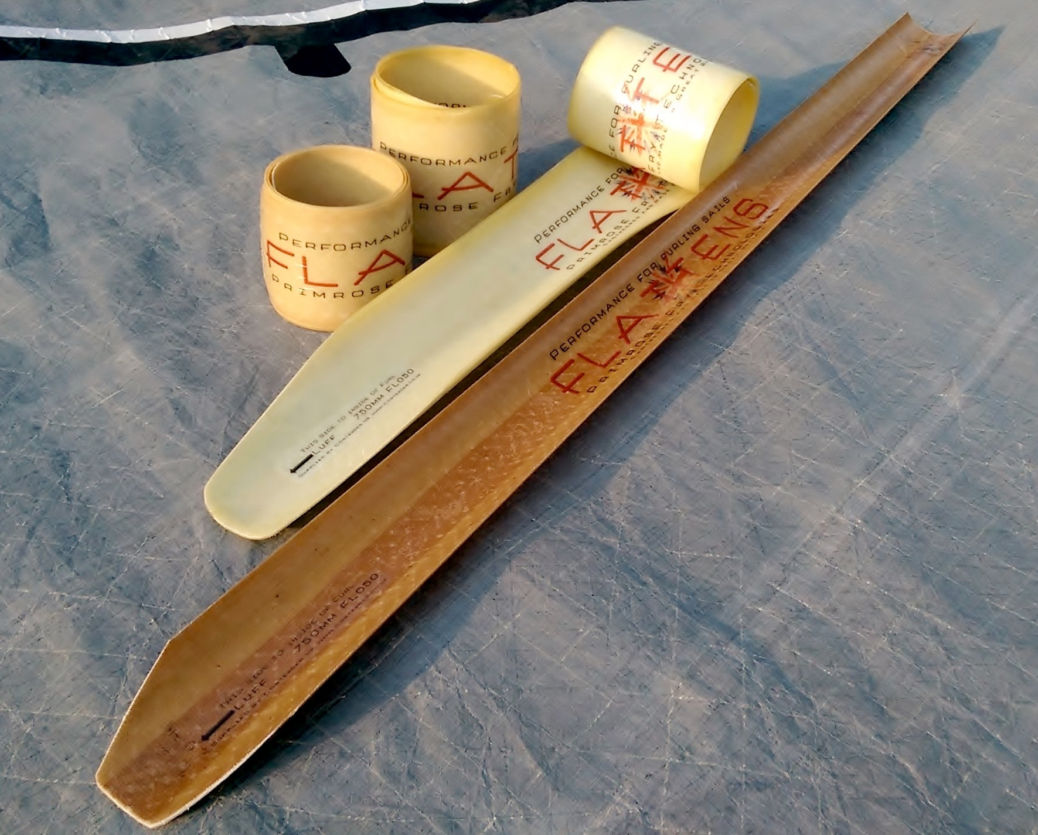
Contender UK, major supplier of “best in class” fabrics and hardware products for sailmaking, distributes Flattens. For them, sails with Flattens can be designed with more roach and a flatter leech for optimum shape. The extra support helps create a more durable sail that can maintain its optimum shape for longer. Flattens offer high stiffness in both bending and compression resulting directly in a straighter leech and improved sail control for trimmers. Combine this with the highly stable furled position (they do not try to spring open unlike other furling battens) and zero performance drop off Flattens have over time and they are not only the best choice for performance but also in value for the sailor.
Flattens can be easily retrofitted to sails just by adding a specifically designed pocket that allows the batten to work perfectly. The batten can be left in sails and offers no obstacles to the use of a jib sock.

Flattens: Furling Battens designers follow up prestigious 2014 METS DAME nomination with plans for expanded range
Continued/

Flattens were developed by yachting stalwarts Dan Primrose and Simon Fry, owners of Primrose Fry Technologies (PFT). The pair spotted the potential of a globally patented technology that was developed originally for military use. They acquired exclusive rights to the material for marine applications and commissioned the Flatten design. At the same time, they developed the Flatten Pocket to ensure optimal performance and longevity.

Engineered and manufactured in Great Britain, Flattens are currently available for jibs on boats from 20ft to 55ft across two specifications, the FL030 and FL050. Both types are currently stocked in standard lengths of 450mm, 750mm and 1000mm with custom lengths also available.

To access video of Flattens in use, visit www.PF-Technologies.com or for more information, contact Alastair Shires at Contender UK on 01329 849036.

ENDS//

Notes to Editors

Primrose Fry Technologies Ltd is a British company established in 2011 by Dan Primrose and Simon Fry.

Flattens and Flatten Pockets are engineered and manufactured entirely in Great Britain.

Flattens and Flatten Pockets are available direct to sail makers through Contender UK. Contender UK is the UK representative of the Contender Sailcloth Group, a world leader in fabrics for the sail making industry. In addition to supplying sailcloth, the company is a major supplier of best in class fabrics and hardware for cover making, structural work and architectural work.

Media enquiries via Marine Advertising Agency

Mike Shepherd - mike@marineadagency.com
Tel: 023 9252 2044

Or

Primrose Fry Technologies:
Dan Primrose - dan@pf-technologies.com
Tel: 07775 864875

