New Release
For immediate release 12th September 2014

Flattens: Furling Battens That Really Work
A series winning solution whether furled or set

Following a class winning performance at Quantum Key West Race Week earlier this year, Primrose Fry Technologies Ltd (PFT) has proudly launched its innovative and incredibly successful Flatten furling battens to the racing and cruising worlds.

Unlike traditional furling battens, the deceptively simple yet effective design of the Flattens really works. The leech is as controllable as it would be with normal, non-furling battens plus, when furled, your sail not only stays put, but can actually hold a tighter furl than a sail with no battens at all.

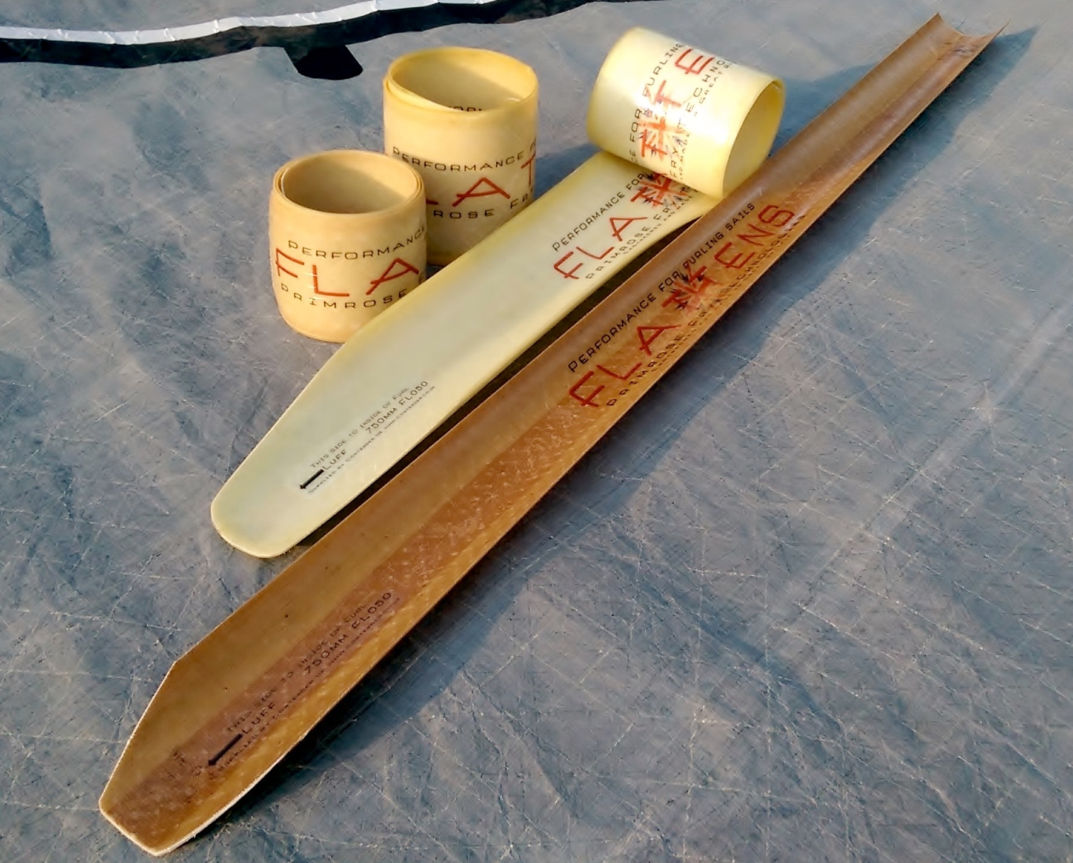
The secret has been to construct Flattens from a highly advanced performance material in combination with critical geometry that means the Flattens are stable rolled up around the headstay or unrolled in the sail. Just like when a retractable tape measure coils away, the Flatten has been engineered to roll up smoothly, neatly and reliably as it approaches the headstay. Built to be extremely durable and to perform in all conditions, from light airs to wilder winds, Flattens have earned the respect of both professional racers and cruising sailors alike. With Flattens in place, sailors of all aspirations can say farewell to underpowered sails and look forward to better speed and jibs that last longer.

This batten revolution owes its existence to yachting stalwarts Dan Primrose and Simon Fry, owners of PFT. The pair spotted the potential of a globally patented technology that was developed originally for military use. They acquired exclusive rights to the material for marine applications and commissioned the Flatten design. At the same time, they developed the Flatten Pocket to ensure optimal performance and longevity.

The Flatten Pocket is as easy and cost effective to fit as traditional batten pockets. It is shaped to allow the Flatten to furl correctly and maintain its shape through sustained use in all conditions. Flattens are easily retrofitted to any sail and both Flattens and Flatten

Pockets are readily available from your sail maker through Contender UK.

When it comes to having new sails, sailors specifying Flattens will see an additional and immediate advantage over tradition furling sail designs. As Flattens have such an outstandingly high bend and compression stiffness, the sail designer has the scope to incorporate more roach than is possible with traditional furling battens, so allowing the option for more area to be built in to the sail.

Engineered and manufactured in Great Britain, Flattens are now available for jibs on boats from 20ft to 55ft across two specifications, the FL030 and FL050. Both types are stocked in standard lengths of 450mm, 750mm and 1000mm with custom lengths also available.

To access video of Flattens in use, visit www.PF-Technologies.com or for more information, contact Alistair Shires at Contender UK on 01329 849036.

ENDS//

Notes to Editors

Primrose Fry Technologies Ltd is a British company established in 2011 by Dan Primrose and Simon Fry.

Flattens and Flatten Pockets are engineered and manufactured entirely in Great Britain.

Flattens and Flatten Pockets are available direct to sail makers through Contender UK. Contender UK is the UK representative of the Contender Sailcloth Group, a world leader in fabrics for the sail making industry.

In addition to supplying sailcloth, the company is a major supplier of best in class fabrics and hardware for cover making, structural work and architectural work.

Media enquiries via Marine Advertising Agency

Mike Shepherd - mike@marineadagency.com

Tel: 023 9252 2044

Or

Primrose Fry Technologies:

Dan Primrose - dan@pf-technologies.com

Tel: 01730 828 188

