**News Release**

**For immediate release**

**26th August 2014**

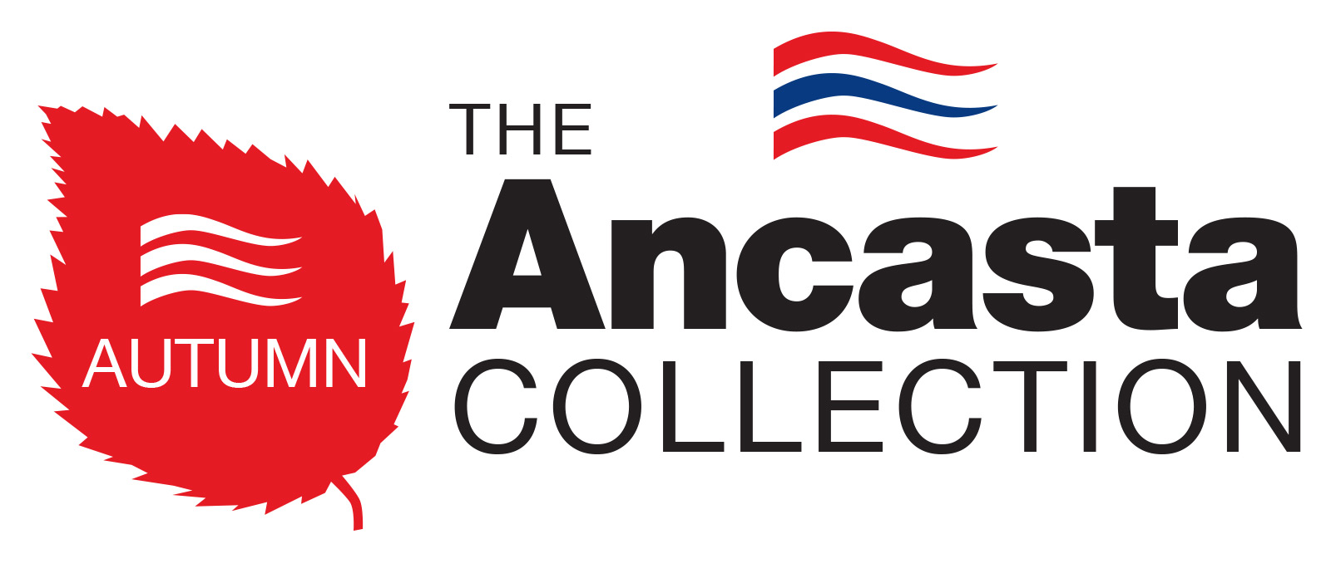

**Ancasta announces “biggest brokerage event of 2014”, the Ancasta Autumn Collection**

Ancasta International Boat Sales has just announced what is set to be “the biggest brokerage event of 2014” which will take place this year with incentives for buyers on offer between the 3rd and 12th October 2014. Broadening the reach beyond the limitations of a traditional, single location used boat show, ***The Ancasta Autumn Collection*** will utilise the entire Ancasta Network – including all locations, both in the UK and overseas.

The event will run throughout the key period of the year for boat sales and, to create a heightened sales intensity, from the 3rd to the 12th October 2014 Ancasta is introducing an added incentive for buyers. During this period, its customers will be able to enjoy peace of mind as Ancasta will cover the cost of some elements of the buying process. Its brokers will be on hand every day at every office to conduct viewings and help find the perfect boat for your needs.

Anyone who is serious about selling their boat this Autumn is encouraged to list their boat with any of Ancasta’s 15 offices immediately. It will be included in the Autumn Collection, which is promoted heavily online and in print throughout August, September and October and contains literally hundreds of quality used sail and motor boats. Ensuring that its vendors’ boats benefit from the increased buying traffic which surrounds the international boat shows, Ancasta will also include a lift, clean and storage deal if required, depending on the location*.

Terms and conditions apply.

For further details please go to [www.ancasta.com/autumncollection](http://www.ancasta.com/autumncollection)

**ENDS**



**Notes to editors**

* Ancasta International Boat Sales is Europe’s Largest Brokerage Network with 15 offices across Europe.
* The Ancasta network features offices in Brighton, Chichester, Port Solent, Cowes, Port Hamble, Swanwick, Lymington, Dartmouth, Falmouth, Mylor, Plymouth, London, Port Napoleon, Palma de Mallorca, Algarve Portugal.
* Ancasta International Boat Sales are new boat dealers for Prestige Luxury Motor Yachts, Bénéteau Yachts, Beneteau Power, Lagoon Catamarans, CNB custom Yachts, Fairlie Modern Classics, McConaghy Race boats.
* The Ancasta network is open seven days a week, staffed by fully qualified ABYA (Association of Brokers and Yacht Agents) trained brokers.
* Ancasta sell over 700 new and used boats annually.
* The Ancasta website is [www.ancasta.com](http://www.ancasta.com/)
* Ancasta Int. Boat Sales is a company within the Ancasta Group.
* Ancasta Int Boat Sales was formed in 1981.
* The Ancasta Group incorporates Ancasta International Boat Sales & Hamble Yacht Services
* Hamble Yacht Services is a full service boat yard operating from Port Hamble.

**Ancasta Int. Boat Sales Ltd registered address is**: Port Hamble Marina, Hamble, Hampshire, SO31 4QD. **Tel:** 023 80 450 000. **Email**: [reception@ancasta.com](mailto:reception@ancasta.com)

Downloadable assets from the campaign can be found at:

<http://www.ancasta.com/AACassets>

Media enquiries via Marine Advertising Agency:

Alison Willis - alison@marineadagency.com

Tel: 023 9252 2044

Or via Ancasta:

Will Blair – willblair@ancasta.com