**News Release**

**For immediate release**

**24th September 2014**

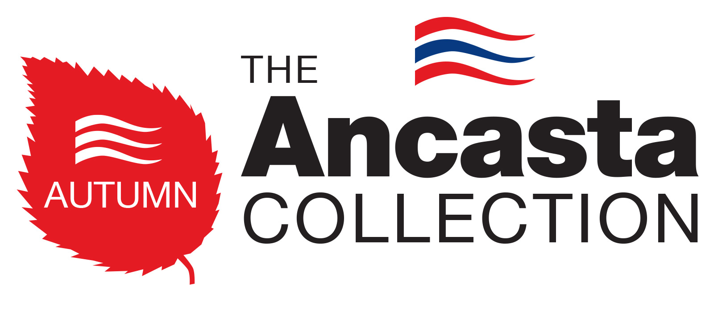

**Ancasta announces 10 days of buying incentives to celebrate the Ancasta Autumn Collection**

Ancasta is offering its customers 10 days to take advantage of four exclusive buying incentives celebrating the **Ancasta Autumn Collection**.

As part of its **Ancasta Autumn Collection**, these buying incentives are only available from the **3rd -12th October 2014.**

The Collection Incentive includes ALL of the following and is applicable to anyone who buys a boat within the ten day promotion period:

* **Discounted berthing** (subject to availability and location)
* **1 year of Sea-Start membership**
* **1st month mortgage repayment holiday**
* **Refund of survey and lift/launch costs**

Terms & Conditions apply.

Ancasta comments that while the incentives benefit purchasers by warding off most of the potential stresses and inconveniences associated with the buying process, they also ensure that vendors capitalise on the increased buying activity at this time of year. Combining the ten day promotion with the **Ancasta Autumn Collection**, which offers Europe’s biggest brokerage collection of quality sail and power boats, Ancasta is making it easier for people to achieve exactly what they want from their next (or first) boating experience.

If you want to list your boat to become part of Ancasta’s Autumn collection you have until the 3rd October to ensure its inclusion.  For more information please phone 02380 450 000 (or your local Ancasta office).

For full details go to [www.ancasta.com/autumncollection](http://www.ancasta.com/autumncollection)



Broadening the reach beyond the limitations of a traditional, single location used boat show, **The Ancasta Autumn Collection** will utilise the entire Ancasta Network – including all locations, both in the UK and overseas.

**ENDS**

**Notes to editors**

* Ancasta International Boat Sales is Europe’s Largest Brokerage Network with 15 offices across Europe.
* The Ancasta network features offices in Brighton, Chichester, Port Solent, Cowes, Port Hamble, Swanwick, Lymington, Dartmouth, Falmouth, Mylor, Plymouth, London, Port Napoleon, Palma de Mallorca, Algarve Portugal.
* Ancasta International Boat Sales are new boat dealers for Prestige Motor Yachts, Bénéteau Yachts, Beneteau Power, Lagoon Catamarans, CNB Yachts, Fairlie Yachts, McConaghy Race boats.
* The Ancasta network is open seven days a week, staffed by fully qualified ABYA (Association of Brokers and Yacht Agents) trained brokers.
* The Ancasta website is [www.ancasta.com](http://www.ancasta.com/)
* Ancasta Int. Boat Sales is a company within the Ancasta Group.
* Ancasta Int Boat Sales was formed in 1981.
* The Ancasta Group incorporates Ancasta International Boat Sales, Hamble Yacht Services and Advanced Rigging & Hydraulics
* Hamble Yacht Services is a full service boat yard operating from Port Hamble.

**Ancasta Int. Boat Sales Ltd registered address is**: Port Hamble Marina, Hamble, Hampshire, SO31 4QD. **Tel:** 023 80 450 000. **Email**: [reception@ancasta.com](mailto:reception@ancasta.com)

Downloadable assets from the campaign can be found at:

<http://www.ancasta.com/AACassets>

Media enquiries via Marine Advertising Agency:

Alison Willis - alison@marineadagency.com

Tel: 023 9252 2044

Or via Ancasta:

Lou Waldegrave – louwaldegrave@ancasta.com