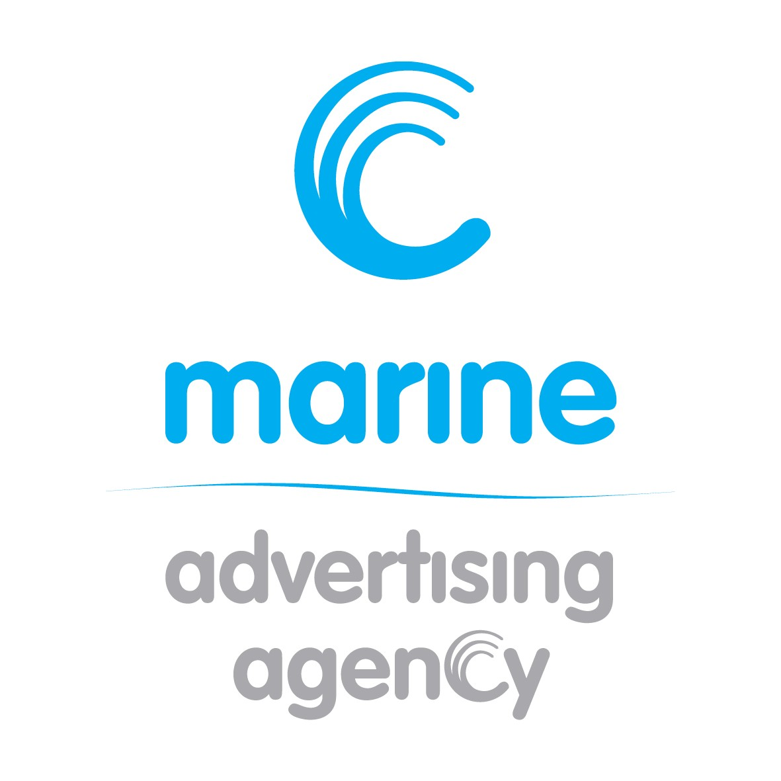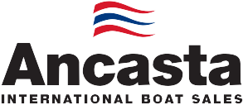N e w s R e l e a s e

For immediate release 15th May 2015
Portsmouth Harbour Multihull Show to take place 5th-­‐7th June 2015
The Portsmouth Harbour Multihull Show will be held at Haslar Marina in Gosport between the 5th and the 7th June 2015. The established show gives visitors the chance to see unique multihull designs from leading brands. The show will be open from 10am to 4pm each day and entry is FREE.

Ancasta will have a strong presence at the show. As exclusive UK dealer for Lagoon Catamarans, the company will be showcasing the Lagoon 39 and Lagoon 450 at the event. Visitors are encouraged to book appointments to view the boats and to really get an understanding of what these boats can deliver. Demonstration sails can be booked departing from 4pm onwards.

Visitors will also be able to see unique multihull designs from all the leading brands; Lagoon, Broadblue, Dragonfly, Fountaine Pajot, Gemini and Corsair. This is a great opportunity to see at least 12 trimarans and catamarans, ranging from 7.5m to 17m in length, in one location, on the water and side-­‐by-­‐side. All the multihulls on show will be open for public viewing and there will be opportunities to take a test sail on selected boats (after 4pm and by pre-­‐arranged appointment only).

The show area is adjacent to the iconic green lightship, “Mary Mouse”, which is berthed at Haslar. Visitors will be able to enjoy food, refreshments and hospitality at Trinity’s At the Lightship. Trinity’s At the Lightship boasts an historic atmospheric setting overlooking Portsmouth Harbour.

For more information visit www.portsmouthmultihullshow.com

Ancasta’s site for the multihull community (www.ancastamultihulls.com), acts as a hub offering information to those interested in starting a multihull adventure, whether committed multihull sailors or occasional catamaran charterers. The site has frequently asked questions about sailing multihulls, news from the world of multihulls and also features stories from multihull owners. Owners are invited to share their own stories, creating a community feel to the site.

ENDS
Notes to editors
- Ancasta International Boat Sales has 15 offices across Europe
- Ancasta is exclusive UK dealer for Lagoon Catamarans
- Ancasta has a commercial relationship with the Catamaran Company, the largest specialist sales company in the world, enabling listings to be presented to the widest possible market
- Ancasta is the UK’s largest Prestige Luxury Motor Yachts dealer, the UK’s largest Beneteau Power and the UK’s largest Beneteau Sail dealer
- In addition Ancasta is a new boat dealer for Bordeaux 60, Fairlie Yachts and McConaghy Yachts
- The Ancasta Group incorporates Hamble Yacht Services Refit & Repair and Advanced Rigging & Hydraulics, both operating from Port Hamble
- For more information on Ancasta visit www.ancasta.com

Media enquiries via Marine Advertising Agency:
Alison Willis -­‐ alison@marineadagency.com, t: 023 9252 2044
T: 023 9252 2044
E: Alison@marineadagency.com www.marineadagency.com

Marine Advertising Agency
15 Haslar Marina
Gosport PO12 1NU

