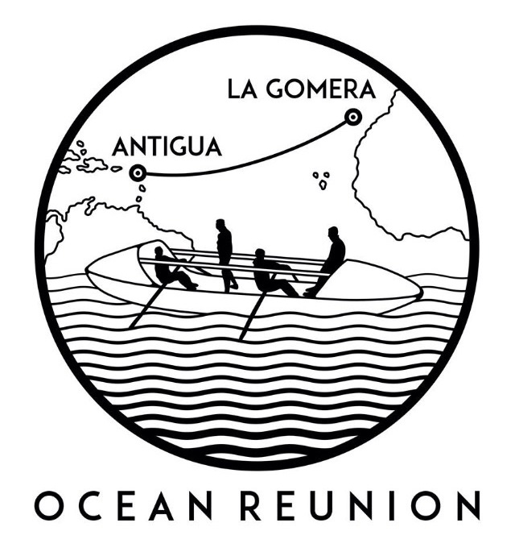
PRESS RELEASE
For release 12th May 2015

Ocean Reunion to row the world’s second largest ocean under the comfort and protection of the new Yak clothing range.
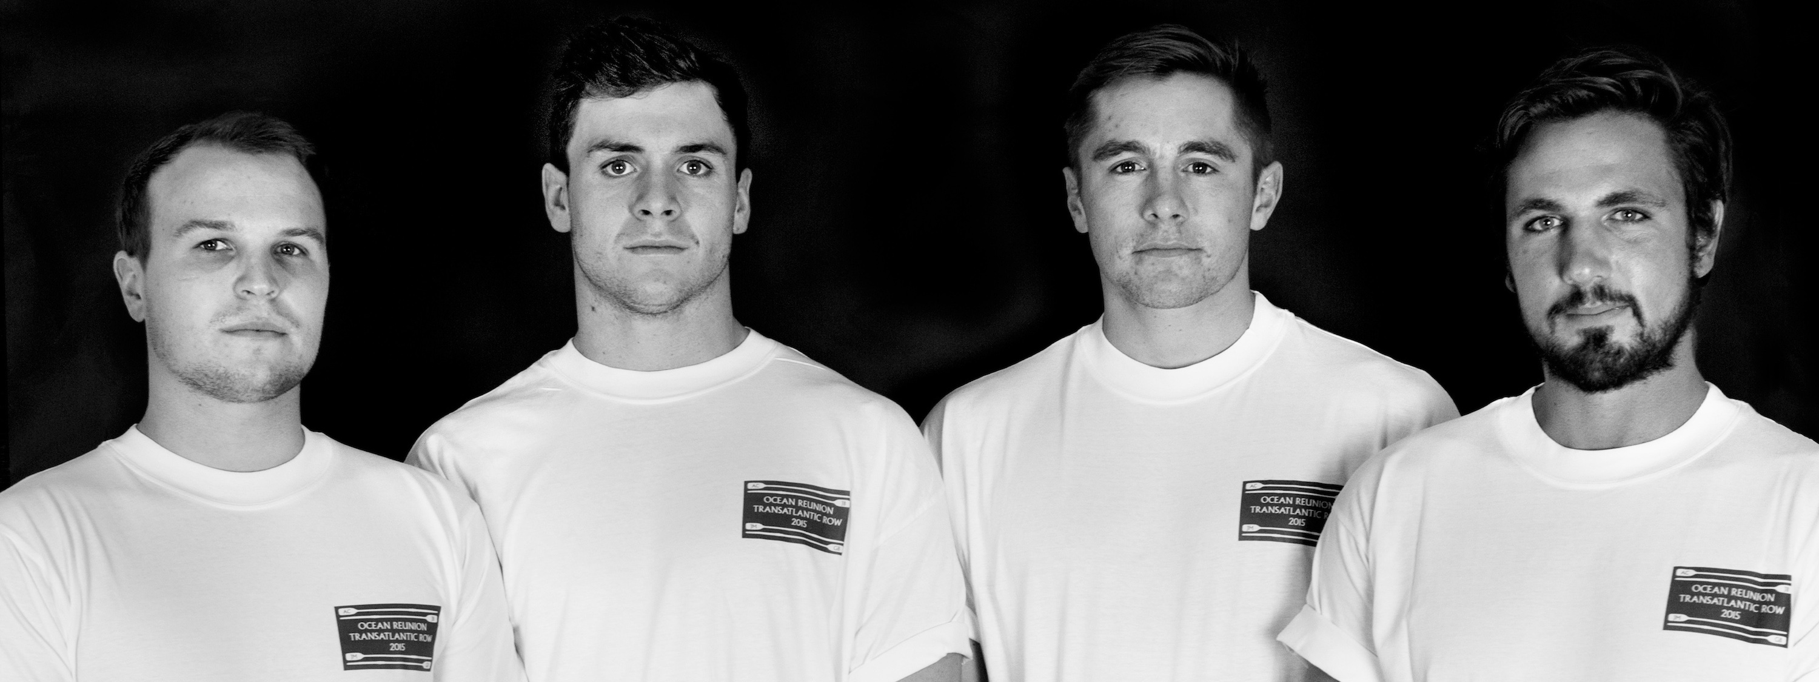
Ocean Reunion will row
3,000 nautical miles across the world’s second largest ocean, heading west from the Canary Islands to Antigua. The team, which reunites four old school friends, are competing in “The world’s toughest race”. They could face 50ft waves, hurricane strength winds, and 40-degree heat.

Thanks to Yak, the team will have all the necessary clothing to keep them warm, dry and comfortable during the row, including Yak dry cags, trousers and thermals.

‘We are dead excited to be working with Yak, we have already been able to try out a variety of the products and have been really impressed by the quality. When you’re out in the big waves and cold winds, it’s imperative to have warm and highly waterproof yet breathable clothing. Yak specialise in whitewater clothing, a sport which means your upside down in the water 50% of the time and therefore ideal for us.’ - Angus Collins, team member.

The row will begin December this year; the team will be rowing for two charities, Cystic Fibrosis Trust and Teenage Cancer Trust. Visit their website to donate.

Click here to watch Ocean Reunion’s video and find out more about the challenge!

Ends//

Notes to editors

About Yak
Part of the Survitec Group which also owns Crewsaver, Yak, produces and manufactures products that are purposely designed for the whitewater, recreational and touring kayaking and canoe markets. A wide range of products suit all styles and experience, giving paddlers more choice and more opportunities to enjoy their sport with total peace of mind. Yak’s products include buoyancy aids, drysuits, cags, trousers, spray decks, gloves, footwear, headwear and buoyancy bags.

Together with Crewsaver, Yak has 50 years of experience manufacturing marine safety products that combine cutting edge technology with high performance and ultimate practicality.

For media information, hi-res images or product tests please contact:

Yak
Hannah Burywood, Marketing Dept
T +44 (0) 1329 820024
E Hannah.Burywood@survitecgroup.com

