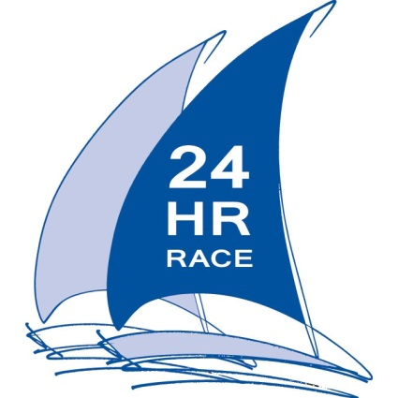
PRESS RELEASE
For release 28th July 2014

The countdown begins - Crewsaver 24 Hour Race 13th and 14th September 2014!

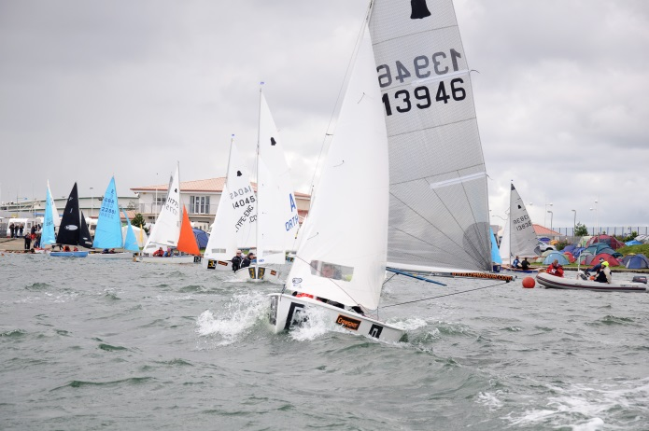
Preparations are well under way for the 48th year of the Crewsaver 24 Hour Race at West Lancashire Yacht Club, Southport. The club are very excited to welcome you to this year’s event.
With 52 boats entered so far entries are up on last year, making this event bigger and better than ever! Of those entries we are pleased to see four boats from the recently re-introduced Firefly Class, numerous boats from various universities and a large increase in Lark entries.
Friday night promises to be a lively one; with the hugely popular sailing band Elephant Juice and resident DJ Steve Blackburn confirmed to keep the entertainment going until the early hours! Back by popular demand is the folk afternoon which will take place on the Saturday, followed by a soul night in the evening.
The main marquee has been increased in size to help house all of the additional entries and providing more room for on shore activities which promise to rival last year’s surf competition. After the catering success of last year, we are again catering in house with beer supplied by Robinsons.
Your local chandlery, 1st Mark , will also be on site selling some of your favourite Crewsaver kit at some fantastic event prices. Due to the extensive popularity of the kit last year he will also be increasing the size of his marquee – helping to ensure all the kit you need is on hand to keep you out on the water.
This year we have Robin Jones and Isaac Marsh from Scammonden Water Sailing Club, sailing a Firefly for the full 24 hours in aid of the Andrew Simpson Sailing Foundation. Please donate to show your support for these two embarking on this fantastic challenge.
Liverpool Yacht Club has gone the extra mile for this year’s event by building an Enterprise especially for the race; we look forward to seeing the results of all your hard work in September.
Huge thanks must be made to Crewsaver, title sponsor of the event, for their on-going support which enables us to improve on the event year on year. In addition, this year Crewsaver have helped to support a prize draw to win some of their fantastic Phase2 sailing gear range on the Saturday in the main marquee – more info to follow on the Facebook page closer to the event. Thanks also to GJW and Robinsons, our other two main sponsors, for their continued help and support.
We can’t wait to see you all and, if you haven’t entered yet, get your entries in soon so we can make sure we have enough sausages and bacon for the breakfast butties!

For more information and live updates before, during and after the event please visit the West Lancashire Sailing Club Facebook page.

Ends//

Notes to editors

About Crewsaver
Crewsaver is a world-leading manufacturer of marine safety equipment and clothing for the commercial and leisure marine industries. Based in Gosport, Hampshire, the company designs and manufactures bespoke safety equipment for several countries’ special forces, the UK government’s Environment Agency and the aviation and oil industries. Crewsaver is part of the Survitec Group.
www.crewsaver.com

West Lancashire Yacht Club

WLYC is one of the premier sailing Clubs in the north west, it has excellent facilities, including sail training and an extensive racing programme on both tidal waters and the relatively safe waters of the Marine Lake at Southport.

www.wlyc.org.uk

For media information, hi-res images or product tests please contact:

Crewsaver
Hannah Burywood, Marketing Dept
T +44 (0) 1329 820024
E Hannah.Burywood@survitecgroup.com

West Lancashire Yacht Club
Nicola Sinclair White
T +44 (0)7841 458720
E nicolasinclairwhite@gmail.com

