PRESS RELEASE
For release 31st July 2014

Crewsaver Abersoch Dinghy Week 2014 celebrates largest fleet since 2007

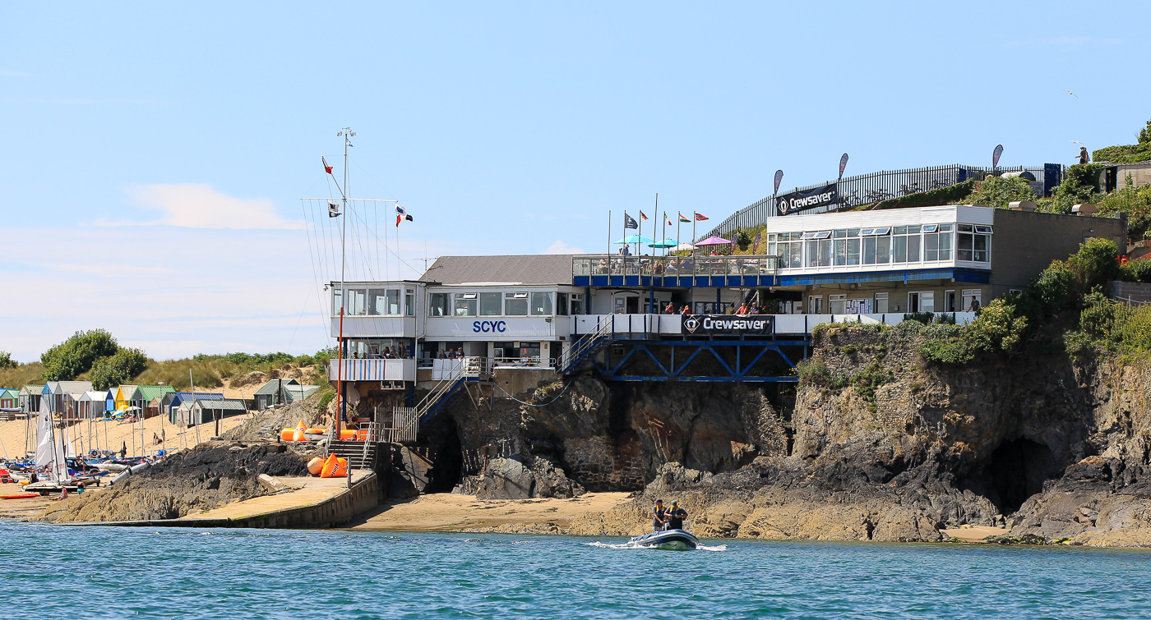
It promised to be bigger and better and, with 273 entries across 51 fleets, the largest entry seen since 2007, the Crewsaver Abersoch Dinghy Week 2014 was certainly an event not to be missed.

The extremely warm weather enabled the competitors to top up their sun tans! This did however result in light winds all week. This did not dampen the sailors’ spirits with hot sun, sea & sand there was still plenty of fun to be had.
Credit: Andy Green

The social program was headlined by Dinghy Week’s favourite band Elephant Juice, who played not once but twice in the week much to the enjoyment of all who came along and danced the night away.

This year saw the successful introduction of a smaller course with committee boat starts for the Topper, Tera and Optimist fleets, resulting in the spectacular sight of 50 youth boats enjoying the competitive side to sailing.

Crewsaver Abersoch Dinghy Week Organiser Andy Teague says ‘I am amazed at the number of entries with competitors coming from as near as Pwllheli and as far as Dubai. I would like to thank everyone for making it such a great event.’

The event finished with a successful prize giving. Lots of sailors were lucky enough to win fantastic products from the brand new Crewsaver Phase2 Dinghy Range.

Hannah Burywood, Marketing Coordinator for Crewsaver comments ‘Crewsaver Abersoch Dinghy Week is an extremely well organised, enjoyable event that every dinghy sailor should have noted in their calendar.’

With this in mind jot the 2015 date in your calendar: Registration, 25th July 2015
Sailing, 26th – 31st July 2015.

Final Results

Standard Laser
1st | Craig Williamson | Staunton Harold SC
2nd | Cameron Smith | Chelmarsh SC
3rd | Ben Ditchburn | Dudworth SC

Solo
1st | Chris Gillard | Sheffield Viking SC
2nd | Paul Heath | Leigh and Lowton SC
3rd | Oliver Whitehead | Hollingworth Lake SC

Single Handed Mixed
1st | Matt Jenkins | Sheffield Viking SC | RS 300
2nd | David Entwistle | Burghfield SC | Blaze
3rd | Stuart Bailey | Tewkesbury SC | D-Zero

Laser Radials
1st | Paul Williamson | Staunton Harold SC
2nd | Penny Downes | SCYC
3rd | Alexander Davies | Leigh and Lowton SC

Phantoms
1st | Philip Worth | Delph SC
2nd | Mike Tustin | Bowmoor SC
3rd | Mike Webster | Northampton SC

Junior/ Family Fleet
1st | Mike Bishop | Amy Cowlishaw | Sheffield Viking SC | Mirror
2nd | Alex Colquit | James Colquit | West Kirby SC | Cadet
3rd | Lucy Best | Sam Viney | Cardiff Bay SC | RS Feva

Optimist
1st | Matthew Ingram | Holyhead SC
2nd | Tyler Green | Port Dinorwic SC
3rd | Thomas Marsden | Holyhead SC

Topper
1st | Oliver Blackburn | Leigh and Lowton SC
2nd | Brandon Banner | Leigh and Lowton SC
3rd | James Wynn Edwards | Chester SC

Tera
1st | Alastair Joyce | Ogston SC
2nd | Dominic Baldwin | SCYC
3rd | William Shelly | SCYC

RS 200
1st | Matt Mee | Emma Norris | Red Wharf Bay SC
2nd | Phil Smith | Niaomi Smith | Bassenthwaite SC
3rd | Mike Budd | Katie Budd | SCYC

Asymmetric Class
1st | Jonny Harris | Alex Harris | SCYC | Cherub
2nd | Alex Knight |  | Castle Cove SC | Musto Skiff
3rd | Nick Orman |  | Castle Cove SC | D-One

RS 400
1st | Chris Pickles | Matt Sharman | Delph SC
2nd | Jon Heissig | Nicky Griffen | Llangorse SC
3rd | Paul Allen | Mike Allen | Leigh and Lowton SC

Fireball
1st | Paul Cullen | Gina Moidinis | Weirwood SC
2nd | Mo Turner | Jez White | Draycote Water SC
3rd | David Stanley |  | Chelmarsh SC

Slow Mixed Dinghies
1st | Tim Lawrence | Charlotte Lawrence | SCYC | Lark
2nd | Jemma Viney | Iago Davies | Cardiff Bay SC | 420
3rd | Alan Johnson | Paula Fisher | SCYC | Enterprise

Fast Mixed Dinghies
1st | Steve Hunt | Ruth Critchley | Pilks/Bass SC | Merlin Rocket
2nd | Lizzie Hendon | Steven Hendon | Blithfield SC | Merlin Rocket
3rd | Mike Banner | Kay Banner | Leigh and Lowton SC | Albacore

Crewsaver Team Challenge Trophy
1st | Delph SC
2nd | Chelmarsh SC
3rd | Staunton Harold SC

Club with the most entries
Leigh and Lowton SC

A full set of results can be found at www.scyc.co.uk.

Ends//

Notes to editors

For media information, hi-res images or product tests please contact:
Hannah Burywood, Marketing Dept, Crewsaver
T +44 (0) 1329 820024
E hannah.burywood@survitecgroup.com
About Crewsaver
Crewsaver is a world-leading manufacturer of marine safety equipment and clothing for the commercial and leisure marine industries. Based in Gosport, Hampshire, the company designs and manufactures bespoke safety equipment for several countries’ special forces, the UK government’s Environment Agency and the aviation and oil industries. Crewsaver is part of the Survitec Group.
www.crewsaver.com

