Contact: Paul Finney, Director of Operations
Boats & Yachts Warranty
T: +44 (0) 3300 101 101
E: Paul.finney@boatsandyachtswarranty.com
W: boatsandyachtswarranty.com

News Release
For immediate release
6th May 2015

Boats & Yachts Warranty launches new mobile site making buying a warranty easier than ever

Boats & Yachts Warranty, the leading provider of marine extended warranty plans, has launched a dedicated mobile website making it easier for customers to get quotes, manage their warranties and submit claims whilst on the move.
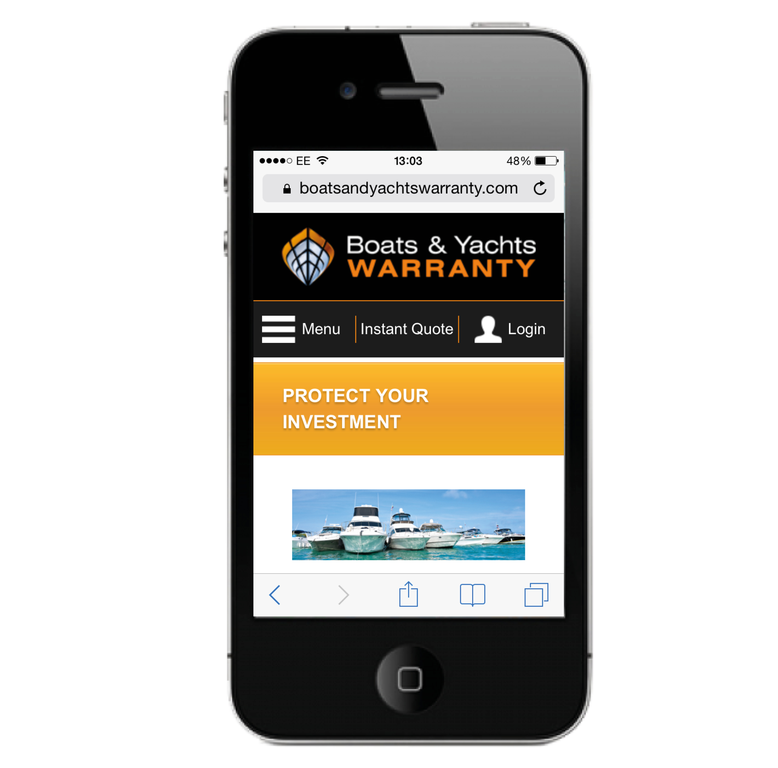
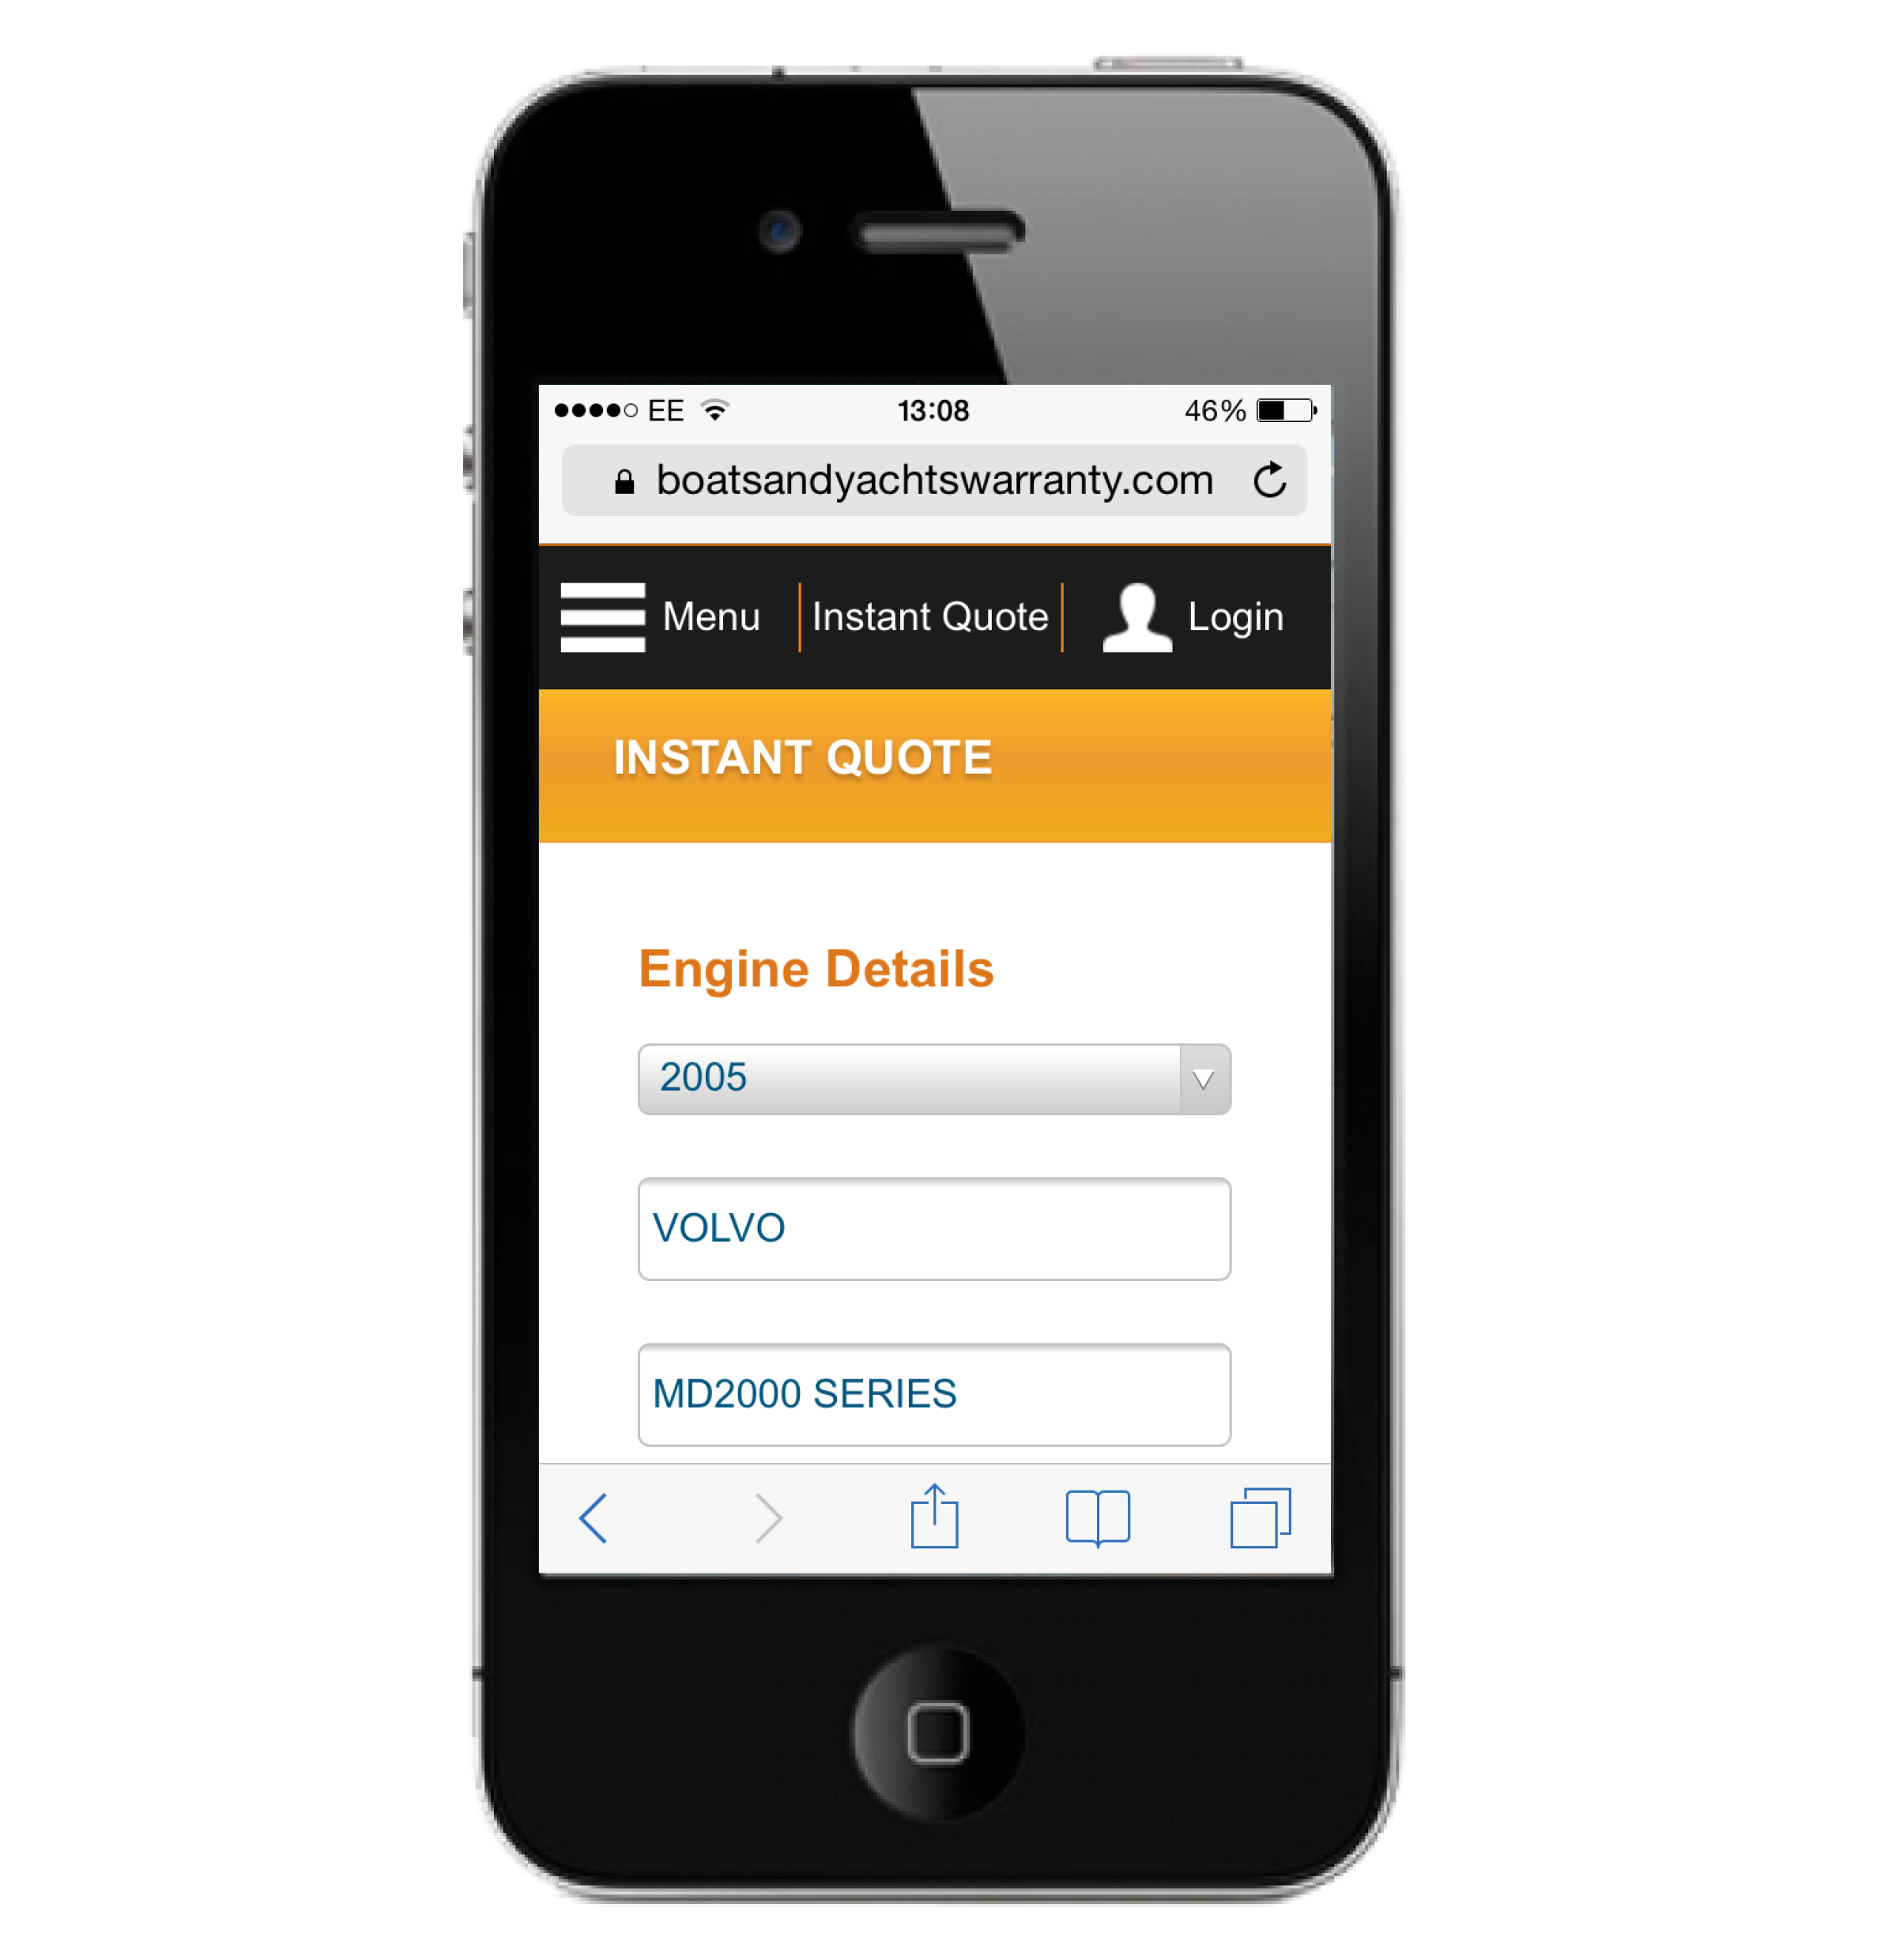
The user-friendly site offers customers an instant quote facility. Just six simple steps generate a quote, which is then emailed to the customer with full details of the warranty plan selected. The intuitive site has all the information that customers looking for an extended warranty might need. As well as the instant quote facility, there are useful FAQ pages and full details of what’s covered (and what’s not), all optimised for viewing on a mobile device.

Customers who already have a warranty will find making claims even easier using the mobile site. The company promotes a clear and simple ethos: “If it’s a valid claim, we’ll pay it.” Customers finding themselves with a problem, with any covered component, can make a claim instantly using the mobile site. The simple process starts as soon as the problem occurs and Boats and Yachts Warranty’s Claims Management System takes users through the process step by step.

During a claim submission, the Claims Management System locates local Service Providers that will be able to perform the repair, a particularly useful feature when in an unfamiliar location. Helpfully, all of this information can be easily accessed via the mobile site.

The flexibility of a Boats & Yachts Warranty Extended Warranty Plan allows customers to choose their own repairer if they prefer. As each Plan comes with a single and aggregate limit, then the amount of claims that can be made within a warranty period is not limited as long as the total cost of repairs doesn’t exceed this limit.

As Paul Finney, Director of Operations explains; “Boats & Yachts Warranty was created to give boat owners peace of mind and confidence. We can provide Extended Warranty Plans with full European cover for most pre-owned, brokerage and new boats either direct or

through local yacht brokers. The introduction of our mobile site means that our services are even easier to access than ever”.

Boats & Yachts Warranty offer Extended Warranty Plans to protect boat owners from costly repairs on both new and pre-owned vessels. The company’s warranty plans pay repair costs, or the replacement costs of any covered components that break down during the warranty period, anywhere throughout Europe. All warranty plans include up to £750 to cover the actual cost of Hoist/Haul-Out and storage to facilitate repairs as standard.

Boats & Yachts Warranty Extended Warranty Plans for pre-owned boats add a layer of protection to your purchase and let you buy a pre-owned boat with peace of mind. Extended Warranty Plans are also available to prolong the coverage of standard one- or two-year new boat warranties.

For more information visit www.boatsandyachtswarranty.com or call +44 (0) 3300 101 101

ENDS

Notes for editors:

Boats & Yachts Warranty aims to be the global leader in Marine Extended Warranty & Service Contracts, giving boat owners complete peace of mind to protect their investment. Its mission is to eliminate unexpected repair costs, while helping retain the value of warranty holders’ craft.

Boats & Yachts Warranty also offer a partner programme allowing marine businesses to offer extended warranty protection to their customers.

For media enquiries please contact:

Alison Willis or Mike Shepherd
Marine Advertising Agency
T: 023 9252 2044
E: alison@marineadagency.com
E: mike@marineadagency.com

