PRESS RELEASE

Visit our stand to view the jacket: 01.440

Crewsaver introduces inshore clothing range into the Ergofit collection!
Expanding on the success of the Ergofit lifejacket collection, Crewsaver has introduced the Crewsaver Ergofit inshore clothing range, with the aim of producing comfortable and affordable inshore clothing into the sailing, powerboat and Centre markets.

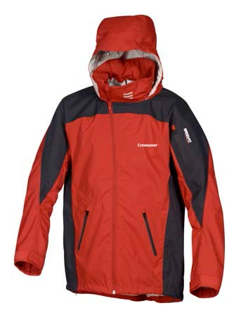
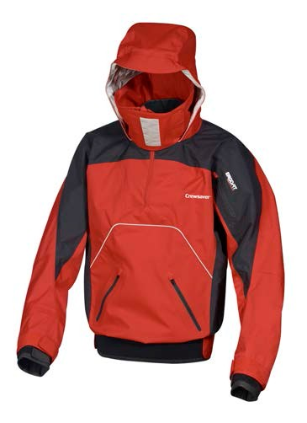
Crewsaver's Ergofit clothing collection includes the Ergofit Jacket, Smock and Salopettes. The clothing is constructed from 2.5 layer fabric and is designed to be breathable,
100% waterproof and windproof keeping you warm and dry when out on the water.

Specific Product Features Include:

Ergofit Smock -­‐ Perfect for dinghy, keelboat and sports boat sailing
✓✓ Comes complete with a high neck for maximum protection, particularly useful on wet and windy days!
✓✓ Articulated arms, designed for a sports fit for additional comfort
✓✓ Reinforced elbow panels helping to prevent wear from everyday use
✓✓ Two large front pockets and arm pocket for easy and comfortable storage solutions
✓✓ Inner storm cuffs and velcro outercuffs providing a secure fit
✓✓ Greater visibility with the help of the reflective piping detail on the back of the smock
✓✓ Stow away hood with single handed adjusters

Ergofit Jacket -­‐ Ideal for yacht sailing and general powerboat use
✓✓ Reinforced elbow panels helping to prevent wear from everyday use
✓✓ Cleverly designed curved off centre zip to avoid rubbing on the chin
✓✓ Articulated arms, designed for a sports fit for additional comfort
✓✓ Two large front pockets and arm pocket for easy and comfortable storage solutions
✓✓ High front hem to stop the jacket from bunching up when sitting down
✓✓ Adjustable hem and and velcro cuffs for a secure fit
✓✓ Greater visibility with the help of the reflective piping detail on the back of the jacket
✓✓ Stow away hood
Registered Office:

Ergofit Smock RRP £150

Ergofit Jacket RRP £130

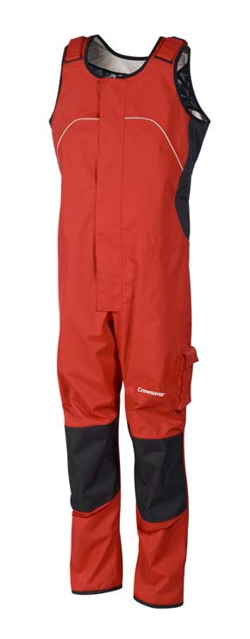
Ergofit Salopettes -­‐ Suitable for all types of inshore boating
✓✓ Reinforced knees and seat areas to help prevent wear from everyday use
✓✓ Leg pocket for easy and comfortable storage solutions
✓✓ Extra long front zip
✓✓ Adjustable shoulders for a secure fit
✓✓ Velcro ankle closure for an adjustable fit

Notes to editors About Crewsaver
Ergofit Salopettes
RRP £120

Crewsaver is the UK’s leading lifejacket and watersports equipment manufacturer, founded in Gosport, England in 1957.

Crewsaver continues to be recognised as the premier lifejacket brand. Many prestigious institutions including the RNLI, the MoD and a number of emergency services choose its products.

For media information, hi-­‐res images or product tests please contact:

Crewsaver
Hannah Burywood, Marketing Dept
T +44 (0) 1329 820024
EHannah.Leah-­‐Burywood@survitecgroup.com

Registered Office:

