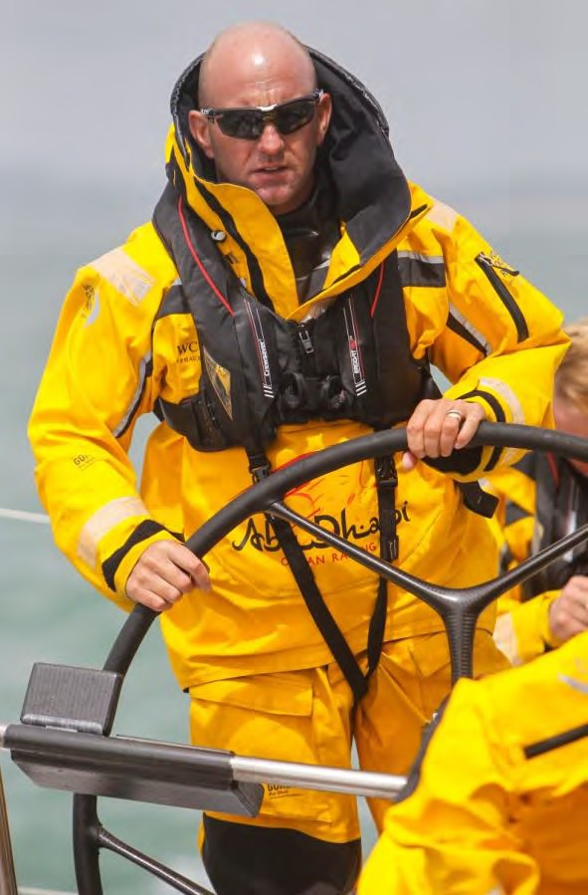
PRESS RELEASE

Crewsaver ErgoFit: the Ultimate Lifejacket

Visit our stand to view the complete Ergofit Collection: 01.440

Crewsaver, the UK’s leading marine safety and watersports equipment manufacturer, a year ago launched the high-performance Ergofit Lifejacket collection, the “must have” range for anyone who takes safety on the water seriously.

Today the lifejackets prove to be more successful than ever, providing the marine market with a safer, technical lifejacket in three different styles to suit varying needs. We now supply the lifejackets to a range of different teams and organisations including the Environment Agency and Volvo Ocean Race team, Abu Dhabi Ocean Racing.

Ian Walker, Skipper of Abu Dhabi Ocean Racing

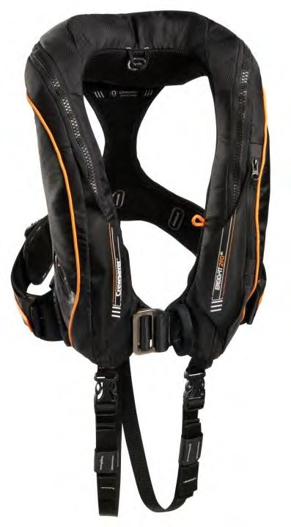
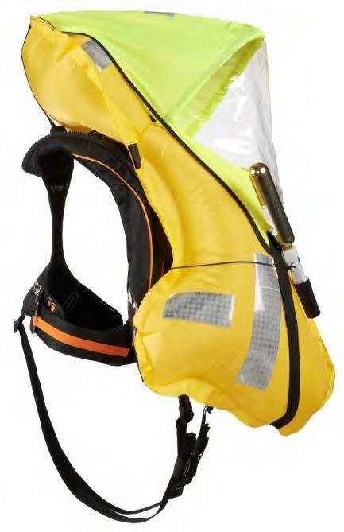
The Ultimate Lifejacket Collection comprises the ErgoFit 290 OC, ErgoFit 190 OS and ErgoFit 190 CS.

ErgoFit 290 OC, from £250 RRP

The ErgoFit 290 OC is for the serious sailor who is exposed to the full fury of the elements and refuses to compromise on safety. With nowhere to hide when a storm rolls in, it is vital to have the best kit on the market to stay safe. In extreme conditions with fierce waves breaking over the deck, a lifejacket is a sailor’s most important piece of kit, and the ErgoFit 290 is guaranteed to do the business. With full ocean layered clothing creating trapped air pockets, the extra buoyancy of the ErgoFit 290 ensures a fast turn speed and the airway is kept well clear of the water whatever the conditions (exceeding ISO 12402-2 standards). Features include a pocket on the outer cover,

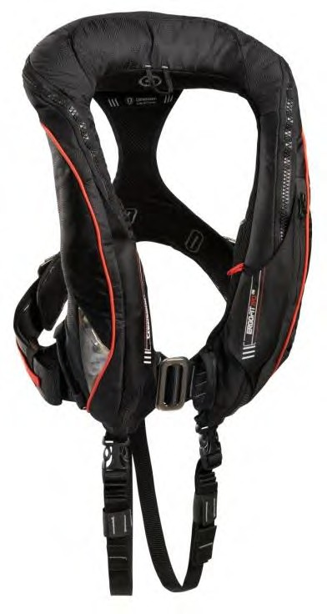
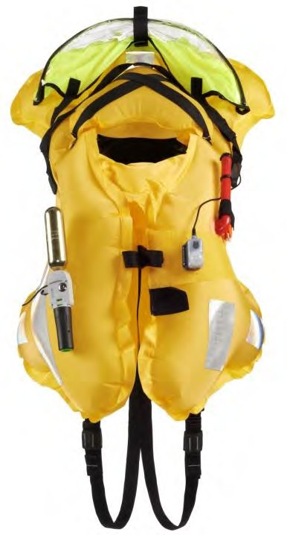
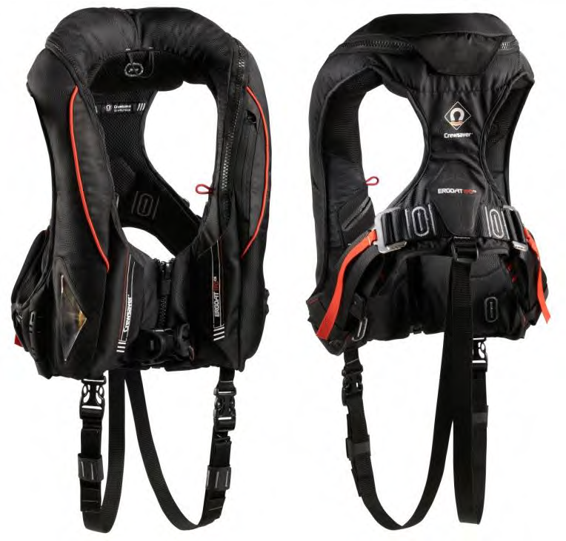
Velcro tab on the bladder to attach a PLB, like the McMurdo PLB 220, an internal knife pocket with a neoprene backing to avoid damaging the bladder.

With a powerful range of high-end features, plus unbeatable fit, cutting-edge style and class- leading buoyancy, Crewsaver’s ErgoFit OC 290 is the must-have lifejacket for those who demand the ultimate in performance without compromise.

ErgoFit 190 OS, from £200 RRP

The ErgoFit 190 OS is for those who venture out, whether under sail or power, and require extra security to stay safe whatever the conditions.
Whether racing overnight across the Channel or delivering a motor yacht to the Mediterranean, the ErgoFit 190 OS is the perfect choice. When you lose sight of land you need to be confident that your safety kit is the best on the market.
Rigorous testing and re-testing ensures that the ErgoFit 190 exceeds ISO 12402-3 standards, and a robust three-layer construction makes it extremely durable to cope with challenging conditions. Features include a pocket on the outer cover and a Velcro tab on the bladder for a Personal Locator Beacon. By combining the dynamic ‘cutaway’ design of the ErgoFit 290 OC
model with the updated 190-Newton buoyancy of the ErgoFit 190 OS is a lifejacket that you can trust however extreme it gets.

ErgoFit 190 CS, from £135 RRP

The Crewsaver ErgoFit 190 CS enjoys the same high levels of construction, style and comfort as the ErgoFit 290 OC and the ErgoFit 190 OS providing the reassurance of a professional quality jacket for recreational boating. The ErgoFit 190 CS provides best-in-class 190N buoyancy, exceeding ISO 12402-3 standards, fast fix buckle adjustability offers exceptional comfort and ease of movement. The ergonomic design of the ErgoFit 190 CS is especially comfortable for women’s contours, with foam

padding for maximum comfort. Other features include an external pocket, an internal pocket for a knife with a neoprene backing to avoid damaging the bladder and Velcro tab for attaching a PLB to the bladder. For all sailors and anyone who gets out on the water in a sports boat, motorboat or RIB, the ErgoFit 190 CS offers the security of a top-spec lifejacket at an affordable price.

Developing the ErgoFit Range:

Since the launch in 2012 Crewsaver have been developing on the Ergofit range continuing to introduce more products including the Ergofit safety knife, Ergofit lifejackets with fitted Mcmurdo Smartfind S20, and the Ergofit clothing collection which includes Jacket, Smock and Salopettes designed for inshore use, (see additional press release on the launch of the clothing
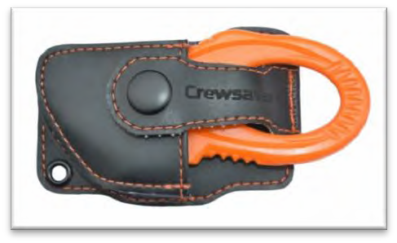
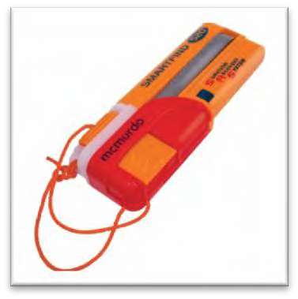
collection).

The ErgoFit Lifejackets can now be purchased with a fitted mcmurdo S20!

RRP, from £359

Now in the range the Ergofit Safety Knife, RRP £15

For more information on the ErgoFit range visit: www.crewsaver.co.uk/Crewsaver/Crewsaver_Leisure_Products/index.html?catid=109 To view the full Crewsaver range visit: www.crewsaver.co.uk

Notes to editors About Crewsaver

Crewsaver is the UK’s leading lifejacket and watersports equipment manufacturer, founded in Gosport, England in 1957.

Crewsaver continues to be recognised as the premier lifejacket brand. Many prestigious institutions including the RNLI, the MoD and a number of emergency services choose its products.

For media information, hi-res images or product tests please contact:
Crewsaver
Hannah Burywood, Marketing Dept
T +44 (0) 1329 820024
E Hannah.Leah-Burywood@survitecgroup.com

