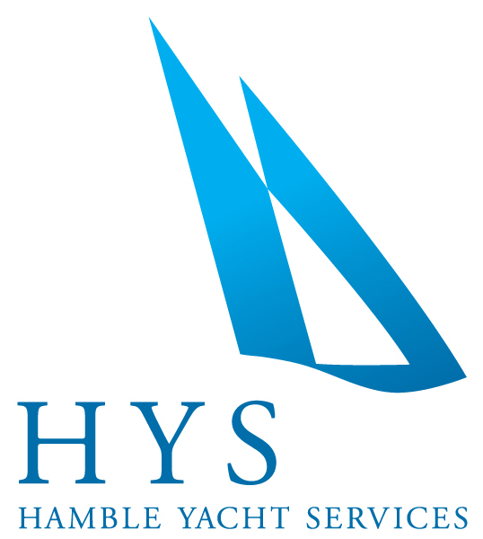

**News Release**

**For immediate release**

**28th April 2014**

**Ancasta’s Race Boat Division Class 40 Open Day hailed a success**

Saturday the 12th of April saw Ancasta's Race Boat Division host a **Class 40** Open Day at Hamble Yacht Services.  When the call was put out inviting enthusiasts to come and ‘have a go’ on these exceptional racing boats, Ancasta was absolutely thrilled to receive such as enthusiastic response.

Originally set out to make offshore races and cruising accessible to amateur sailors with monohulls which are a maximum of 40 feet, the class has proven so successful that it has now moved well beyond these parameters, and is attracting many more professional sailors. Part of that attraction is the simple and stringent box-rule, which keeps costs down. And now the class benefits both amateurs and professionals, there are an increasing number of boats being built.

Ancasta’s guests arrived at Hamble Yacht Services newly decked area in front of Blue Box Sailing and were greeted with coffee and pastries from the yard’s resident café Yacht Catering, while everyone was given a quick de-briefing.  Ancasta’s Race Boat Broker, Sam Pearson, had secured the voluntary services of two regulars among the Class 40 fleet, **Forty Shades**, helmed and owned by David Pearce and **Swish,** belonging to Rod Knowles and helmed by Rod and Paul Peggs. Fortuitously as people arrived, the wind decided to up its tempo and while the boats were launched with the first group of enthusiasts, those still on shore were able to take a close look at ‘Concise’ a Ker Class 40 which is berthed at HYS. Ancasta’s team drove a Boston Whaler and a RIB to take their guests out to the boats, and complete the swap overs before bringing the previous groups back to HYS.  After everyone had indulged in an exhilarating sail on the Solent, Ancasta really turned on the hospitality with a barbequed lunch and those of us who were not driving, enjoyed the wine and beer which flowed very freely!

Later in the day, enthusiasts of the **Ker 40** were able to talk to the designer himself, Jason Ker, who also joined the gathering for a well deserved beer and regaled his audience with the intricacies of his renowned racing designs.

Sam Pearson told us…

“ The day proved to be a fantastic opportunity to raise the profile of the Class 40 fleet in the UK and it was invaluable not only meeting a lot of potential new members to the class, but finding out what they would like to achieve and how we can help.”



(continued)

The day proved to be so much fun, and was such a great introduction to the Class 40 Association, that Ancasta have said they will no doubt be doing the same again soon, and will be sure to let everyone know.

ENDS//

**Notes to editors**

* Ancasta International Boat Sales have 15 offices across Europe.
* New boat dealers for Prestige Motor Yachts, Bénéteau Yachts, Lagoon Catamarans, Bordeaux 60, Fairlie Yachts, McConaghy Yachts
* The Ancasta website is www.ancasta.com
* The Ancasta Group incorporates Hamble Yacht Services, a full service boat yard operating from Port Hamble.

**For further information:**

Hamble Yacht Services & Ancasta International Boat Sales

Tel: 02380 450 000

Email: louwaldegrave@ancasta.com

**Media enquiries via Marine Advertising Agency:**

Alison Willis

Tel: 023 9252 2044

Email: alison@marineadagency.com

**Find high-res downloadable images for editorial use at:**

[www.marineadagency.com/gallery/1325/ancasta-race-boat-division---class-40-open-day](http://www.marineadagency.com/gallery/1325/ancasta-race-boat-division---class-40-open-day)