NEWS RELEASE
For immediate release
7th April 2014

Crewsaver lifejackets all over the 2014 University Boat Race
Crewsaver lifejackets were in evidence all over the BBC coverage of the 2014 University Boat Race, which took place on Sunday 6th April 2014. The BBC's Clare Balding OBE, Olympic gold medallist Katherine Grainger and Olympic champion Tom James were all seen sporting Crewsaver lifejackets similar to the Crewfit 150N (RRP from £120).

Two RNLI events, which formed part of the BBC's coverage of the 2014 University Boat Race, also featured Crewsaver lifejackets; the William Riley historic lifeboat row saw Olympic Rowers wearing RNLI branded Crewsaver lifejackets, while all RNLI personnel on the water for the event were kitted out in Crewsaver ErgoFit lifejackets. 2013 Cambridge Cox, Henry Fieldman, also wore a Crewsaver ErgoFit lifejacket.
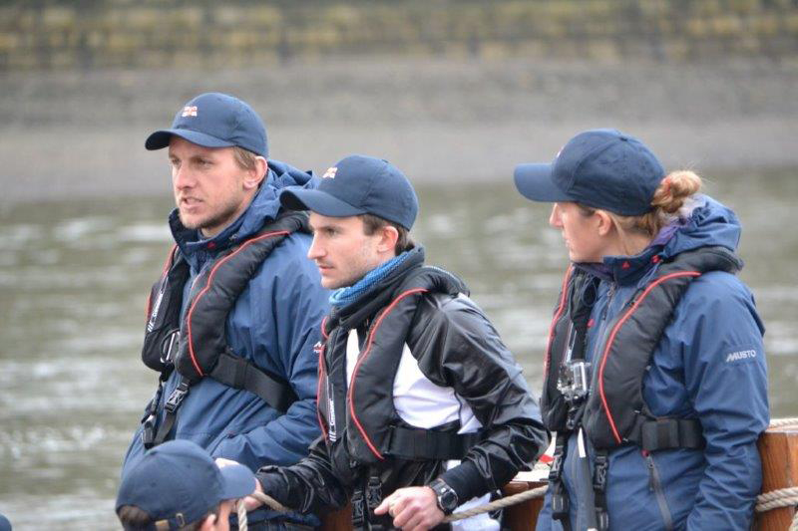

2013 Cambridge Cox, Henry Fieldman, wearing a Crewsaver ErgoFit lifejacket steering the William Riley, historic lifeboat.

Yesterday also saw the RNLI's first ever Alternative Boat Race on the River Thames shortly before the start of the 2014 University Boat Race with RNLI ambassador and Olympic rowing silver medallist Rob Williams starting the race. 250 sponsored mini lifeboats took part in the floating race, accompanied by London lifeboat crews from Tower, Teddington and Chiswick lifeboat stations. Crewsaver provided the RNLI with ErgoFit lifejackets as well as RNLI Crewsaver lifejackets for this event too.

The Crewsaver ErgoFit Offshore lifejacket is available for RRP from £200 - £215.

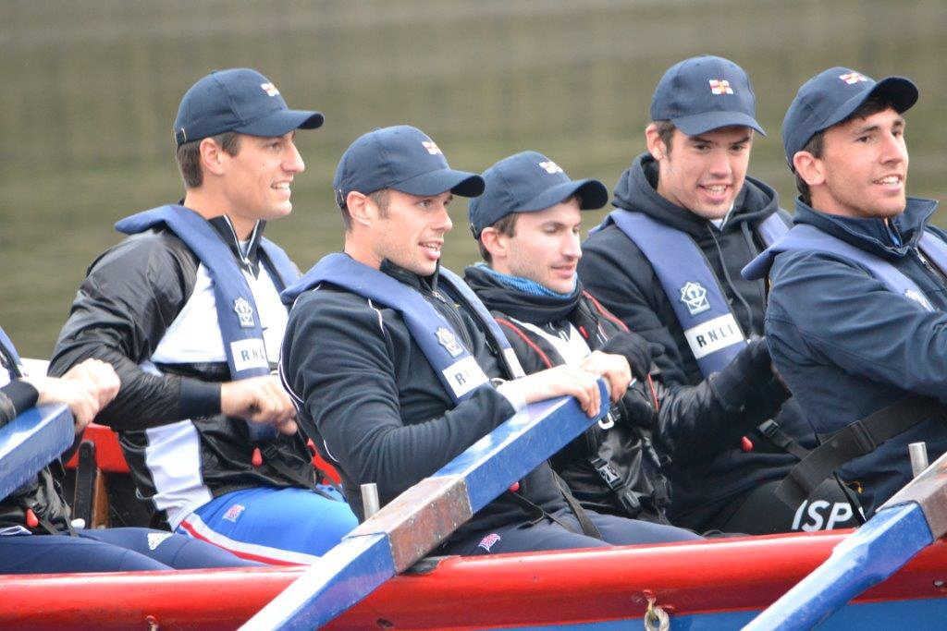
Crewsaver, the leading lifejacket and watersports equipment manufacturer, has a long-standing partnership with the Royal National Lifeboat Institution (RNLI). For many years the RNLI's operational crews have put their trust in Crewsaver equipment when saving lives at sea. Crewsaver has built a worldwide reputation for the performance, reliability and quality of its lifejackets and the company has worked closely with the RNLI to design and develop products that can withstand the rigours of both offshore and coastal rescue work. These products were designed, tested and developed collaboratively, involving RNLI Engineers in the design work and RNLI crews in testing. The first lifejacket is for use on all-weather lifeboats. The second is for use on inshore lifeboats. Designed for maximum safety and comfort these lifejackets ensure the crews are fully protected yet free to move and swim, including in the toughest sea and weather conditions.
2013 Cambridge Cox (centre), Henry Fieldman, wearing a Crewsaver ErgoFit lifejacket, with other members of the Historic Lifeboat Row crew kitted out with RNLI branded Crewsaver lifejackets.

Crewsaver is proud to support the RNLI and its work. Both organisations share the same commitment to safety afloat whether it is learning about water safety or making sure people wear the appropriate type lifejacket.
ENDS//
Notes to editors
About Crewsaver
Crewsaver is the UK’s leading lifejacket and watersports equipment manufacturer, founded in
Gosport, England in 1957.

Crewsaver continues to be recognised as the premier lifejacket brand. Many prestigious
Institutions including the RNLI, the MoD and a number of emergency services choose its products.
For media information, hi-res images or product tests please contact:
Crewsaver
Hannah Burywood, Marketing Dept
T +44 (0) 1329 820024
E Hannah.Leah-Burywood@survitecgroup.com

