Press Information

19th November 2013, Southampton, UK

CREWSAVER LAUNCHES NEW LEISURE LIFERAFT AT METS

Crewsaver, a leading brand within Survitec Group’s portfolio, will be launching a new liferaft aimed squarely at the leisure market at this year's METS, on stand 01.440. Lightweight and compact, the Crewsaver ISO Ocean Liferaft is easy to store and takes up minimal deck space, whilst offering complete confidence in an emergency, being deployed in just 40 seconds.

Approved to ISO 9650-1, the Crewsaver ISO Ocean Liferaft is manufactured to the highest quality standards and builds on the success of previous Crewsaver leisure liferafts, yet benefits from improved performance and easier handling.

Stand out features include the highly durable yet lightweight PU material that provides long lasting resistance to corrosion and abrasion. High volume water pockets also ensure maximum liferaft stability when inflated and a simple to close but tough canopy, manufactured in high visibility orange to SOLAS standards, provides added protection from the elements. The canopy is also fitted with an internal and external strobe light to make it easier for search and rescue teams locate the liferaft at night.

Other features include a semi-rigid boarding ramp for quick, easy and safe boarding, as well as interior and exterior lifelines to help occupants stabilise themselves in heavy seas. The liferaft is supplied in either a weather proof valise or an innovative, sleek, lightweight container, which includes side handles, to make transportation easier and features a document/certificate holder. Three emergency pack options provide rations for under 24 hour, over 24 hour and SOLAS B operation.

Said Greg O’Brien, Crewsaver Sales and Marketing Manager: "We are very pleased to launch the Crewsaver ISO Ocean Liferaft after many months of dedicated research and development. This liferaft is a game changer for our leisure customers. The design is not only more compact and takes up minimum deck stowage space, but it is also lightweight and robust. This new liferaft complements our already extensive range of safety equipment for the leisure mariner, which includes lifejackets, tenders, emergency locators, pyrotechnics and firefighting equipment."

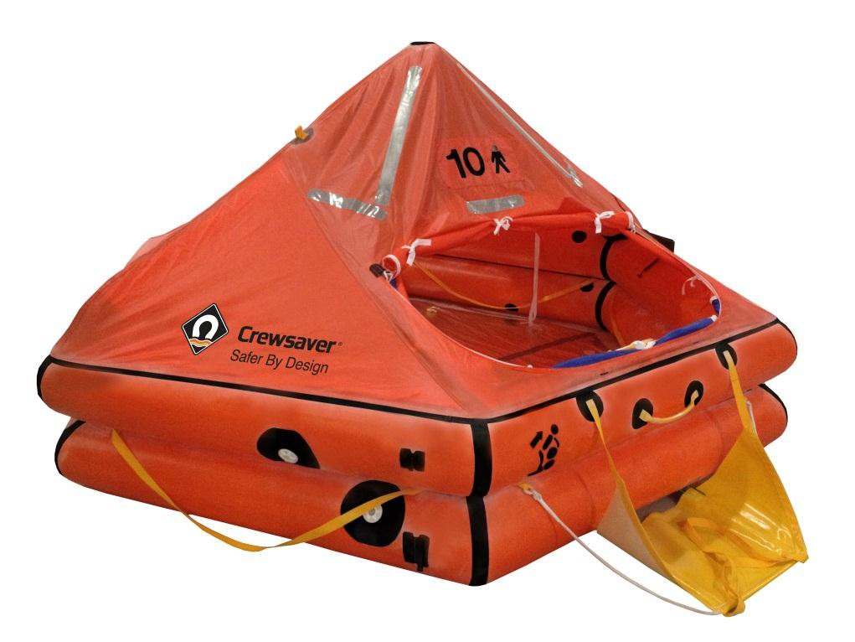

For further information on Crewsaver products and services visit Stand 01.440 at METS or visit www.crewsaver.co.uk or www.survitecgroup.com

Background

Crewsaver is the UK’s leading lifejacket and watersports equipment manufacturer, founded in Gosport, England in 1957. Crewsaver continues to be recognised as the premier lifejacket brand. Many prestigious institutions including the RNLI, the MoD and a number of emergency services choose its products.

Notes to Editors: About Survitec Group

Survitec Group holds market-leading positions worldwide in marine, defence and aerospace survival technology. Headquartered in Southampton, the company employs 2000 people across 10 manufacturing sites and 50 service centres, operating through a network of a further 550 distributors and agents to bring its best-in-class products and services to a global customer base. With an extensive history spanning over 160 years and a portfolio of some of the most reputable brands in the safety and survival industry, Survitec is committed to product innovation, technological advancement and quality assurance.

Key products within Survitec’s portfolio include marine, defence and aviation liferafts, world leading submarine escape technology, lifejackets for commercial airlines and the offshore industry as well as pilot flight equipment, including anti-g clothing used for the Eurofighter and JSF programmes. The Group also pioneered marine evacuation technology and today the unique Marin Ark system is used on many major cruise ships across the globe.

For more information please visit www.survitecgroup.com

ends

