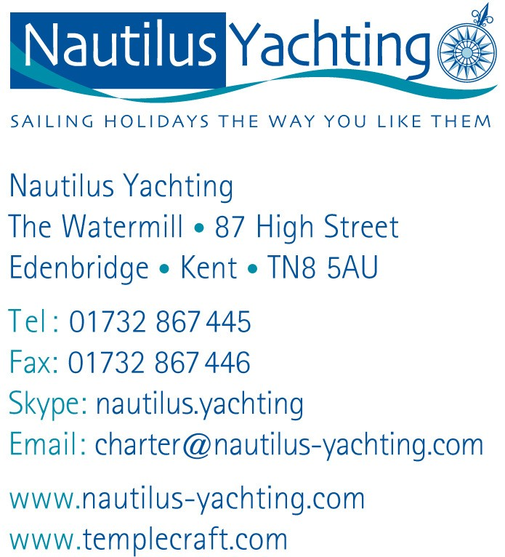

PRESS RELEASE
4 January 2014

London Boat Show 2014
Nautilus Yachting is exhibiting for our 21st year at the London Boat Show at ExCel 4-12 January 2014. Come and see us on Stand A142 in the Charter & Holidays Section.
We offer sailing holidays throughout the Mediterranean and Caribbean, both bareboat charter and family- friendly flotillas. With an excellent choice of yachts and cruising areas, there is a yachting holiday to suit everyone. Our flexibility and commitment to service ensure that each holiday fits the client’s individual requirements.

What’s happening at the Show:
- Boat Show discounts up to 20% OFF available on all holidays booked at the Show.
- Enter our exciting Competition to win £500 off your next Nautilus Yachting holiday. Just sign up for our E-newsletters and you'll be entered into the prize draw.
- On Thursday 9th January, the British Virgin Islands Tourist Board are joining us to host a BVI cocktail party serving their world-famous Painkiller cocktails 5pm to 9pm.

What’s new for 2014:
- A new base at Orhaniye in Turkey. Explore a different part of the Turkish coast - the unspoilt coastline between Datca and Marmaris. We have yachts and catamarans for bareboat charter and flotilla sailing from this exciting new base
- A new flotilla from Kos in Greece. Explore the scenic and unspoilt Dodecanese islands and visit Turkey - an irresistible flotilla choice for more experienced sailors. With stronger winds, these islands combine excellent sailing with traditional Greek charm.
- A new flotilla from Skiathos in Greece. Join this new flotilla from Skiathos, with direct flights and a 5 minute transfer to your yacht – the ONLY 1-week flotilla in the beautiful Sporades islands.

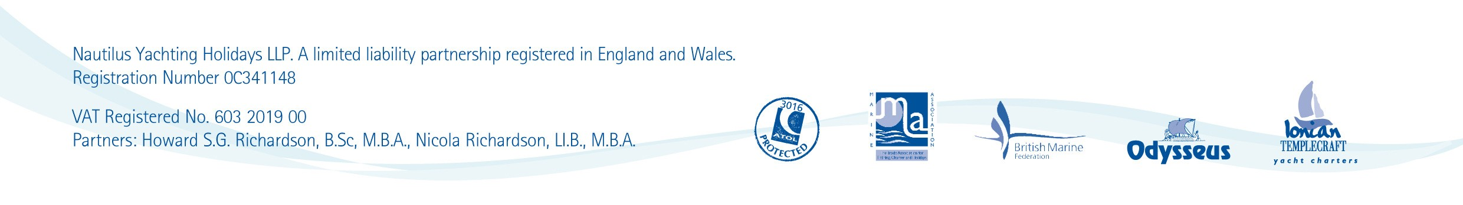

We can book flights if clients want an ATOL-bonded flight-inclusive holiday or they can book their own. Clients really liked the transparency of our pricing and the choice to tailor-make their own holiday arrangements.

Nautilus Yachting has been selling sailing holidays throughout the Mediterranean and Caribbean since 1992 and has established itself as the leading UK independent yacht charter agency. We are a fully bonded tour operator and hold Air Travel Organiser’s Licence ATOL 3016. We are also a member of the Marine Leisure Association (MLA) and British Marine Federation (BMF).

Howard Richardson, Nautilus Yachting Tel: 01732 867 445
e-mail: charter@nautilusyachting.com Website: www.nautilusyachting.com

