PRESS RELEASE
25th February 2014

Crewsaver Phase2 range available to all at RYA Dinghy Show 2014
SAIL, TRAIN, HIKE, RACE, TACK, GYBE

Crewsaver Phase2, Crewsaver’s new dinghy sailing range, will be on sale at the RYA Dinghy Show 2014 on 1st & 2nd March 2014 at Alexandra Palace in London. Consumers will be able to view and purchase the much-anticipated new Crewsaver Phase2 range, which encompasses everything you could possibly need when dinghy sailing. The range includes Spray Top, Race Top, Pro Hiking Pads, Hiking Shorts, Dry Suit, Rash Vests, Long Johns, Buoyancy Aid, Control Top, Polypro Top, Gloves, Dry Towel, Harness, Boots, Shorts, Balaclava, Neck Gaiter and Dry Bag.

5 Days FREE Coaching

To celebrate the launch of Crewsaver Phase2 during the show, Crewsaver will be giving away 5 days of FREE coaching to one lucky winner. Show visitors can grab an entry card from any Crewsaver retailer during the show to enter, or enter online via the yachtsandyachting.com website.

Where to buy

Crewsaver Phase2 can be purchased during the show from any of the following retailers:
- Andark
- P&B
- Nucleus Watersports
- Gibson Sails
- Coast Watersports

Visitors to the show will be able to discuss the range with any of the Crewsaver sales representatives who will be located on numerous stands throughout the show. To make it easier to find them, the Crewsaver team will be wearing grey Crewsaver Phase2 hoodies. They’ll also be giving away Phase2 water bottles completely free!

Crewsaver Phase2 was officially launched during METS Trade Show 2013, since then Crewsaver has received some fantastic feedback, here is just some:

'Crewsaver Phase2 offers exceptional design features which ensures the most advanced performance possible without breaking the bank and for this reason we anticipate a very good year for the Phase2 range.' P&B (UK Retailer).

'I have chosen Crewsaver Phase2 because the kit allows me to move freely and be comfortable in all conditions. It has obviously been designed for sailors with the sailing specific body movements in mind.' Matt Mee (RS 200 UK National Champion 2013).

Crewsaver’s design department has worked particularly hard to ensure that these products are designed as you would want them for the most advanced performance possible. Including wrap around Pro Hiking Pads for the ultimate in flexibility, comfort and protection exactly where you want it. 3D shaped super soft foam with a low profile waist cut out and neoprene side panels makes the Crewsaver Phase2 Buoyancy Aid an exceptional, highly comfortable fit.

'Crewsaver Phase2 offers a complete fresh new look to dinghy sailing kit as we know it, the unique colour ways and new designs make these products a welcome addition to both retail outlets and the sailors sailing wardrobe.' commented Greg O'Brien (UK Sales and Marketing Manager for Crewsaver).
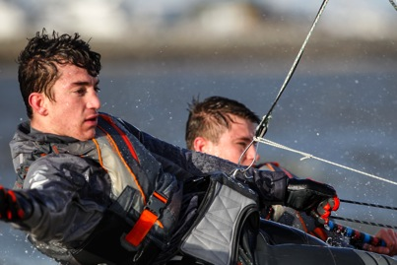

Notes to editors

About Crewsaver

Crewsaver is the UK’s leading lifejacket and watersports equipment manufacturer, founded in
Gosport, England in 1957.

Crewsaver continues to be recognised as the premier lifejacket brand. Many prestigious
institutions including the RNLI, the MoD and a number of emergency services choose its products.
For media information, or product tests please contact:

Crewsaver
Hannah Burywood, Marketing Dept
T +44 (0) 1329 820024
E hannah.burywood@survitecgroup.com

For High-Res images please visit:
www.marineadagency.com

