PRESS RELEASE

Crewsaver launches Phase2, the ultimate dinghy range! TRAIN, HIKE, RACE, TACK, GYBE, SAIL
Visit our stand to view the range: 01.440
The Crewsaver Phase2 range is the latest complete dinghy range to hit the market. Fashionable products with purposely designed key features to significantly advance your performance, a step above your average sailing; you won't want to go on the water without it!

'Phase2 offers a complete fresh new look to dinghy sailing kit as we know it, the unique colour ways and new designs make these products a welcome addition to both retail outlets and the sailor’s sailing wardrobe.' commented Greg O'Brien, UK Sales and Marketing Manager for Crewsaver.

This range encompasses everything you could possibly need when dingy sailing including; Spray Top, Race Top, Pro Hiking Pads, Hiking Shorts, Dry Suit, Rash Vests, Long Johns, Buoyancy Aid, Control Top, Polypro Top, Gloves, Dry Towel, Harness, Boots, Shorts, Balaclava, Neck Gaiter and Dry Bag.

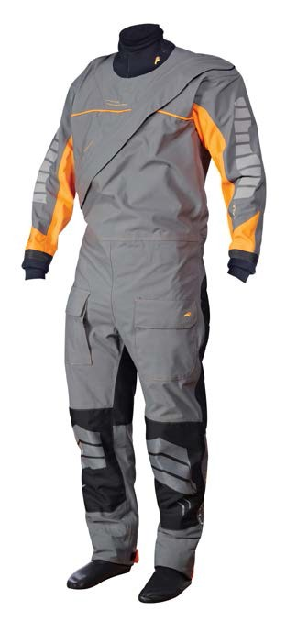
Crewsaver’s design department have worked particularly hard to ensure that these products are designed as you would want them for the most advanced performance possible. Including wrap around Pro Hiking Pads for the ultimate in flexibility, comfort and protection exactly where you want it. 3D shaped super soft foam with a low profile waist cut out and neoprene
side panels makes the Phase2 Buoyancy Aid an exceptional, highly comfortable fit.

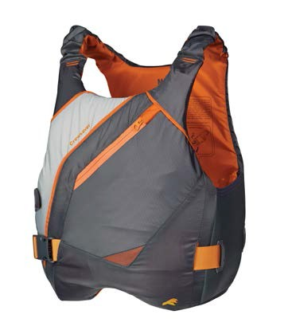
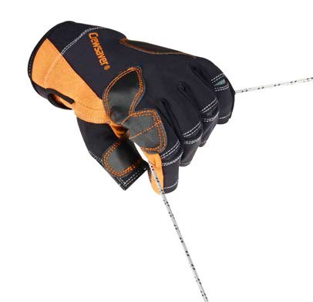
All of the kit will be on full display during METS providing retailers and distributors with the perfect opportunity to see the product on display and talk through the gear with our sales reps. Or simply pop to the stand, pick up a brochure and read more about what these products have to offer.

Notes to editors About Crewsaver
Crewsaver is the UK’s leading lifejacket and watersports equipment manufacturer, founded in Gosport, England in 1957.

Crewsaver continues to be recognised as the premier lifejacket brand. Many prestigious institutions including the RNLI, the MoD and a number of emergency services choose its products.

For media information, hi-­‐res images or product tests please contact:

Crewsaver
Hannah Burywood, Marketing Dept
T +44 (0) 1329 820024
EHannah.Leah-­‐Burywood@survitecgroup.com

