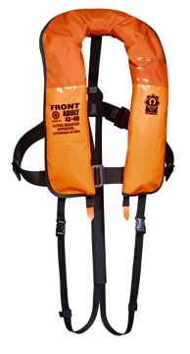
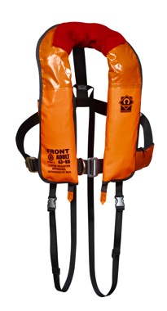
PRESS RELEASE
Thursday 5th June 2014

New Crewsaver lifejackets for wind farms and offshore use.

Responding to ever-increasing demand for specialist commercial lifejackets, Crewsaver is launching its industry-leading Wind Farm and Rope Access jackets on stand B137 at Seawork 2014 in Southampton, June 10th-12th.

More than 100 of the new 275N Rope Access Lifejackets are already in use on offshore oil rigs and the first production models of the Wind
Wind Farm 275N
Rope Access 275N
Farm jacket in use by a major wind energy
company.

Both jackets are light and easy to wear and robustly constructed for industrial use. Intense research and testing by Crewsaver on twin-chamber design has produced lifejackets that will give the wearer the maximum chance of survival if he falls into the water. The twin chambers provide excellent turning speed and industry-leading freeboard, and an inflatable chin support helps keep the airways clear. On the Wind Farm model a stainless steel D-ring for retrieval by rescuers is fitted as standard.

When personnel wear a lifejacket all day, every day it needs to be comfortable and not inhibit movement. A unique feature of these new models is the two different materials used for the cover. The top part is a flexible lightweight wipe-clean fabric selected for ultimate flexibility, ensuring the jacket doesn’t push the wearer’s helmet forward when working. On the Wind Farm jacket a fleece collar is soft on the neck and detachable for easy replacement if it becomes worn.

The jacket also needs to be robust enough to withstand constant wearing in a harsh environment so the lower sections of the cover are constructed in heavy-duty, abrasion resistant material for longer service life.

Safety features include a spray hood, whistle, reflective tape, buddy line, lifting beckett and attachment points for McMurdo PLB and AIS beacons. The Wind Farm jacket also has an optional pocket for a Sea Marshall rescue device.

Ends//

For media information, hi-res images or product tests please contact:
Hannah Burywood, Marketing Dept, Crewsaver
T +44 (0) 1329 820024
E hannah.burywood@survitecgroup.com

Seawork June 10th-12th 2014

Seawork International is one of Europe’s largest international commercial maritime and workboat exhibition and business forums. It takes place over three days in June every year at the Port of Southampton, UK, attracting more than 6000 visitors from 40 countries.

www.ssa.org.uk

About Crewsaver
Crewsaver is a world-leading manufacturer of marine safety equipment and clothing for the commercial and leisure marine industries. Based in Gosport, Hampshire, the company designs and manufactures bespoke safety equipment for several countries’ special forces, the UK government’s Environment Agency and the aviation and oil industries. Crewsaver is part of the Survitec Group.
www.crewsaver.com

About Survitec Group
Survitec Group holds market-leading positions worldwide in marine, defence and aerospace survival technology. Headquartered in Southampton, the company employs 2000 people across 10 manufacturing sites and 50 service centres, operating through a network of a further 550 distributors and agents to bring its best-in-class products and services to a global customer base. With an extensive history spanning over 160 years and a portfolio of some of the most reputable brands in the safety and survival industry, Survitec is committed to product innovation, technological advancement and quality assurance.
Key products within Survitec’s portfolio include marine, defence and aviation Liferafts, world leading submarine escape technology, lifejackets for commercial airlines and the offshore industry as well as pilot flight equipment, including anti-g clothing used for the Eurofighter and JSF programmes. The Group also pioneered marine evacuation technology and today the unique MarinArk system is used on many major cruise ships across the globe.
www.survitecgroup.com

