PRESS RELEASE

Crewsaver introduces new Swift Water Rescue Jacket, providing critical safety solutions.

Visit our stand to view the jacket:  Crewsaver is very proud of its marine | 01.440
safety equipment heritage which has set the benchmark for quality and performance over many years. The latest Swift Water Rescue Jacket has yet again raised the bar in multi-­‐purpose rescue and emergency response jackets.
A user friendly buoyancy aid with waist supports to provide a one size fits all design makes this jacket an easy and efficient choice for rescue teams.
The jacket is designed with key features to enable carriage of all of the accessories to ensure you have the best gear possible to do the job you need to do and that all of your equipment is easily stored and easily accessible. Some of the features of the jacket include side flaps for impact protection which can also be folded to stop build up of heat, reflective print to aid visibility, specially positioned handles to enable a swift retrieval, lash tabs and lots more!

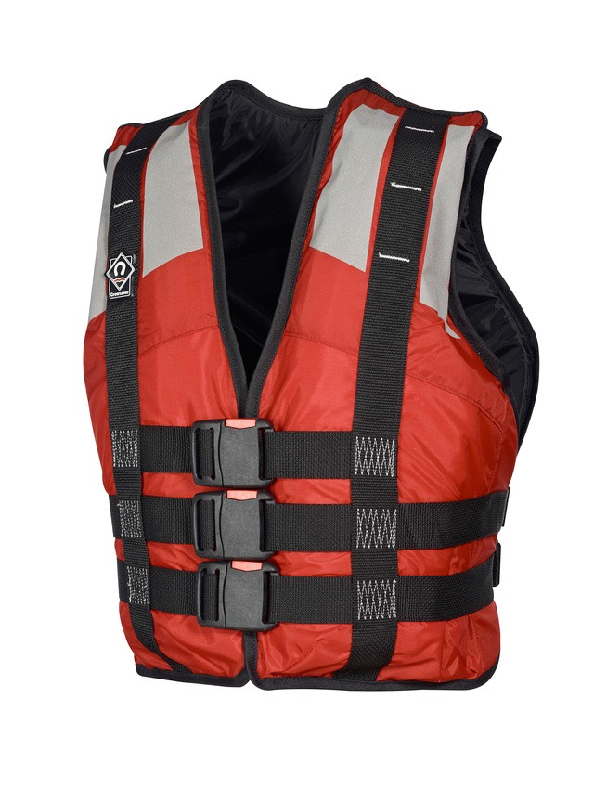
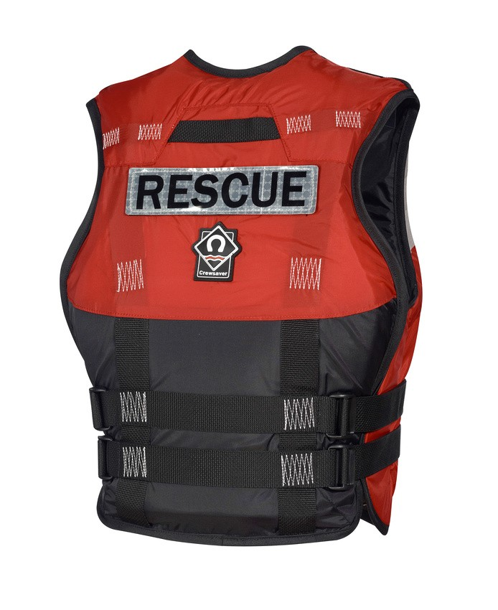
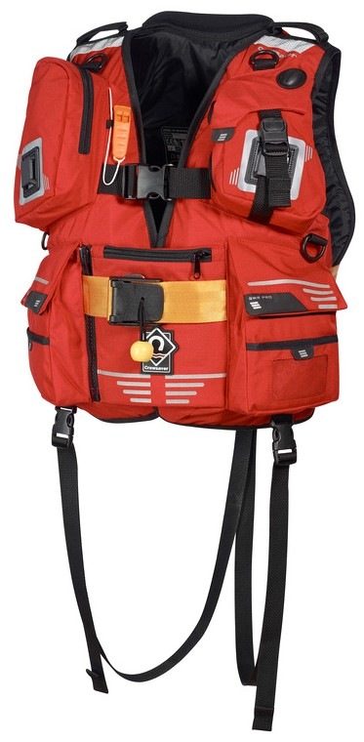
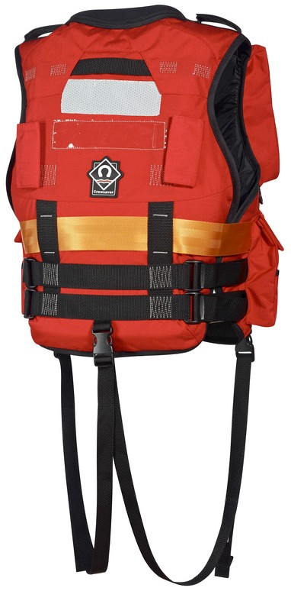
These jackets will be on full display during METS Trade Show, a perfect opportunity to visit the Crewsaver stand and talk through the products with one of our sales agents. They will be able to talk you through the products and the features it has to offer.

A lower spec option is also available providing rescue teams with a low cost solution when additional jackets are requires. These jackets can be stored easily in all basic tenders ready to be distributed in an emergency situation.

Notes to editors About Crewsaver
Crewsaver is the UK’s leading lifejacket and watersports equipment manufacturer, founded in Gosport, England in 1957.

Crewsaver continues to be recognised as the premier lifejacket brand. Many prestigious institutions including the RNLI, the MoD and a number of emergency services choose its products.

For media information, hi-­‐res images or product tests please contact:

Crewsaver
Hannah Burywood, Marketing Dept
T +44 (0) 1329 820024
E Hannah.Leah-­‐Burywood@survitecgroup.com

