**News Release**

**3rd July 2015**

**Round the Island Race Victory in debut event for Ker 40+**

Having only landed on UK soil a couple of weeks back it was going to be a very tall order for Sir Keith Mills and his team to fully commission the brand new Ker 40+ and win the RTIR but that is exactly what they did.

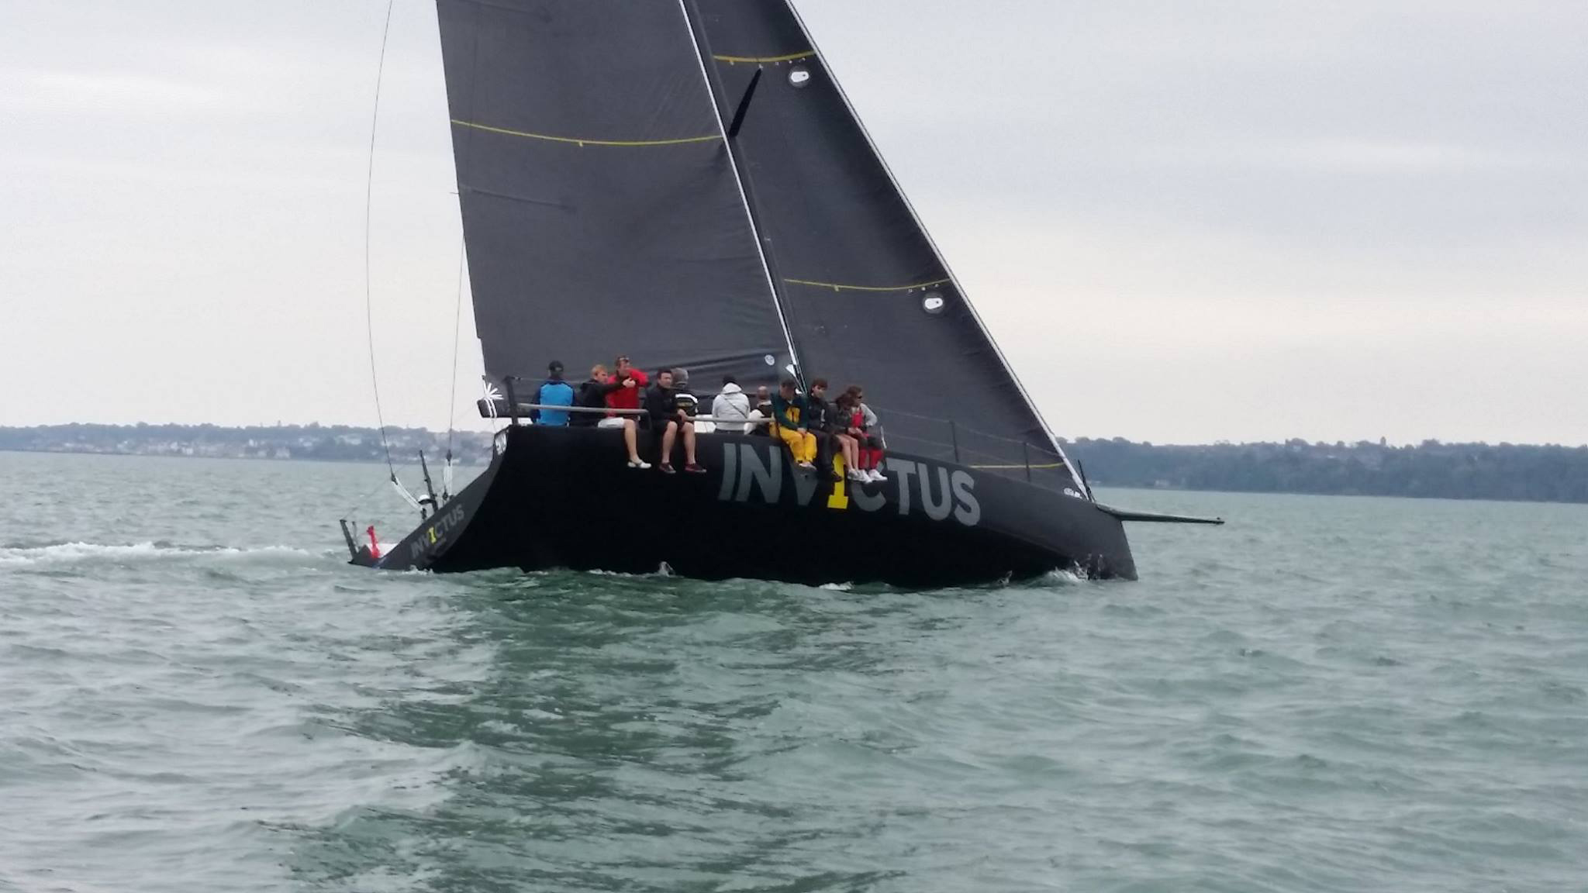

The long awaited 40+, which is a new, optimised version of the original Ker 40, looks set for total IRC domination having beaten many other well established campaigners on their very first outing. This shows that Jason Ker and his team, along with McConaghy Boats are very much the go-to-guys for an IRC winner.

Although upwind speeds were comparable to the old boat during the long beat to the Needles, it was clear to see where the majority of the improvements have been made when the boats bore away and headed for St Catherine’s with one onlooker commenting they ‘done a horizon job’ after deploying spinnakers.

Consistent speeds of 18 knots in as much wind meant that the 40+ stepped away from its closest rivals and was able to clinch the coveted IRC Black Group Win.

The boat will also be competing in the upcoming IRC nationals and Bicentenary regattas and so all eyes will be on it to see if this first outing was not just a lucky roll of dice.

Contact Ancasta ([www.ancasta.com](http://www.ancasta.com/)) for more details on the Ker 40+ as well as many other quality offerings in the race boat world.

**ENDS**

**Notes to editors**

* Ancasta International Boat Sales has 15 offices across Europe
* Ancasta is the UK’s largest Prestige Luxury Motor Yachts dealer, the UK’s largest Beneteau Power and the UK’s largest Beneteau Sail dealer
* Ancasta is exclusive UK dealer for Lagoon Catamarans
* In addition Ancasta is a new boat dealer for Bordeaux 60, Fairlie Yachts and McConaghy Yachts
* The Ancasta Race Boat Division specialises in performance sail boats ranging from 25ft to 100ft.
* The Ancasta Group incorporates Hamble Yacht Services Refit & Repair and Advanced Rigging and Hydraulics, both operating from Port Hamble.
* For more information on Ancasta visit www.ancasta.com

Media enquiries via Marine Advertising Agency:

Alison Willis - alison@marineadagency.com

Tel: 023 9252 2044