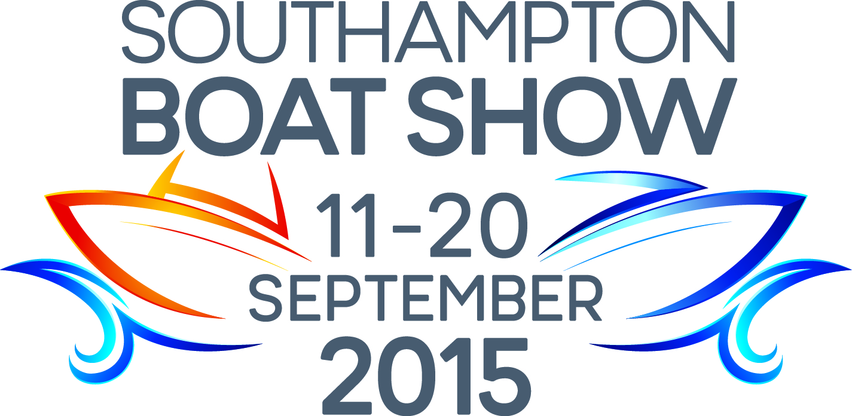
Press Release
For Immediate Release
24th August 2015

Exclusive Crewsaver designed Artemis Racing team products for 2017 America’s Cup to be shown at Southampton Boat Show 2015

In June 2015 Crewsaver was proud to announce it had been chosen by Artemis Racing to be their Official Safety Supplier for the 35th America’s Cup.

Five brand new products are being supplied including two unique new lifejackets, all of which will be on full display at Southampton Boat Show 2015 - Crewsaver stand, Ocean Hall, Stand No. G1804.
“We are very excited to be able to showcase some of the designs we created for Artemis Racing to enable them to perform safely and effectively at the America’s Cup.” says Ross Wilkinson, Managing Director of Crewsaver.
“This is a great opportunity for the general public to view these products close up and get an understanding of what the team goes through.”

Crewsaver exclusively created two new radical buoyancy aids including one designed to meet the sailors’ unique needs aboard the foiling AC 48 Class boat to ensure the Artemis Racing team perform safely, yet to the very best of their ability, under the most challenging of conditions.

These lifejackets combine cutting edge technology with innovative design. Key features include air bottle stowage, hands-free regulator, shoulder mounted knife, stretch to fit design, and an integrated communications system.
On top of this, and in collaboration with ForceField Body Armour, Crewsaver has incorporated its full level 2 spinal protection, a first for lifejacket technology. This, along with the chest and side armour protection, provides 360-degree impact protection.
Other items designed for Artemis Racing by Crewsaver and on display include branded long johns, helmets and rash vests.

In addition, every day visitors have the chance to win a Crewsaver Artemis Pro lifejacket, a signed picture of the team and a McMurdo S20 AIS, all presented in a lifejacket box.

To be in with a chance of winning visitors simply have to;

- Visit the Crewsaver stand during the 2015 Southampton Boat Show: Ocean Hall, Stand No. G1804
- Collect a Crewsaver goody bag
- Visit the stand at 4pm the same day
- Hand the completed entry form located in the bag to one of the sales representatives

The winner will then be selected at random from the completed entries received.
ENDS

For media information, hi-res images or product tests please contact:
Crewsaver
Hannah Burywood, Marketing Dept
T +44 (0) 1329 820024
E hannah.burywood@survitecgroup.com

Or

Alison Willis – Marine Advertising Agency Ltd
T +44 (0) 23 9252 2044
E Alison@marineadagency.com

Notes to Editors

Crewsaver is a world-leading manufacturer of marine safety equipment and clothing for the commercial and leisure marine industries. Based in Gosport, Hampshire, the company designs and manufactures bespoke safety equipment for several countries’ Special Forces, and the aviation and oil industries. Crewsaver is the only company to hold an exclusive contract to supply lifejackets to the UK government’s Environment Agency and the Royal National Lifeboat Institution (RNLI). They are part of the Survitec Group.

www.crewsaver.com

Survitec Group holds market-leading positions worldwide in marine, defence and aerospace survival technology. Headquartered in Birkenhead, the company employs 2000 people across 10 manufacturing sites and 50 service centres, operating through a network of a further 550 distributors and agents to bring its best-in-class products and services to a global customer base. With an extensive history spanning over 160 years and a portfolio of some of the most reputable brands in the safety and survival industry, Survitec is committed to product innovation, technological advancement and quality assurance.
Key products within Survitec’s portfolio include marine, defence and aviation Liferafts, world leading submarine escape technology, lifejackets for commercial airlines and the offshore industry as well as pilot flight equipment, including anti-g clothing used for the Eurofighter and JSF programmes. The Group also pioneered marine evacuation technology and today the unique MarinArk system is used on many major cruise ships across the globe.

www.survitecgroup.com

