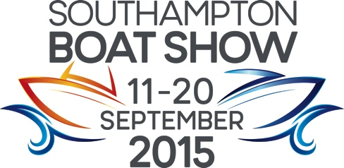
Press Release
For Immediate Release
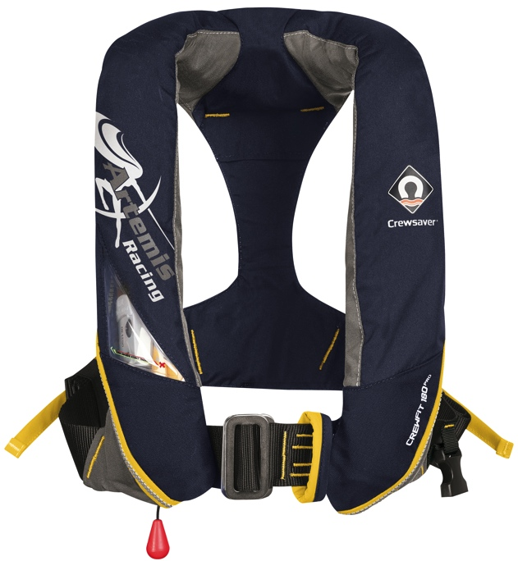
24th August 2015

WIN a Crewsaver Artemis Pro lifejacket and signed picture of the Artemis Racing team at Southampton Boat Show 2015

Crewsaver is delighted to announce that its Southampton Boat Show daily lifejacket competition is back! This time up for grabs each day is an exclusive Artemis branded Crewsaver Artemis Pro lifejacket.

Winners will also receive a signed photo of the Artemis Racing Team and a McMurdo S20 AIS. The lifejacket, the signed photo and the S20 will be presented in a lifejacket box.

How to win
To be in with the chance of winning one of these very special box sets, visitors need to:

- Visit the Crewsaver stand during the Southampton Boat Show: Ocean Hall, Stand No. G1804
- Collect a Crewsaver goody bag
- Visit the stand at 4pm the same day
- Hand the completed entry form located in the bag to one of the sales representatives

The winner will then be selected at random from the completed entries received.

Visit the Crewsaver stand to be in with a chance of winning this exclusive prize!

Show offers
In addition, visitors to the show can take advantage of some fantastic offers when purchasing their lifejackets including the following:

- FREE lifejacket light with every Crewfit 180N Pro purchase
- FREE ErgoFit safety knife with every ErgoFit lifejacket purchase
- FREE lifejacket bag when any combination of four or more Crewsaver lifejackets are purchased
- FREE McMurdo 220 Fast Find with every 4man liferaft purchase

A wide range of Crewsaver products can be purchased from the following retailers at the show:
- Marine Superstore stand F003
- Andark Diving & Watersports stand F001
- Force 4 Chandlery stand B017/ D025
- Jimmy Green Marine stand G116
- Piplers of Poole stand G136
- P&B stand J054

To claim their free gifts, visitors simply need to take their receipts to the Crewsaver stand.

Terms and conditions apply, while stocks last, E&OE.

ENDS

For media information, hi-res images or product tests please contact:

Crewsaver
Hannah Burywood, Marketing Dept
T +44 (0) 1329 820024
E hannah.burywood@survitecgroup.com

Or

Alison Willis – Marine Advertising Agency Ltd
T +44 (0) 23 9252 2044
E Alison@marineadagency.com

Notes to Editors

Crewsaver is a world-leading manufacturer of marine safety equipment and clothing for the commercial and leisure marine industries. Based in Gosport, Hampshire, the company designs and manufactures bespoke safety equipment for several countries’ Special Forces, and the aviation and oil industries. Crewsaver is the only company to hold an exclusive contract to supply lifejackets to the UK government’s Environment Agency and the Royal National Lifeboat Institution (RNLI). They are part of the Survitec Group.

www.crewsaver.com

Survitec Group holds market-leading positions worldwide in marine, defence and aerospace survival technology. Headquartered in Birkenhead, the company employs 2000 people across 10 manufacturing sites and 50 service centres, operating through a network of a further 550 distributors and agents to bring its best-in-class products and services to a global customer base. With an extensive history spanning over 160 years and a portfolio of some of the most reputable brands in the safety and survival industry, Survitec is committed to product innovation, technological advancement and quality assurance.
Key products within Survitec’s portfolio include marine, defence and aviation Liferafts, world leading submarine escape technology, lifejackets for commercial airlines and the offshore industry as well as pilot flight equipment, including anti-g clothing used for the Eurofighter and JSF programmes. The Group also pioneered marine evacuation technology and today the unique MarinArk system is used on many major cruise ships across the globe.

www.survitecgroup.com

