PRESS RELEASE
For immediate release - 24th August 2015

Yak is back- come and see us at PADDLEexpo 2015
There’s more to see - and more to want – at Yak.
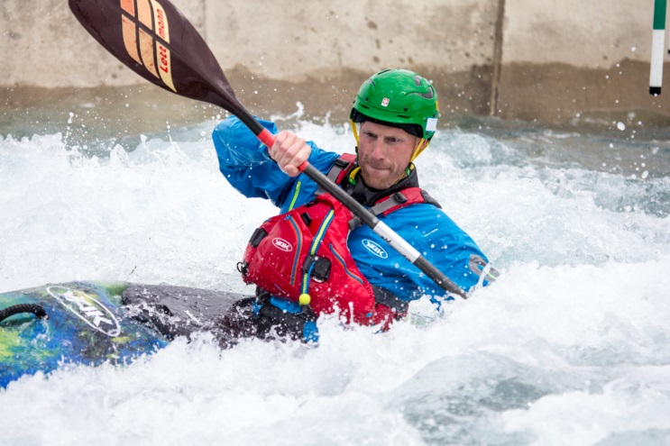
Following the successful launch of our new complete whitewater, touring and recreational ranges, showcased at PADDLEexpo 2014, Yak is back at PADDLEexpo 2015 (17-19th September 2015) to exhibit our ever popular range and more.

Yak brand manager, Peter Ford says: “We are delighted to be exhibiting at the PADDLEexpo again. It gives us the opportunity to showcase the entire Yak product range, show our customers what’s new and get their valuable feedback.”

Visitors can immerse themselves in the Yak world where colours are more vibrant, kit more functional, innovations more compelling. On display will be a variety of PFDs, technical clothing and accessories, plus our complete junior range, so you can be assured we have everything to suit everybody, whatever the age or ability.

All Yak ranges provide state-of-the-art technology and safety solutions combined with bold and colourful designs, which continue to push paddle equipment through new frontiers and which are fast becoming the sought after item every paddler wants.

#WheresYakAt

We recently held our #WheresYakAt competition. The aim of the game was to grab a Yak, then take a snap of it in the most obscure and daring places around the world. We received hundreds of entries with the winner receiving a complete set of Yak kit including a PFD, Paddle top, trousers and a spray deck.
This year Yak has received a make-over and a herd of Yaks will be stampeding their way to the stand. So come along and see what he’s up to next.

Those keen to know more can check out the entire range on the Yak website; www.YakAdventureEquipment.com

ENDS//

For media information, hi-res images or product tests please contact:

Yak
Hannah Burywood, Marketing Dept
T +44 (0) 1329 820024
E hannah.burywood@survitecgroup.com

Or

Alison Willis – Marine Advertising Agency Ltd
T +44 (0) 23 9252 2044
E Alison@marineadagency.com

Notes to Editors

Part of the Survitec Group which also owns Crewsaver, Yak, produces and manufactures products that are purposely designed for the whitewater, recreational and touring kayaking and canoe markets. A wide range of products suit all styles and experience, giving paddlers more choice and more opportunities to enjoy their sport with total peace of mind. Yak’s products include buoyancy aids, drysuits, cags, trousers, spray decks, gloves, footwear, headwear and buoyancy bags.

Together with Crewsaver, Yak has 50 years of experience manufacturing marine safety products that combine cutting edge technology with high performance and ultimate practicality.

