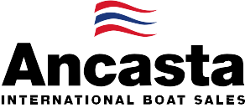

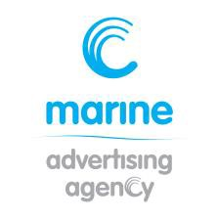
N e w s R e l e a s e
8th September 2015

Ancasta showcases Ker 33 at 2015 Southampton Boat Show

The Ker 33 IRC Racer / Cruiser from McConaghy is being presented by Ancasta at the 2015 Southampton Boat Show, where it makes its show debut from 11 to 20th September 2015.
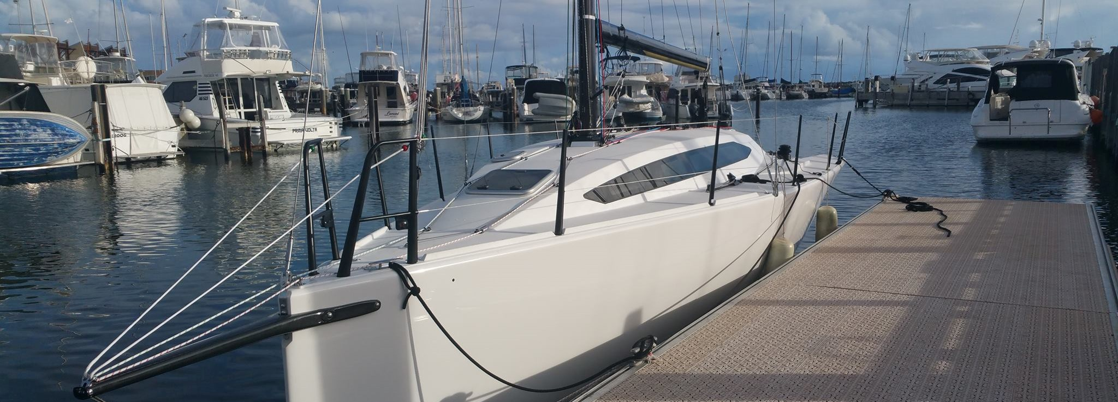

The Ker 33 IRC Racer / Cruiser is looking to lay down a new benchmark in the racer/cruiser division. With the huge success of Ker Design over the years and McConaghy’s unrivalled build quality, it is already proving popular.
The philosophy behind the Ker 33 was to highlight the design, build expertise and techniques that the Ker/McConaghy team can deliver, while keeping the boat financially in line with its competitors. Every hull of the Ker 33 is supplied to a near identical package. Variations come from the choice of an aluminium or carbon rig, and from the choice of opting for a fixed bowsprit or conventional pole. The bowsprit option is for short handed, and primarily offshore, sailing, meaning easier sail handling when using the asymmetric spinnaker system. The conventional pole is more IRC and inshore-friendly for use with symmetric spinnakers.

Specification:
- Manufacturer McConaghy Boats
- Model Ker 33
- Designer Jason Ker
- Base price £120,000 (exc. VAT)
- LOA 10.1m
- Maximum Beam 3.35m

Displacement 3800kg
- Category of Sailing Racer/Cruiser
- Cabins & berths 3 cabins, 6 berths
- Standard fuel capacity 40 ltr
- Rig Aluminium or Carbon
- IRC Rating 1.020

The Ker 33 will be on berth M321 at Southampton Boat Show from 11th to 20th September 2015. Contact Ancasta now to make an appointment to view, email sampearson@ancasta.com or call +44 2380 450 000.

For more information visit: http://www.ancasta.com/boats-for-sale/new-boats/mcconaghy/ker/33/

ENDS

Notes to editors
  - Ancasta International Boat Sales has 15 offices across Europe
  - Ancasta is the UK’s largest Prestige Luxury Motor Yachts dealer, the UK’s largest Beneteau Power and the UK’s largest Beneteau Sail dealer
  - Ancasta is exclusive UK dealer for Lagoon Catamarans
  - In addition Ancasta is a new boat dealer for CNB Yachts, Fairlie Yachts and McConaghy Yachts
  - The Ancasta Group incorporates Hamble Yacht Services Refit & Repair and Advanced Rigging and Hydraulics, both operating from Port Hamble.
  - For more information on Ancasta visit www.ancasta.com Media enquiries via Marine Advertising Agency:
Alison Willis - alison@marineadagency.com Tel: 023 9252 2044

