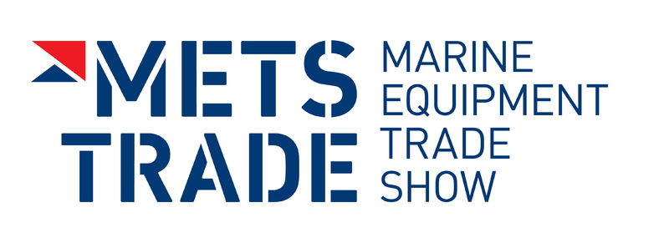
Press Release
For Immediate Release
23rd October 2015

Crewsaver USCG & ISO approved leisure lifejackets to be showcased alongside each other for the very first time at METS 2015
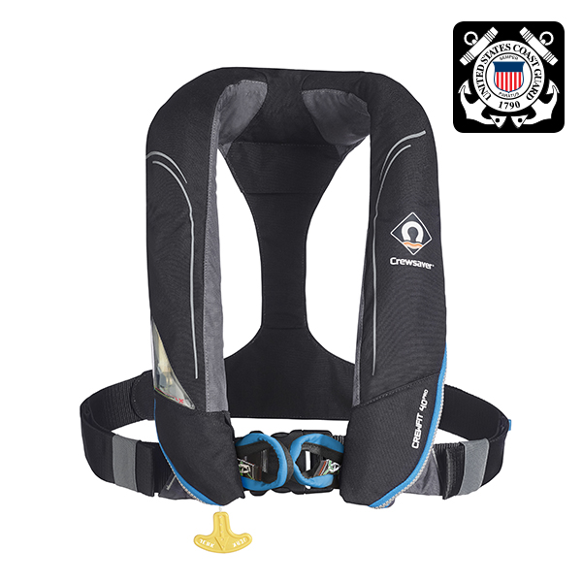
Crewsaver Stand Number 03.114
Crewsaver has announced that the full range of U.S. Coast Guard (USCG) approved Crewsaver lifejackets will be showcased alongside their popular ISO approved Fusion 3D lifejacket range at the Marine Equipment Trade Show (METS) in Amsterdam, which takes place 17-19th November 2015.
Crewsaver is proud to deliver its first USCG-approved range of inflatable lifejackets, which are currently available for sale in North America. The new lifejackets made their debut earlier this year at the U.S. Sailboat Show in Annapolis. This follows over a year of in-depth work and research with Underwriter's Laboratory (UL) and the U.S. Coast Guard (USCG).
The USCG range includes;

- Crewfit 35 Sport
- Crewfit 40 Pro
- ErgoFit 40 Pro
- Crewfit 35
- Crewfit 35 Work Vest

Ross Wilkinson, Managing Director of Crewsaver says, ‘Following the success of our range of Fusion 3D ISO approved lifejackets, which launched at METS 2014, we were quick to respond to demand and follow this up with USCG versions of these lifejackets. We are delighted to now have these displayed at METS 2015.’

Visitors will be able to view both ranges of lifejackets at the Crewsaver stand 03.114 at METS from 17th November to 19th November 2015.

As a global market-leading manufacturer of integral safety equipment, Crewsaver has taken on the challenge of reducing the number of people that simply do not wear a lifejacket by producing a complete range focused on Comfort. Style. Performance. All of which are key in the leisure industry.
ENDS

For media information, hi-res images or product tests please contact:

Crewsaver
Hannah Burywood, Marketing Dept
T +44 (0) 1329 820024
E hannah.burywood@survitecgroup.com

Or

Alison Willis – Marine Advertising Agency Ltd
T +44 (0) 23 9252 2044
E Alison@marineadagency.com

Notes to Editors

Crewsaver is a world-leading manufacturer of marine safety equipment and clothing for the commercial and leisure marine industries. Based in Gosport, Hampshire, the company designs and manufactures bespoke safety equipment for several countries’ Special Forces, and the aviation and oil industries. Crewsaver is the only company to hold an exclusive contract to supply lifejackets to the UK government’s Environment Agency and the Royal National Lifeboat Institution (RNLI). They are part of the Survitec Group.

www.crewsaver.com

Survitec Group holds market-leading positions worldwide in marine, defence and aerospace survival technology. Headquartered in Birkenhead, the company employs 2000 people across 10 manufacturing sites and 50 service centres, operating through a network of a further 550 distributors and agents to bring its best-in-class products and services to a global customer base. With an extensive history spanning over 160 years and a portfolio of some of the most reputable brands in the safety and survival industry, Survitec is committed to product innovation, technological advancement and quality assurance.
Key products within Survitec’s portfolio include marine, defence and aviation Liferafts, world leading submarine escape technology, lifejackets for commercial airlines and the offshore industry as well as pilot flight equipment, including anti-g clothing used for the Eurofighter and JSF programmes. The Group also pioneered marine evacuation technology and today the unique MarinArk system is used on many major cruise ships across the globe.

www.survitecgroup.com

