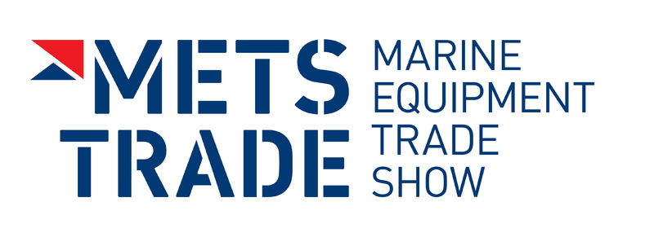
Press Release
For Immediate Release
23rd October 2015
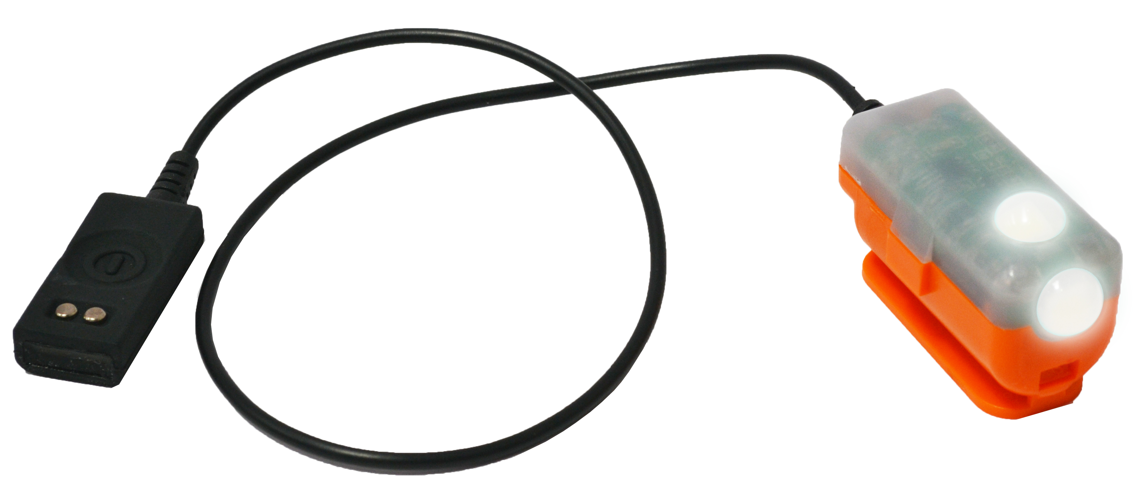
Crewsaver Universal Lifejacket Light on display at METS 2015

Crewsaver Stand Number 03.114

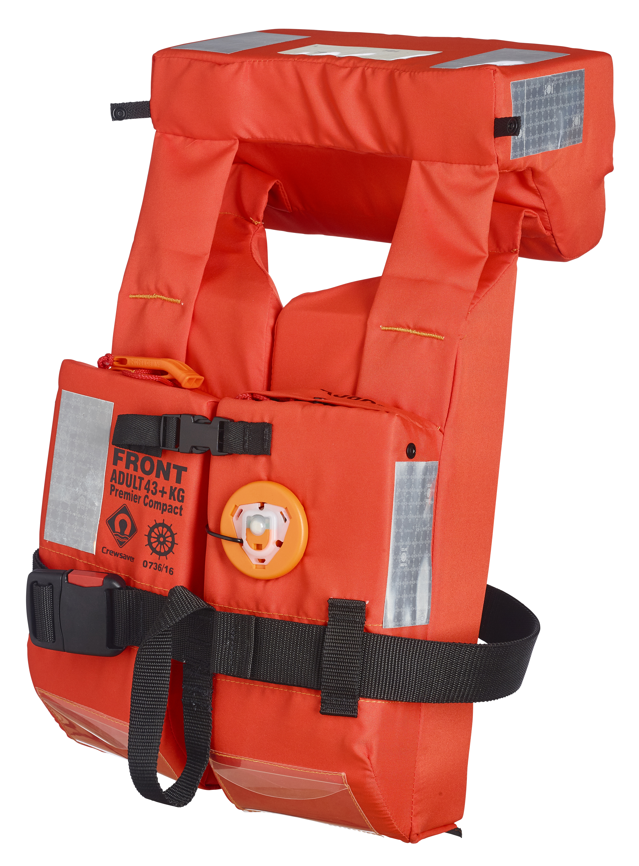
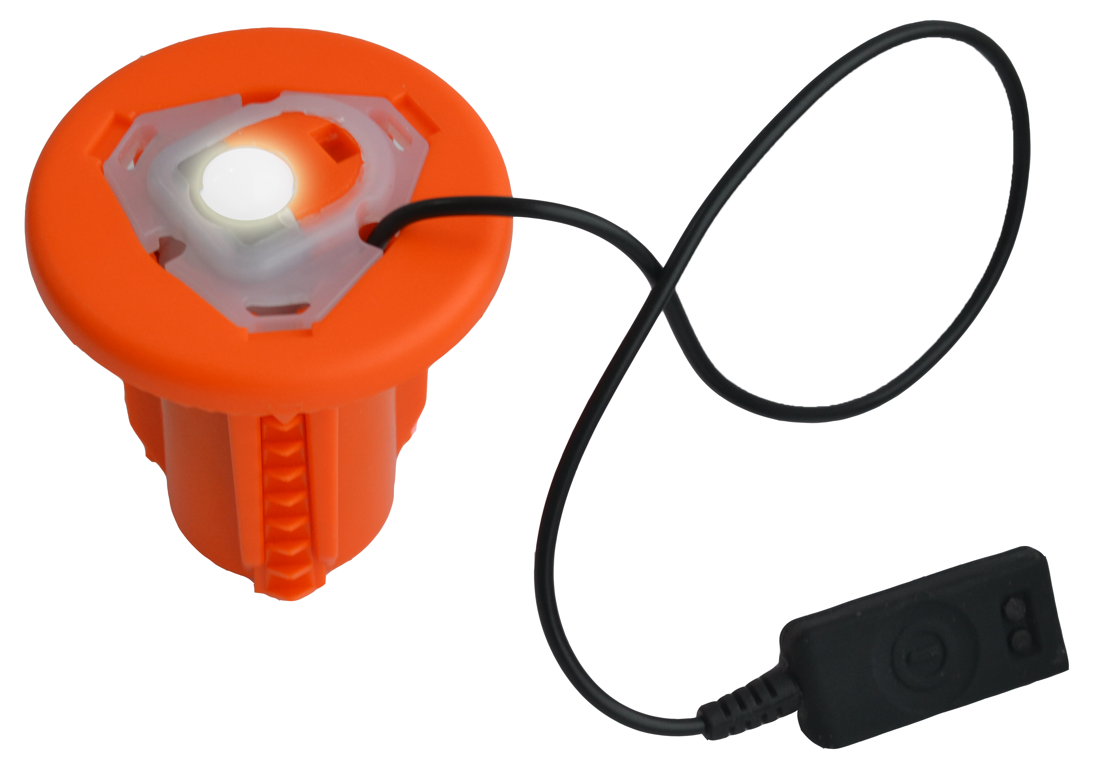
Crewsaver is pleased to announce that its Universal lifejacket light will be on display and on sale to customers at this year’s Marine Equipment Trade Show (METS) in Amsterdam, which takes place 17-19th November 2015.

The Universal light is one of the only lights available to date that can accommodate both surface and recess mounting solutions effectively. The light can be attached to a point on the jacket to become a surface light or placed into either a circular or rectangular housing unit, which is permanently set in the lifejacket. When recess mounts are used the light has an extremely low profile and is non-intrusive.
In addition, the light offers two points of illumination, as opposed to the standard one when surface mounted. This helps to aid additional visibility from varied angles should the unexpected occur.
Key Features
- Activates on contact with water or manually
- Flashing LED light
- SOLAS, MED & USCG Approved
- Minimum 8hrs light duration
- Maximum 5 Year storage life
ENDS

For media information, hi-res images or product tests please contact:

Crewsaver
Hannah Burywood, Marketing manager
T +44 (0) 1329 820024
E hannah.burywood@survitecgroup.com

Or

Alison Willis – Marine Advertising Agency Ltd
T +44 (0) 23 9252 2044
E Alison@marineadagency.com

Notes to Editors

Crewsaver is a world-leading manufacturer of marine safety equipment and clothing for the commercial and leisure marine industries. Based in Gosport, Hampshire, the company designs and manufactures bespoke safety equipment for several countries’ Special Forces, and the aviation and oil industries. Crewsaver is the only company to hold an exclusive contract to supply lifejackets to the UK government’s Environment Agency and the Royal National Lifeboat Institution (RNLI). They are part of the Survitec Group.

www.crewsaver.com

Survitec Group holds market-leading positions worldwide in marine, defence and aerospace survival technology. Headquartered in Birkenhead, the company employs 2000 people across 10 manufacturing sites and 50 service centres, operating through a network of a further 550 distributors and agents to bring its best-in-class products and services to a global customer base. With an extensive history spanning over 160 years and a portfolio of some of the most reputable brands in the safety and survival industry, Survitec is committed to product innovation, technological advancement and quality assurance.
Key products within Survitec’s portfolio include marine, defence and aviation Liferafts, world leading submarine escape technology, lifejackets for commercial airlines and the offshore industry as well as pilot flight equipment, including anti-g clothing used for the Eurofighter and JSF programmes. The Group also pioneered marine evacuation technology and today the unique MarinArk system is used on many major cruise ships across the globe.

www.survitecgroup.com

