**Press Release – Immediate Release**
28th October 2015

Superyacht Tenders & Toys adds exclusive new product, iLC (inflatable Landing Craft), to range
Superyacht Tenders and Toys is pleased to announce the addition of a new inflatable tender, the inflatable Landing Craft (iLC) to its range of products for the large yacht and commercial ships market. The iLC is exclusively available through Superyacht Tenders and Toys.
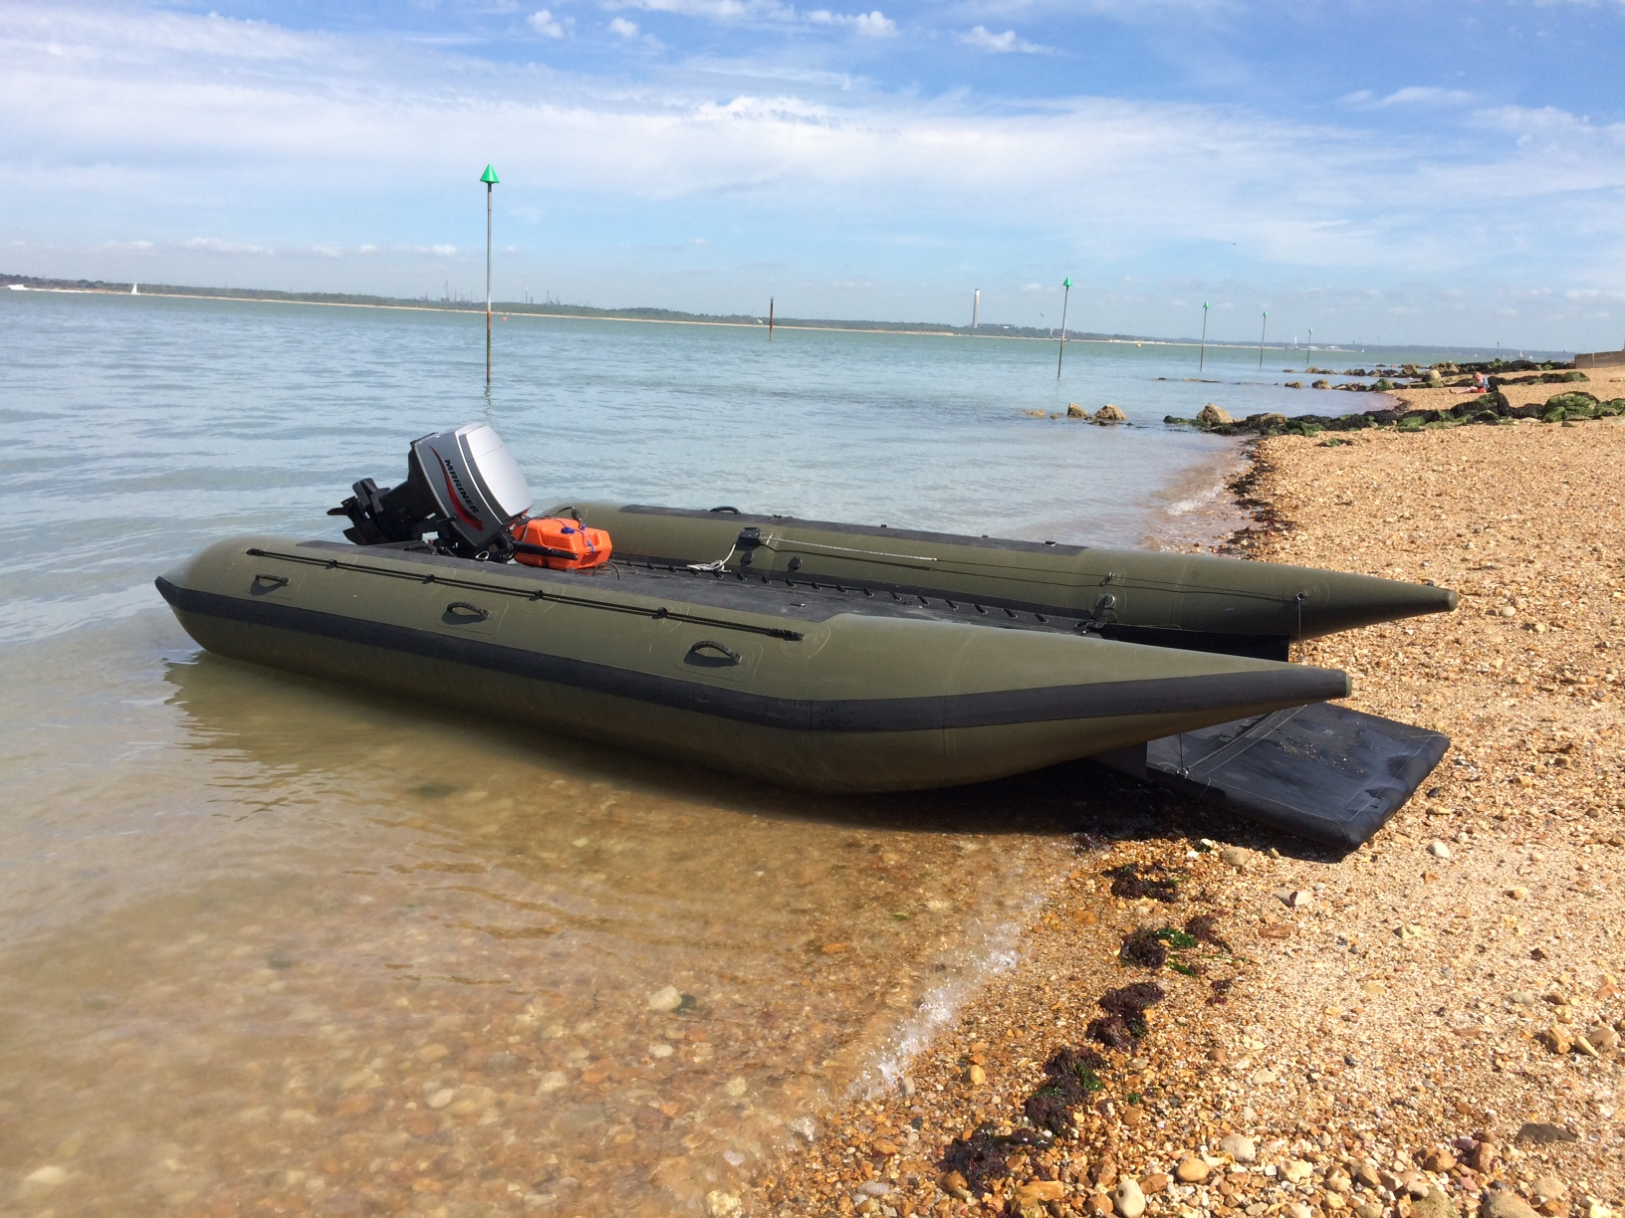
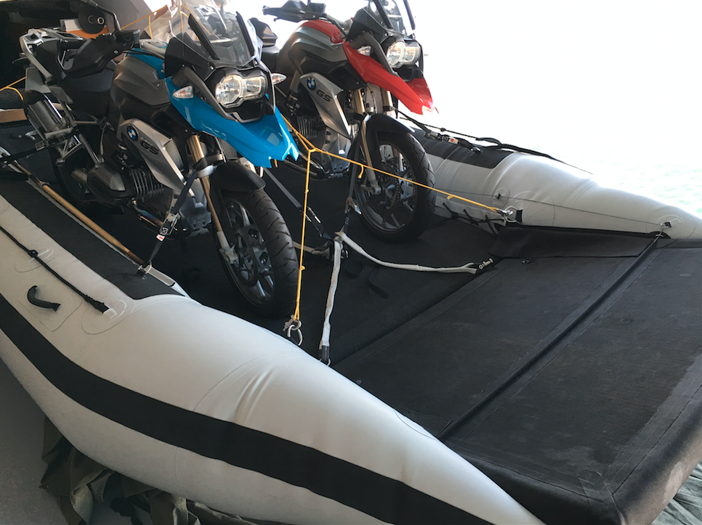
The iLC is an inflatable landing craft that will pack away into a single bag when deflated. Designed to be the most versatile small tender available for all yachts, this truly is a boat that performs all roles. Designed and built in the UK, the iLC is available in various sizes to meet clients’ requirements. The standard size is 5.5m long. This boat offers a large deck volume and high performance by utilising catamaran hulls. The deck can provide a large, useful area for supplies, dive gear, carrying loads, watersports etc. and help perform general crew duties. It is perfect for beach landings due to its shallow draft and lightweight. The boat is also rated to be lifted with 900kg payload by cranes, meaning it can be lifted on board safely even with a large load.
The design utilises recent advances in inflatable materials with a drop stitch floor (the material used for inflatable stand up paddleboards, which is extremely firm under pressure but when deflated packs down very small) and Hypalon tubes. Rigging time is approximately 15 minutes out of the bag. The only non-inflatable item is the transom, which is used to roll the rest of the boat around when stowing.
The boat was originally designed around a specific client’s needs to transport a Quad bike (ATV) from his superyacht to the shore, with additional uses being for diving, beach barbeques and general crew duties. The expectation is that this will sell well to yachts who need a crew tender but do not have a lot of space for a rigid one on board, as well as to the commercial market.
Key Specifications:
- Length 5.53m (customisable for the client)
- Beam 2.76m
- Pack down size: 1.6m x 0.7m x 0.4m (excluding engine)
- Build time: 6 weeks from order confirmation
- Tiller steered engines up to 40hp are able to be offered, giving exhilarating performance up to 30 knots
- Any colour combination and design available
- Prices start from just £9,495.00 ex VAT boat only
This boat is exclusively available through Superyacht Tenders and Toys.
Guy Whitehouse from Guy Whitehouse Yacht Design, who designed the iLC, commented: “This type of boat is only possible because we are taking advantage of the latest Hypalon fabrics. We are able to design and manufacture inflatable products with genuine "rigid" but inflated structure; the drop stitch is normally inflated to about 8psi. This is not a toy tender but a serious bit of kit.”
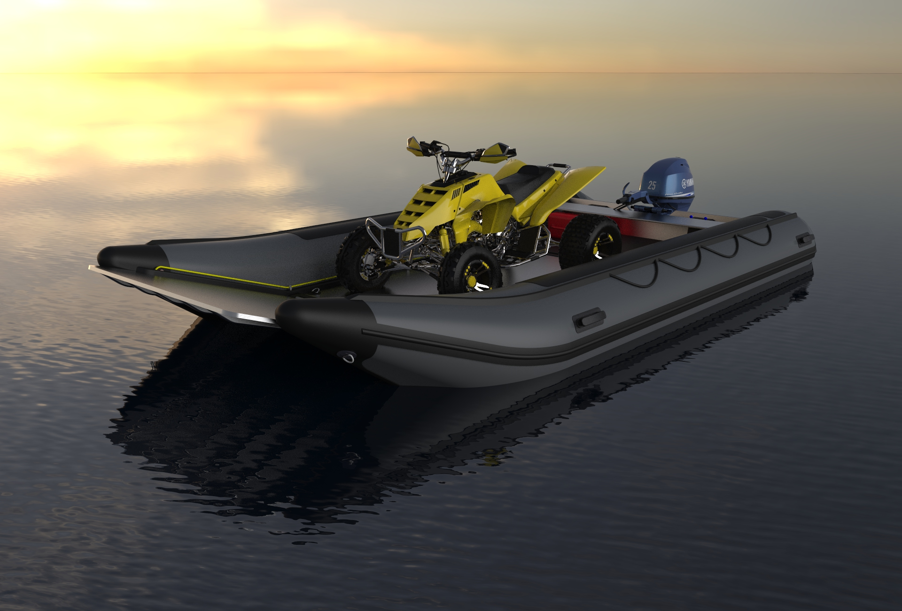
Recently nominated for Outstanding Product of the Year in the Institute of Mechanical Engineers Excellence Awards, Wessex Region, and already being delivered on board some of the most high profile yachts in the world, this boat is clearly filling a niche in the market.
Models have been designed for the POLICE, MILITARY, FIRE SERVICE and also as an approved SOLAS RESCUE craft for commercial ships.
For more information on Superyacht Tenders and Toys visit www.superyachttendersandtoys.com
For more information on Guy Whitehouse Yacht Design visit www.guywhitehouse.com
ENDS

Media enquiries and further information:

Alison Willis, Marine Advertising Agency
E: alison@marineadagency.com

Emma Stanbury, Marine Advertising Agency
E: emma@marineadagency.com

T: 023 9252 2044

or

Josh Richardson, Superyacht Tenders and Toys

T: UK +442380016363
T: France +33489733347
T: US +19643029066
E: info@superyachttendersandtoys.com

For high resolution images to accompany this release, please see:

http://marineadagency.com/gallery/sytt-ilc/

Notes to Editors:

Superyacht Tenders and Toys is the leading independent consultancy and management company specialising in all superyacht tender and toy needs and provides practical solutions for the World’s finest yachts.

