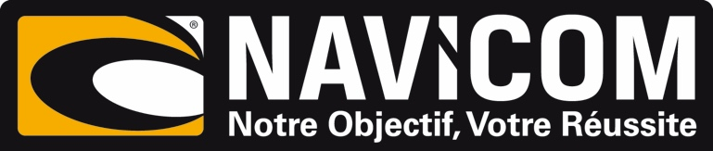
PRESS RELEASE
For release 10th December 2015

Navicom takes on the distribution of Crewsaver products in France

Crewsaver is delighted to announce the recent appointment of Navicom, who will take on distribution of the Crewsaver leisure product range throughout France.

With many top brands already being represented by Navicom, Crewsaver sees this partnership as a natural progression and are excited about working together to significantly improve the brand’s presence in France. ‘It is a great partnership. Navicom is an extremely proactive distributor, the Crewsaver safety product range will make an excellent addition to their portfolio’ says David Duffin, Crewsaver Sales Director.

Christophe Soares, CEO of Navicom, comments ‘we are happy that once again a big brand has the confidence to trust Navicom with its distribution in France. The Crewsaver brand offers quality technical products that all the Navicom team are already excited about presenting.’

Navicom has recognised that Crewsaver never stops innovating in the area of marine safety and particularly lifejackets, which will allow it to offer high performance products capable of responding to varying needs.

Known and recognised the world over, Crewsaver lifejackets are perfect to complete the range of products distributed by Navicom.

Ends//

For media information, hi-res images or product tests please contact:

Crewsaver
Hannah Burywood, Marketing Dept
T +44 (0) 1329 820024
E hannah.burywood@survitecgroup.com

Notes to Editors

Crewsaver is a world-leading manufacturer of marine safety equipment and clothing for the commercial and leisure marine industries. Based in Gosport, Hampshire, the company designs and manufactures bespoke safety equipment for several countries’ Special Forces, the UK government’s Environment Agency and the aviation and oil industries. Crewsaver is part of the Survitec Group.

www.crewsaver.com

Survitec Group holds market-leading positions worldwide in marine, defence and aerospace survival technology. Headquartered in Birkenhead, the company employs 2000 people across 10 manufacturing sites and 50 service centres, operating through a network of a further 550 distributors and agents to bring its best-in-class products and services to a global customer base. With an extensive history spanning over 160 years and a portfolio of some of the most reputable brands in the safety and survival industry, Survitec is committed to product innovation, technological advancement and quality assurance.
Key products within Survitec’s portfolio include marine, defence and aviation Liferafts, world leading submarine escape technology, lifejackets for commercial airlines and the offshore industry as well as pilot flight equipment, including anti-g clothing used for the Eurofighter and JSF programmes. The Group also pioneered marine evacuation technology and today the unique MarinArk system is used on many major cruise ships across the globe.

www.survitecgroup.com

