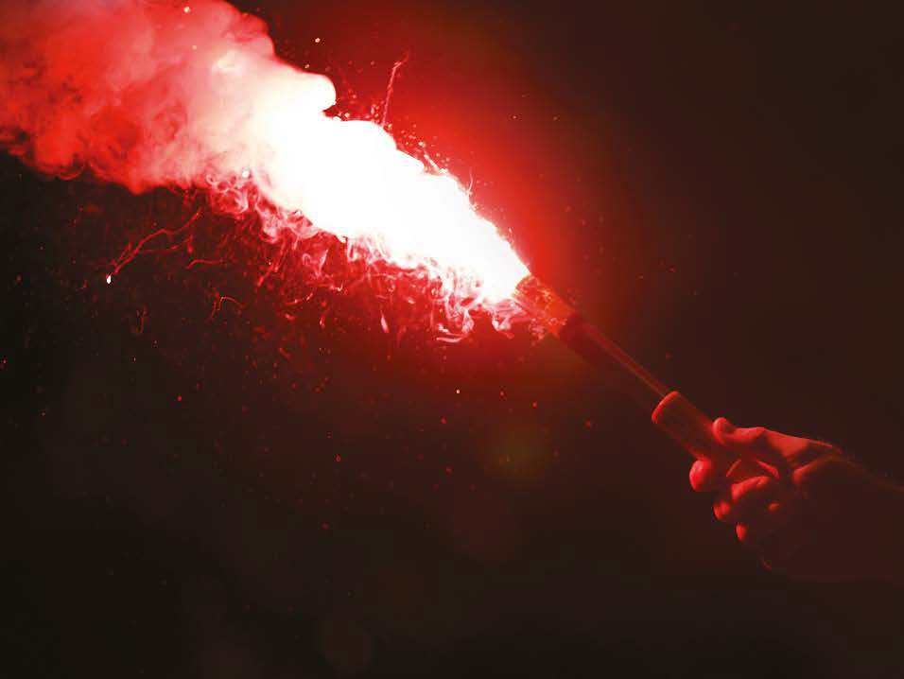
Press Release
For Immediate Release
London Boat Show 8th – 17th January 2016
Stands #A011/A012/A020/A033/B025/B009/B032
F045
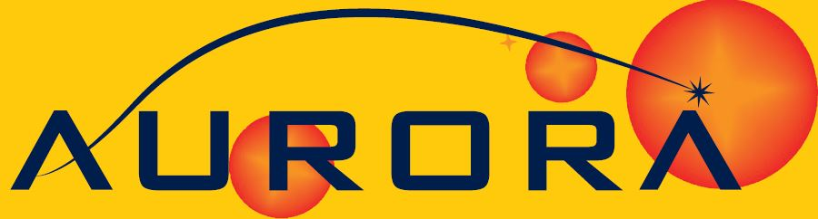
WHEN IT COMES TO THE WORST, YOU REQUIRE THE BEST.

Crewsaver, in partnership with Pains Wessex, brings you the Aurora pyrotechnic leisure range which will be available from Crewsaver retailers at the London Boat Show 2016
Crewsaver, in partnership with Pains Wessex, launched a brand new range of pyrotechnics, aimed solely at the marine leisure market, to the trade at the Marine Equipment Trade Show (METS) in November. The London Boat Show which takes place 8th – 17th January 2016 sees the complete range become available for purchase for the first time, with sales representatives on hand to talk to visitors through the entire range.
Bringing together the expertise of the two companies, the Crewsaver Aurora pyrotechnic range has something to offer every level of recreational boater, from daytime compact Lifesmokes, to the brand new, innovative Sky-Lite 2 Star Aerial Distress Flare.

‘Survitec Group has been successfully distributing pyrotechnics to the global marine commercial markets for over eight years. Using our Crewsaver brand and our experience in supplying pyrotechnics, and working with Pains Wessex, we are delighted to be able to supply the marine leisure market with this exciting new range,’ says Ross Wilkinson, Survitec Group Managing Director.

This brand new complete range of flares for the marine leisure market includes the following;

- Sky Lite 2 Star Aerial Distress Flare
- Day & Night Distress Signal
- Red Parachute Rocket
- White Handflare
- Red Handflare
- Orange Handsmoke
- Lifesmoke
- A variety of different flare packages

With the addition of the new Crewsaver Aurora distress signals to its existing range of unique lifejackets, liferafts and safety equipment, which already includes McMurdo emergency beacons, Crewsaver has created the most comprehensive safety range available. So you can rest assured - when it comes to the worst, you have the best.

ENDS//

For media information, hi-res images or product tests please contact:

Crewsaver
Hazel Proudlock, Marketing Dept
T +44 (0) 1329 820000
E hazel.proudlock@survitecgroup.com

Or

Alison Willis – Marine Advertising Agency Ltd
T +44 (0) 23 9252 2044
E Alison@marineadagency.com

Notes to Editors

Crewsaver is a world-leading manufacturer of marine safety equipment and clothing for the commercial and leisure marine industries. Based in Gosport, Hampshire, the company designs and manufactures bespoke safety equipment for several countries’ Special Forces, and the aviation and oil industries. Crewsaver is the only company to hold an exclusive contract to supply lifejackets to the UK government’s Environment Agency and the Royal National Lifeboat Institution (RNLI). They are part of the Survitec Group.

www.crewsaver.com

Survitec Group holds market-leading positions worldwide in marine, defence and aerospace survival technology. Headquartered in Birkenhead, the company employs 2000 people across 10 manufacturing sites and 50 service centres, operating through a network of a further 550 distributors and agents to bring its best-in-class products and services to a global customer base. With an extensive history spanning over 160 years and a portfolio of some of the most reputable brands in the safety and survival industry, Survitec is committed to product innovation, technological advancement and quality assurance.
Key products within Survitec’s portfolio include marine, defence and aviation Liferafts, world leading submarine escape technology, lifejackets for commercial airlines and the offshore industry as well as pilot flight equipment, including anti-g clothing used for the Eurofighter and JSF programmes. The Group also pioneered marine evacuation technology and today the unique MarinArk system is used on many major cruise ships across the globe.

www.survitecgroup.com

