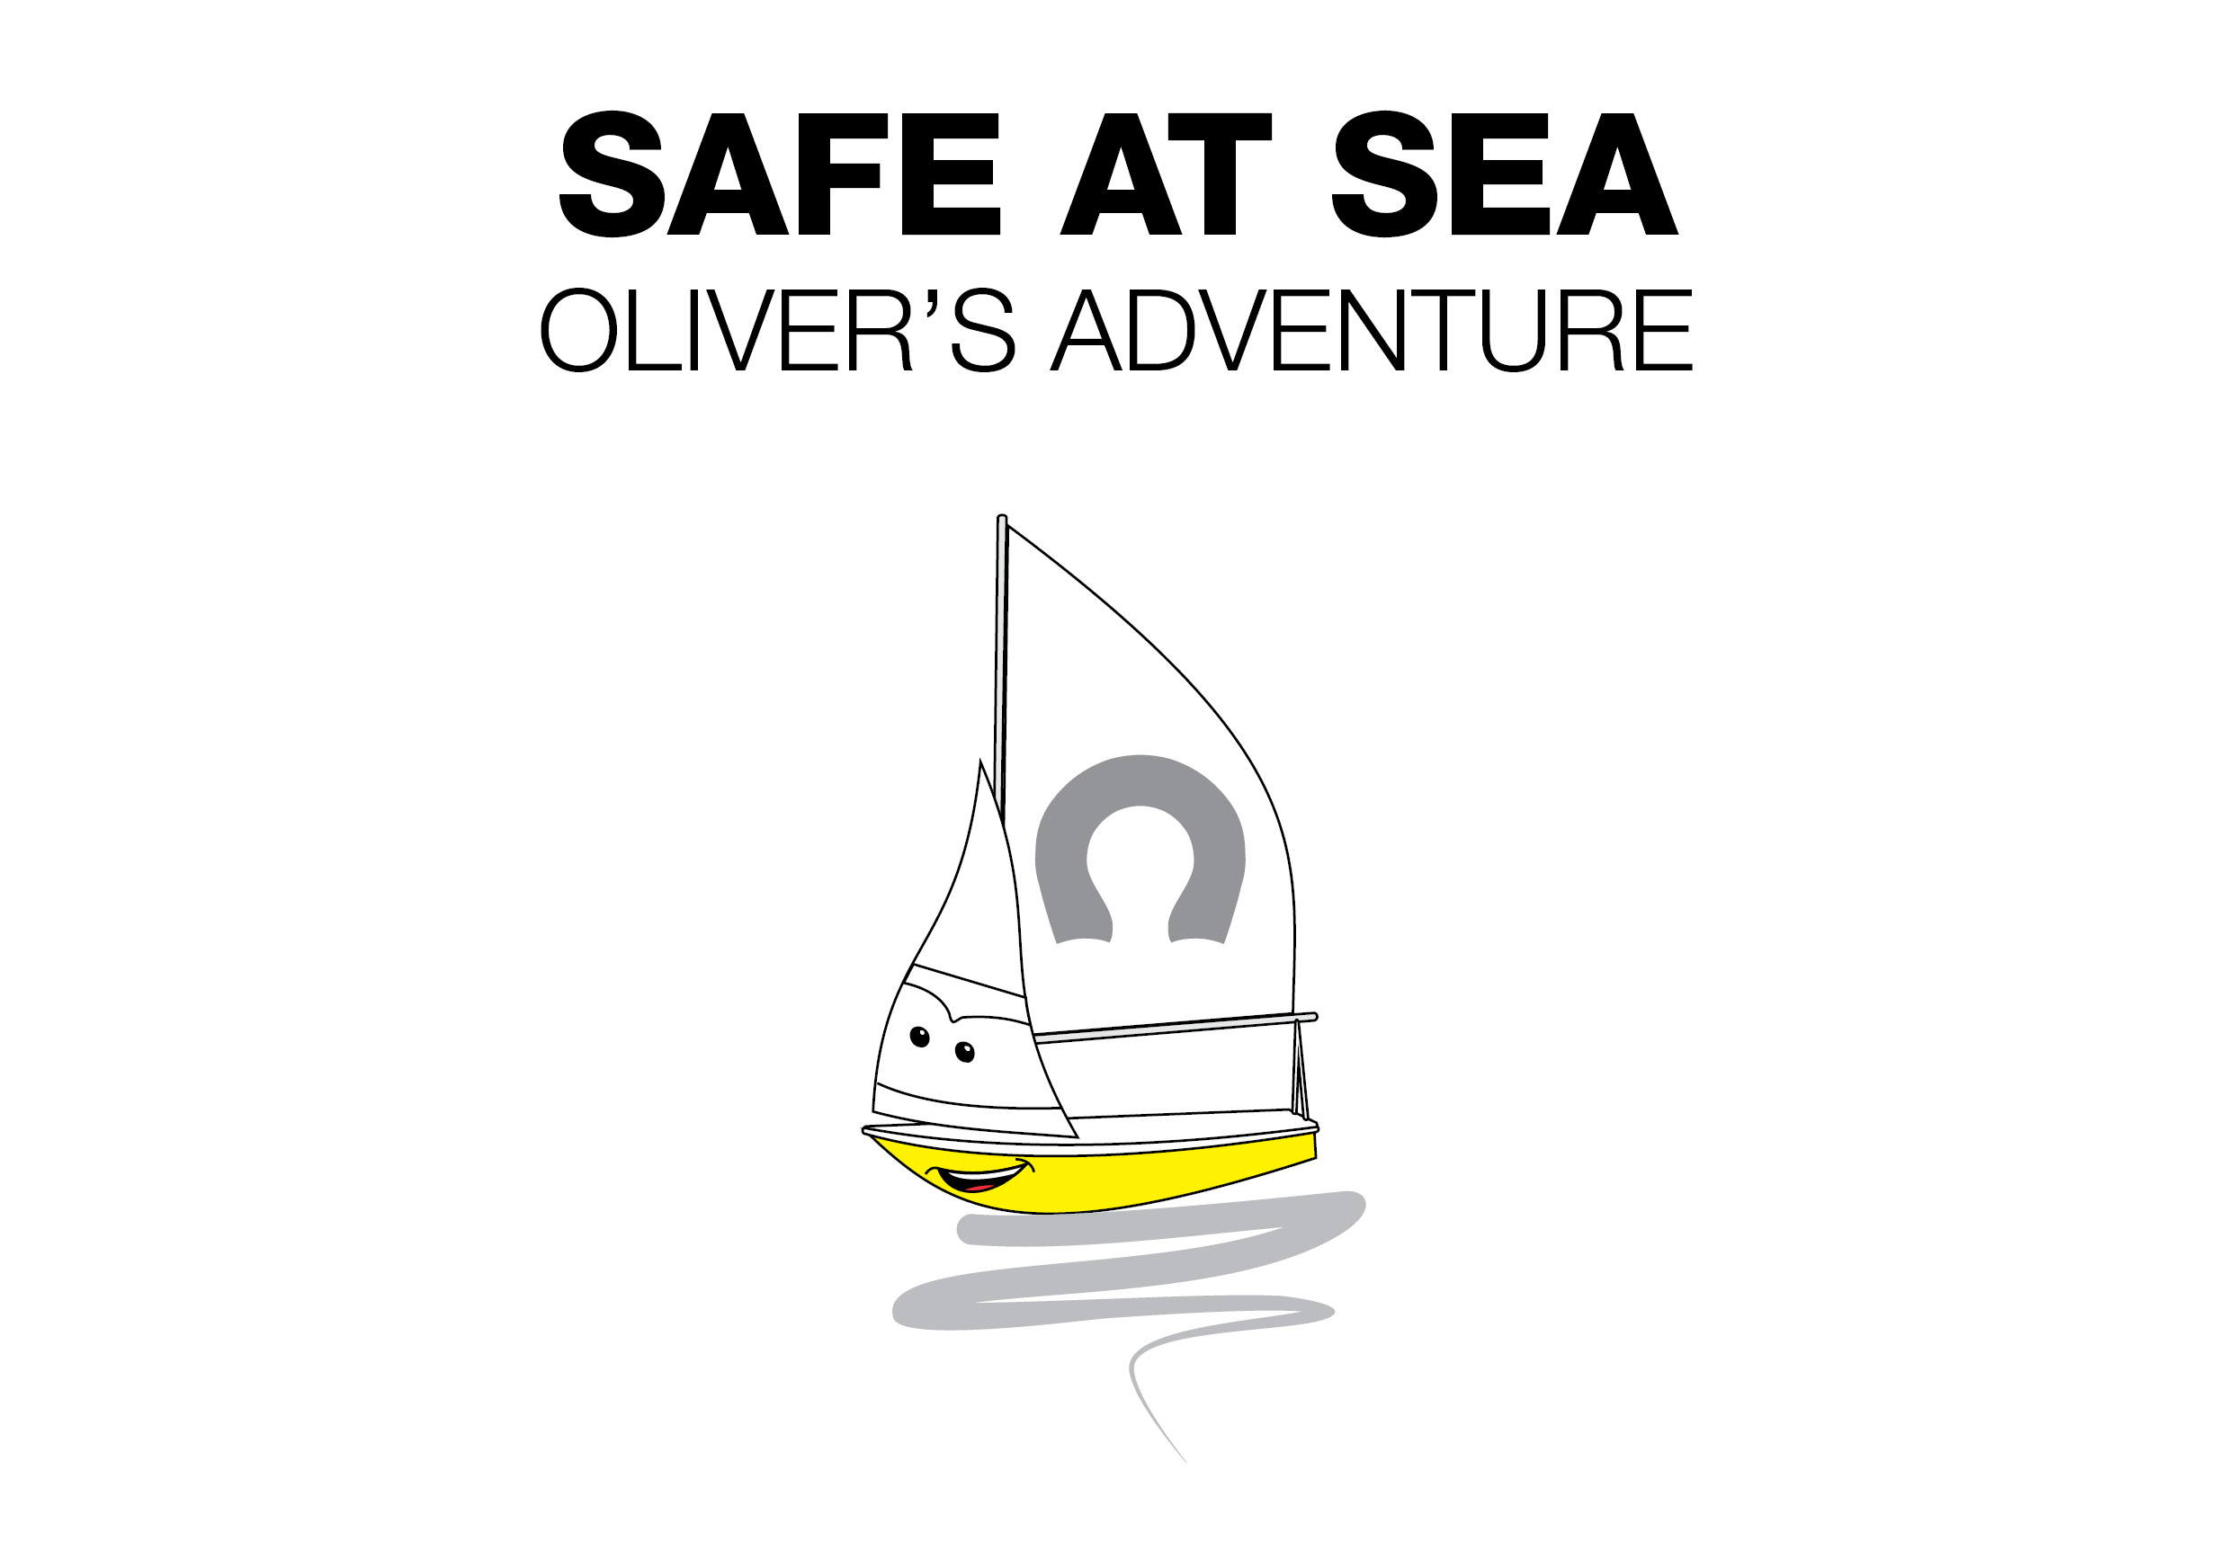
Press Release
For Immediate Release
London Boat Show 8th – 17th January 2016
Stands #A011/A012/A020/A033/B025/B009/B032/ F045

Crewsaver release ‘Safe at Sea’ Children’s Book
Safer by design – and fun too!
When you take your family on the water, you need their safety equipment to be the very best. Crewsaver’s extensive children’s lifejacket range is one of the only brands that offers 150N of superior buoyancy opposed to the standard 100N, whilst retaining a comfortable and practical fit.
To help children understand the importance of wearing a lifejacket, Crewsaver has created a great children’s storybook. This fun and interactive book follows the adventures of Oliver, a young sailboat, who looks up to Rory the speedboat. Rory decides not to wear a lifejacket and gets into trouble.
The storybook complements the children’s lifejacket range and will be fitted to products at point of sale as standard from April 2016.
However, visitors at the London Boat Show 2016 will have a sneak preview and will receive a FREE storybook with every children’s lifejacket purchased.
ENDS//
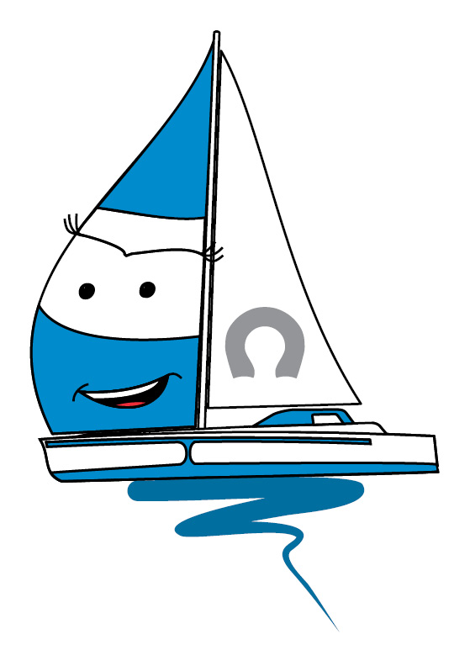
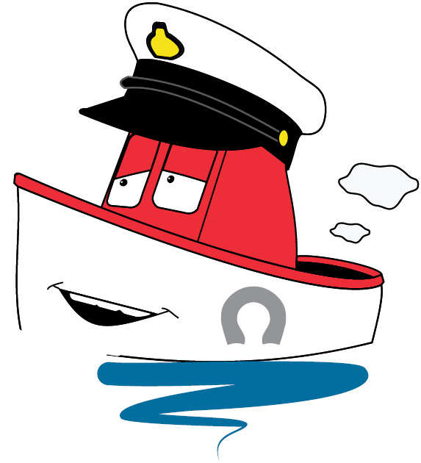
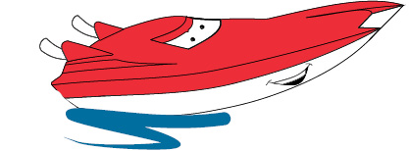

For media information, hi-res images or product tests please contact:

Crewsaver
Hazel Proudlock, Marketing Dept
T +44 (0) 1329 820000
E hazel.proudlock@survitecgroup.com

Or

Alison Willis – Marine Advertising Agency Ltd
T +44 (0) 23 9252 2044
E Alison@marineadagency.com

Notes to Editors

Crewsaver is a world-leading manufacturer of marine safety equipment and clothing for the commercial and leisure marine industries. Based in Gosport, Hampshire, the company designs and manufactures bespoke safety equipment for several countries’ Special Forces, and the aviation and oil industries. Crewsaver is the only company to hold an exclusive contract to supply lifejackets to the UK government’s Environment Agency and the Royal National Lifeboat Institution (RNLI). They are part of the Survitec Group.

www.crewsaver.com

Survitec Group holds market-leading positions worldwide in marine, defence and aerospace survival technology. Headquartered in Birkenhead, the company employs 2000 people across 10 manufacturing sites and 50 service centres, operating through a network of a further 550 distributors and agents to bring its best-in-class products and services to a global customer base. With an extensive history spanning over 160 years and a portfolio of some of the most reputable brands in the safety and survival industry, Survitec is committed to product innovation, technological advancement and quality assurance.
Key products within Survitec’s portfolio include marine, defence and aviation Liferafts, world leading submarine escape technology, lifejackets for commercial airlines and the offshore industry as well as pilot flight equipment, including anti-g clothing used for the Eurofighter and JSF programmes. The Group also pioneered marine evacuation technology and today the unique MarinArk system is used on many major cruise ships across the globe.

www.survitecgroup.com

