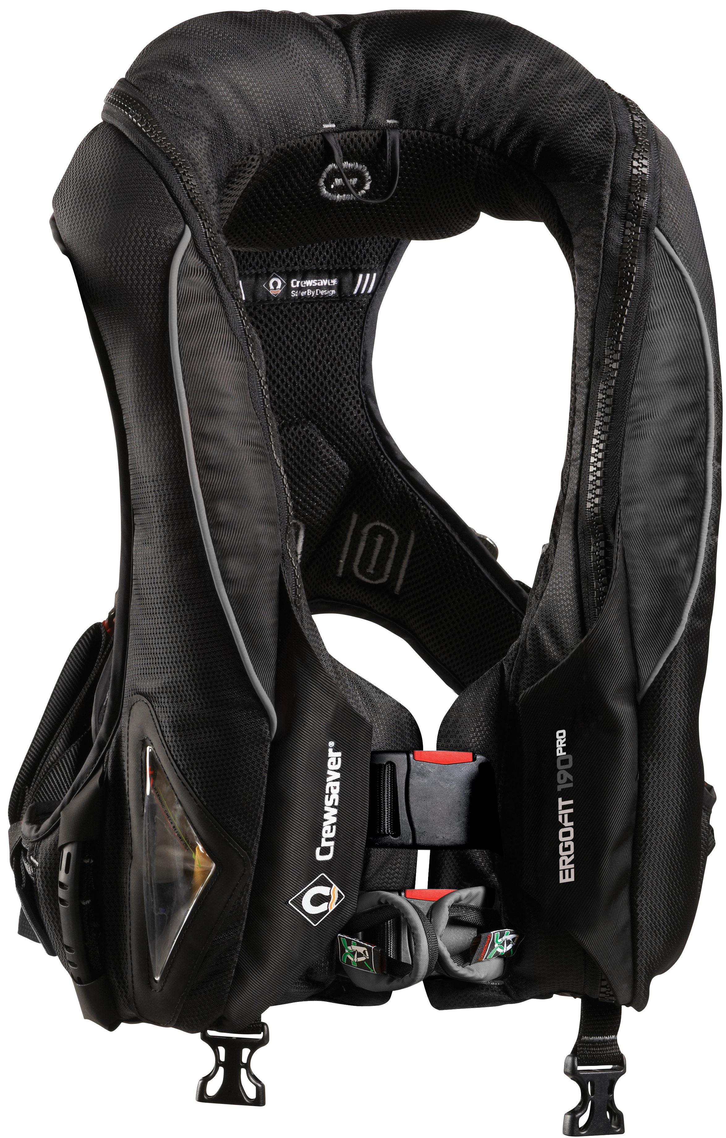
Press Release
For Immediate Release
London Boat Show 8th – 17th January 2016
Stands #A011/A012/A020/A033/B025/B009/B032/F045

Crewsaver is delighted to attend the 2016 London Boat Show where visitors will be able to buy the Crewsaver ErgoFit Pro lifejacket for the first time.

The ErgoFit 190N Pro is the new addition to the Crewsaver Fusion 3D ErgoFit range and encompasses the very best in comfort, style and performance. The ErgoFit 190N Pro maintains the high specification safety features of the ErgoFit 190N Offshore, whilst minimising external features for a sleek and professional finish.

The ErgoFit 190N Pro, awarded Yachting Monthly’s ‘Best on Test’, is easy to wear, versatile, stylish and completely functional. It is ideally suited to recreational users and the marine work environment alike.

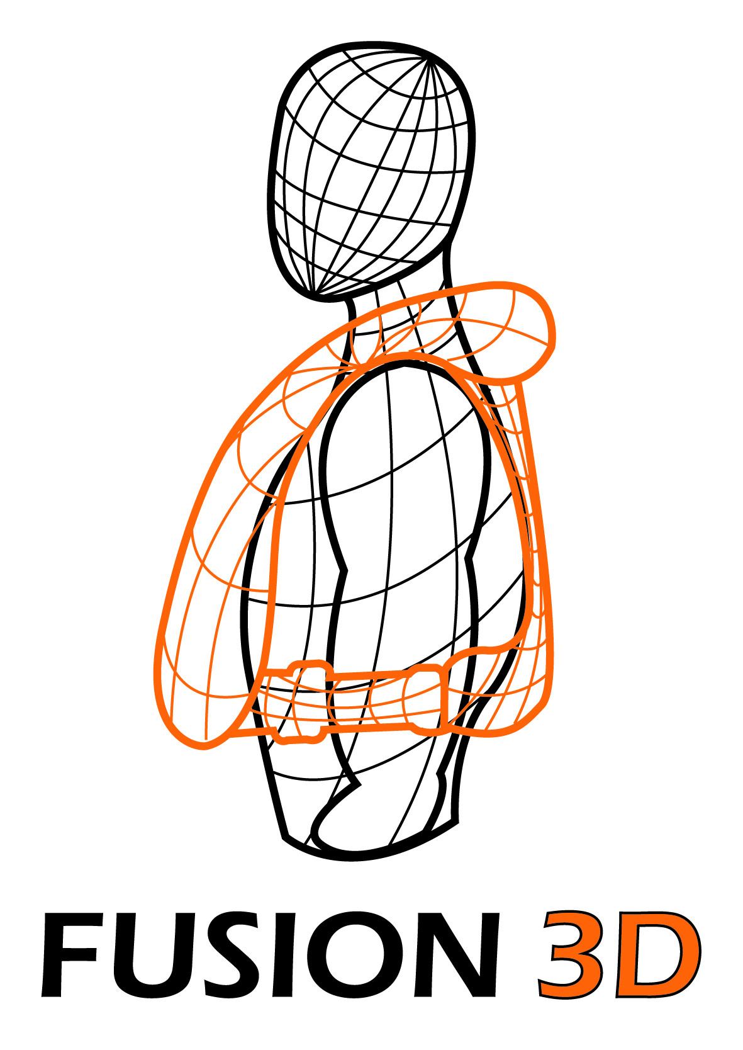
The complete Fusion 3D range of lifejackets will be available at the show with knowledgeable sales representatives on hand to talk visitors through the choices and recommend the best option to suit each individual’s requirements.

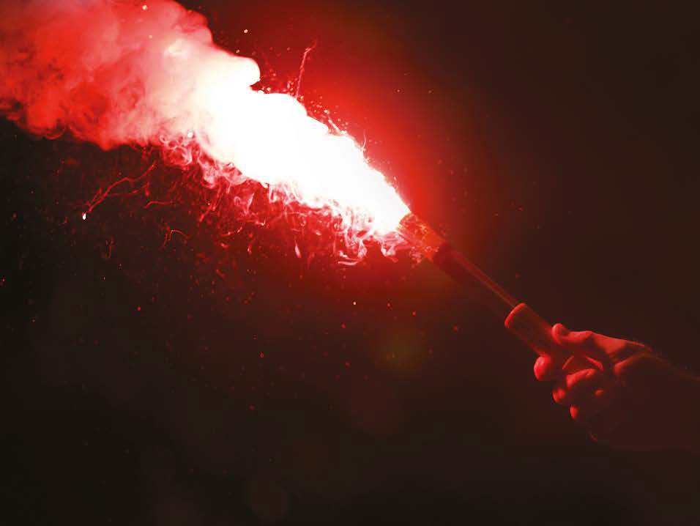
Find Crewsaver at…

- Marine Super Store A011/A012/A020
- Andark Diving & Watersports A033
- Jimmy Green Marine B025
- Piplers of Poole B009
- TCS Chandlery B032
- Arthur Beale F045

Show offers include…

- 2 x free limited edition Artemis Pro lifejackets (worth £234) with any Crewsaver liferaft
- Free rearming kit (worth up to £31) with any ErgoFit automatic lifejacket
- Free lifejacket light (worth £19.50) with any Crewfit Pro lifejacket
- Free lifejacket bag (worth £25) with every 4 x Crewsaver lifejackets purchased
- Free ‘Safe at Sea’ children’s storybook with every children’s lifejacket

T&Cs: Max 1 per purchase. Max 2 per customer. E&OE. Terms and conditions apply. Redeemable at stand of purchase.

ENDS//

For media information, hi-res images or product tests please contact:

Crewsaver
Hazel Proudlock, Marketing Dept
T +44 (0) 1329 820000
E hazel.proudlock@survitecgroup.com

Or

Alison Willis – Marine Advertising Agency Ltd
T +44 (0) 23 9252 2044
E Alison@marineadagency.com

Notes to Editors

Crewsaver is a world-leading manufacturer of marine safety equipment and clothing for the commercial and leisure marine industries. Based in Gosport, Hampshire, the company designs and manufactures bespoke safety equipment for several countries’ Special Forces, and the aviation and oil industries. Crewsaver is the only company to hold an exclusive contract to supply lifejackets to the UK government’s Environment Agency and the Royal National Lifeboat Institution (RNLI). They are part of the Survitec Group.

www.crewsaver.com

Survitec Group holds market-leading positions worldwide in marine, defence and aerospace survival technology. Headquartered in Birkenhead, the company employs 2000 people across 10 manufacturing sites and 50 service centres, operating through a network of a further 550 distributors and agents to bring its best-in-class products and services to a global customer base. With an extensive history spanning over 160 years and a portfolio of some of the most reputable brands in the safety and survival industry, Survitec is committed to product innovation, technological advancement and quality assurance.
Key products within Survitec’s portfolio include marine, defence and aviation Liferafts, world leading submarine escape technology, lifejackets for commercial airlines and the offshore industry as well as pilot flight equipment, including anti-g clothing used for the Eurofighter and JSF programmes. The Group also pioneered marine evacuation technology and today the unique MarinArk system is used on many major cruise ships across the globe.

www.survitecgroup.com

