New Release
For immediate release
1 December 2015

First Mara Buoy now on test with Royal Naval Sailing Association

The Royal Naval Sailing Association (RNSA) is trialing the first Mara Buoy at one of its 300 moorings in Portsmouth Harbour.

George Smith of Mara Engineering for the Sea (Mara EFS) has developed the Mara Buoy, an innovative new mooring buoy for yachts and small commercial vessels, which is now on test with the RNSA.

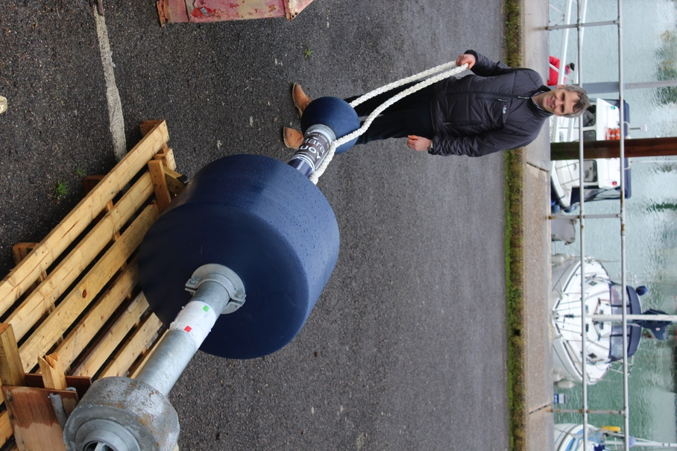
The design of the new mooring buoy has a number of features, which revolutionise current mooring systems. It boasts significant areas of improvement in terms of longevity, safety, ease of use, reliability, maintenance and night-time visibility. It can even be personalised with your own yacht name, logo or artwork.

The mooring line pick up point is at deck level and the mooring line ‘gives’ upon pick up allowing the deckhand time to make fast. The Mara Buoy features a highly reliable, galvanised steel backbone through which the mooring force is transmitted from the mooring line to the mooring chain. Reliability is increased by the fact that the mooring line runs over radiused surfaces, which reduces chaff. An underwater swivel is eliminated by allowing the line to swivel inside the galvanised steel backbone.

To make maintenance easier, inspection of the mooring line and swivel are carried out through a window in the backbone. Underwater connection is by way of a shackle to the mooring chain, which gives a simple, strong connection and peace of mind. Reflective surfaces help to improve night-time visibility and close quarters navigation.

Mara Buoy is ready for production and orders are now being taken. Please visit www.maraefs.com or email info@maraefs.com for more information and pricing.

ENDS//

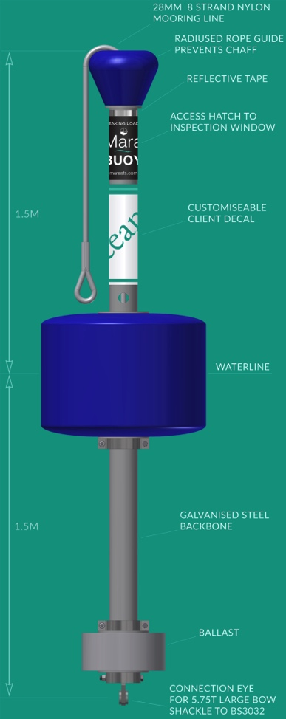
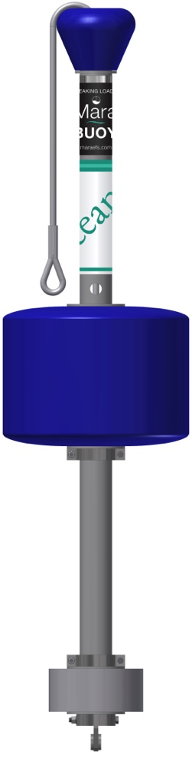

Notes to Editors

Mara EFS is a brand name of Jebb Smith Ltd. Jebb Smith Ltd is a family owned business. Mara EFS has over three decades of offshore engineering heritage behind it. Patent Pending – application no. 1506556.8.

Media enquiries via Marine Advertising Agency

Mike Shepherd - mike@marineadagency.com
Alison Willis – alison@marineadagency.com
Emma Stanbury – emma@marineadagency.com

Tel: 023 9252 2044

