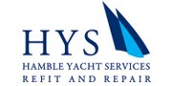
News Release
For immediate release
11th December 2015

Hamble Yacht Services Refit & Repair delivers Ark to Totton school
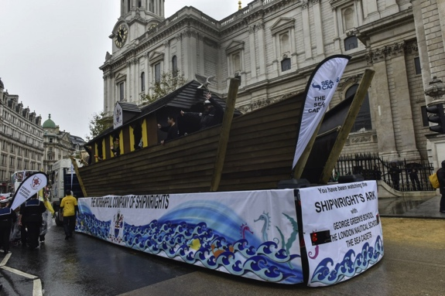
Hamble Yacht Services Refit & Repair (HYSRR) showed its versatility and mastery of special projects by building an Ark for the 800th Lord Mayor’s Show, which took place in London in November 2015. The Ark is now being donated to Oakfield Primary School in Totton, Hampshire and was delivered on Friday 11th December 2015.

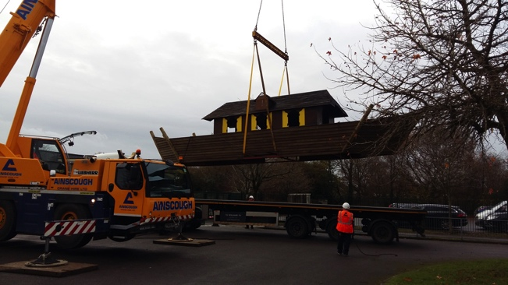
Elizabeth Smith, Headteacher at Oakfield Primary School, taking delivery of the Ark said, "It's marvellous! The children are thrilled to have been chosen to have the Ark. We already have an outdoor classroom and this will further enhance the children's learning.” The school plans to use the Ark for literacy, to make stories come to life, and link it to the curriculum in maths and RE. It will also be used for golden (reward) time, and the school is already planning a pirate themed day.
The Ark at the 2015 Lord Mayor’s Show in London.
Image courtesy of the Worshipful Company of Shipwrights.

The project came about as the new Lord Mayor of London, Lord Mountevans, is a Shipwright and the Worshipful Company of Shipwrights, a City of London Livery Company whose Arms feature an Ark, commissioned HYSRR to build the Ark for its float in the Lord Mayor’s Show.

The Ark was designed by Guy Whitehouse Designs, with a structural overview from Richard Oliver of Applied Structural Analysis (a tenant of Hamble Yacht Services). Marineware supplied coatings and all other funding for the Ark was provided by donations from fellow shipwrights.
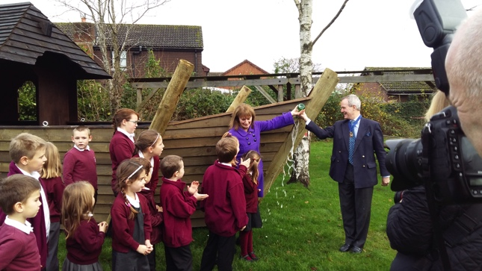
The prime purpose of the Worshipful Company of Shipwrights is charitable work, supporting charities such as the Sea Cadets, Jubilee Sailing Trust and Youth Challenge as well as maritime schools. It also provides grants for yacht and shipbuilding apprenticeship schemes. The livery men of the Worshipful Company of Shipwrights are drawn from the UK ship and yacht builders, lawyers and brokers, all of whom have some connection to the construction and operation of small or large vessels.

Find out more about Hamble Yacht Services Refit & Repair http://www.hambleyachtservices.co.uk/article/hys-refit-repair-build-an-ark/

ENDS

Notes to editors

Hamble Yacht Services Refit and Repair is renowned for its comprehensive range of marine services and convenient location on the Solent. We cater for the refit and repair of vessels large and small and projects of every scale. Our pricing policy and service levels make HYSRR a great place to base your boat for any refit and repair boat work. Over the years HYSRR has managed refit projects and repair contracts for some of the most prestigious yachts and motorboats in the world and our highly accessible location guarantees a wealth of experienced project managers, technicians, craftsmen, engineers and riggers.

Hamble Yacht Services Refit and Repair is part of the Ancasta Group.

Media enquiries via Marine Advertising Agency:

Alison Willis - alison@marineadagency.com Tel: 023 9252 2044

