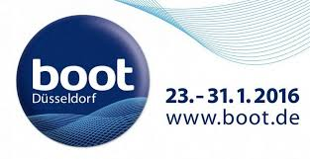
Press Release
For Immediate Release
Düsseldorf Boat Show 23rd – 31st January 2016
Nordwest-Funk: Stand B41 & B42, Hall 11

New Crewsaver ErgoFit 190N Pro available at Düsseldorf Boat Show 2016
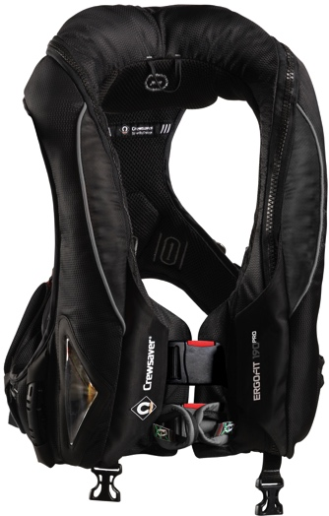
Visitors to the Düsseldorf Boat Show will be able to view the complete Crewsaver lifejacket range including the brand new ErgoFit 190N Pro lifejacket by visiting the Nordwest-Funk stand B41 & B42, Hall 11. The ErgoFit 190N Pro is the newest addition to the Crewsaver Fusion 3D ErgoFit range and encompasses the very best in comfort, style and performance. The ErgoFit 190N Pro will be available for purchase and was voted ‘Best on Test’ by UK magazine, Yachting Monthly. The ErgoFit 190N Pro maintains all the high specification safety features of the ErgoFit 190N Offshore, whilst minimising external features for a sleek and professional finish.

Joining the Crewsaver lifejacket range at the show is the Phase2 dinghy sailing collection. This collection provides a fresh look to sailing gear and offers the ultimate in flexibility, comfort and protection. A step above your average sailing kit, dinghy sailing enthusiasts won’t want to go on the water without it.

A Crewsaver representative will be available at the Nordwest-Funk stand to talk through the Crewsaver ranges and will be happy to recommend the best equipment for the job. The Crewsaver ranges will be available for purchase at the show from the below retailers.

- Lifejacket range: LENZ Rega-Port GmbH & Co.KG, stand A31, Hall 12
- Phase2 dinghy sailing collection: Marina Dellas Segelbedarf und Bootszubehör, stand B34, Hall 12
ENDS//

For further information, product tests and images, please contact:

Crewsaver
Hazel Proudlock, Marketing Dept
T +44 (0) 1329 820000
E hazel.proudlock@survitecgroup.com

Or

Alison Willis – Marine Advertising Agency Ltd
T +44 (0) 23 9252 2044
E Alison@marineadagency.com

Notes to Editors

Crewsaver is a world-leading manufacturer of marine safety equipment and clothing for the commercial and leisure marine industries. Based in Gosport, Hampshire, the company designs and manufactures bespoke safety equipment for several countries’ Special Forces, and the aviation and oil industries. Crewsaver is the only company to hold an exclusive contract to supply lifejackets to the UK government’s Environment Agency and the Royal National Lifeboat Institution (RNLI). They are part of the Survitec Group.

www.crewsaver.com

Survitec Group holds market-leading positions worldwide in marine, defence and aerospace survival technology. Headquartered in Birkenhead, the company employs 2000 people across 10 manufacturing sites and 50 service centres, operating through a network of a further 550 distributors and agents to bring its best-in-class products and services to a global customer base. With an extensive history spanning over 160 years and a portfolio of some of the most reputable brands in the safety and survival industry, Survitec is committed to product innovation, technological advancement and quality assurance.
Key products within Survitec’s portfolio include marine, defence and aviation Liferafts, world leading submarine escape technology, lifejackets for commercial airlines and the offshore industry as well as pilot flight equipment, including anti-g clothing used for the Eurofighter and JSF programmes. The Group also pioneered marine evacuation technology and today the unique MarinArk system is used on many major cruise ships across the globe.

www.survitecgroup.com

