Press Release
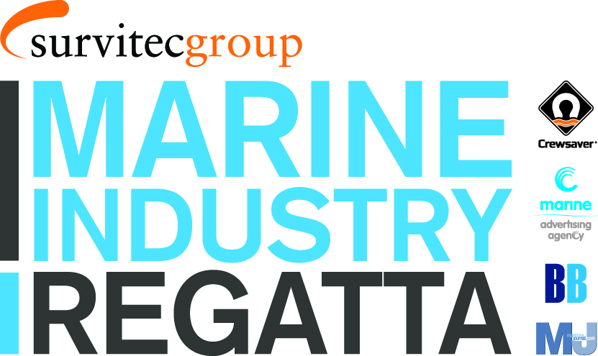
For Immediate Release
London Boat Show 8th – 17th January 2016

Marine Industry Regatta
Drinks Reception

Friday 8th January 2016 5pm – Stand no. G010

Survitec Group, proud sponsors of the Marine Industry Regatta 2016, invites the leisure and commercial sectors of the marine industry along with the marine press to join them for the official Marine Industry Regatta drinks reception.

The drinks reception will be hosted during the London Boat Show on the Sunsail stand (#G010), Friday 8th January 2016 at 5pm. The drinks reception is open to companies and individuals interested in getting involved and is the perfect time to find out what all the excitement is about.

The Marine Industry Regatta takes place on Wednesday 1st June 2016, sailing out of Port Solent in Sunsail First 40’s. The regatta is a great way to get together with other marine professionals and to entertain clients and staff. Charitable donations from the event will raise funds for the John Merricks Sailing Trust and the Andrew Simpson Sailing Foundation, another great reason to get involved.

The Marine Industry Regatta team looks forward to meeting new and old faces at the drinks reception. For more information, and to find out who has already signed up, please call Alex Tredget at Sunsail on 02392 222 221 or visit www.marineindustryregatta.com

ENDS//

For media information & hi-res images please contact:

Crewsaver
Hazel Proudlock, Marketing Dept
T +44 (0) 1329 820000
E hazel.proudlock@survitecgroup.com

Or

Alison Willis – Marine Advertising Agency Ltd
T +44 (0) 23 9252 2044
E Alison@marineadagency.com

Notes to Editors

Crewsaver is a world-leading manufacturer of marine safety equipment and clothing for the commercial and leisure marine industries. Based in Gosport, Hampshire, the company designs and manufactures bespoke safety equipment for several countries’ Special Forces, and the aviation and oil industries. Crewsaver is the only company to hold an exclusive contract to supply lifejackets to the UK government’s Environment Agency and the Royal National Lifeboat Institution (RNLI). They are part of the Survitec Group.

www.crewsaver.com

Survitec Group holds market-leading positions worldwide in marine, defence and aerospace survival technology. Headquartered in Birkenhead, the company employs 2000 people across 10 manufacturing sites and 50 service centres, operating through a network of a further 550 distributors and agents to bring its best-in-class products and services to a global customer base. With an extensive history spanning over 160 years and a portfolio of some of the most reputable brands in the safety and survival industry, Survitec is committed to product innovation, technological advancement and quality assurance.
Key products within Survitec’s portfolio include marine, defence and aviation Liferafts, world leading submarine escape technology, lifejackets for commercial airlines and the offshore industry as well as pilot flight equipment, including anti-g clothing used for the Eurofighter and JSF programmes. The Group also pioneered marine evacuation technology and today the unique MarinArk system is used on many major cruise ships across the globe.

www.survitecgroup.com

