**News Release**

**For immediate release**

**8th January 2016**

**Prestige 680 impresses on UK launch at London Boat Show 2016**

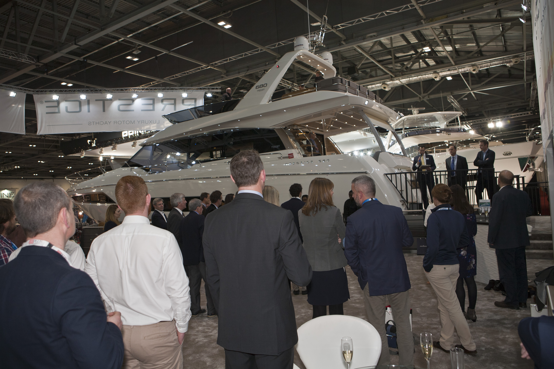**Ancasta presided over the UK launch of the Prestige 680, the newest luxury motor yacht from Prestige, on Friday 8th January 2016 at London Boat Show.** The Prestige 680 has cemented Prestige’s position as a major player in the motor yacht market. Prestige is the fastest growing motorboat brand in the world and the impact it is making at this year’s London Boat Show underlines the fact that now, for the first time, the motorboat brand ‘Big Three’ is not made up of solely British brands. Rather than being seen as a challenger, with the launch of the Prestige 680 and praise for the flagship Prestige 750, Prestige has come of age.

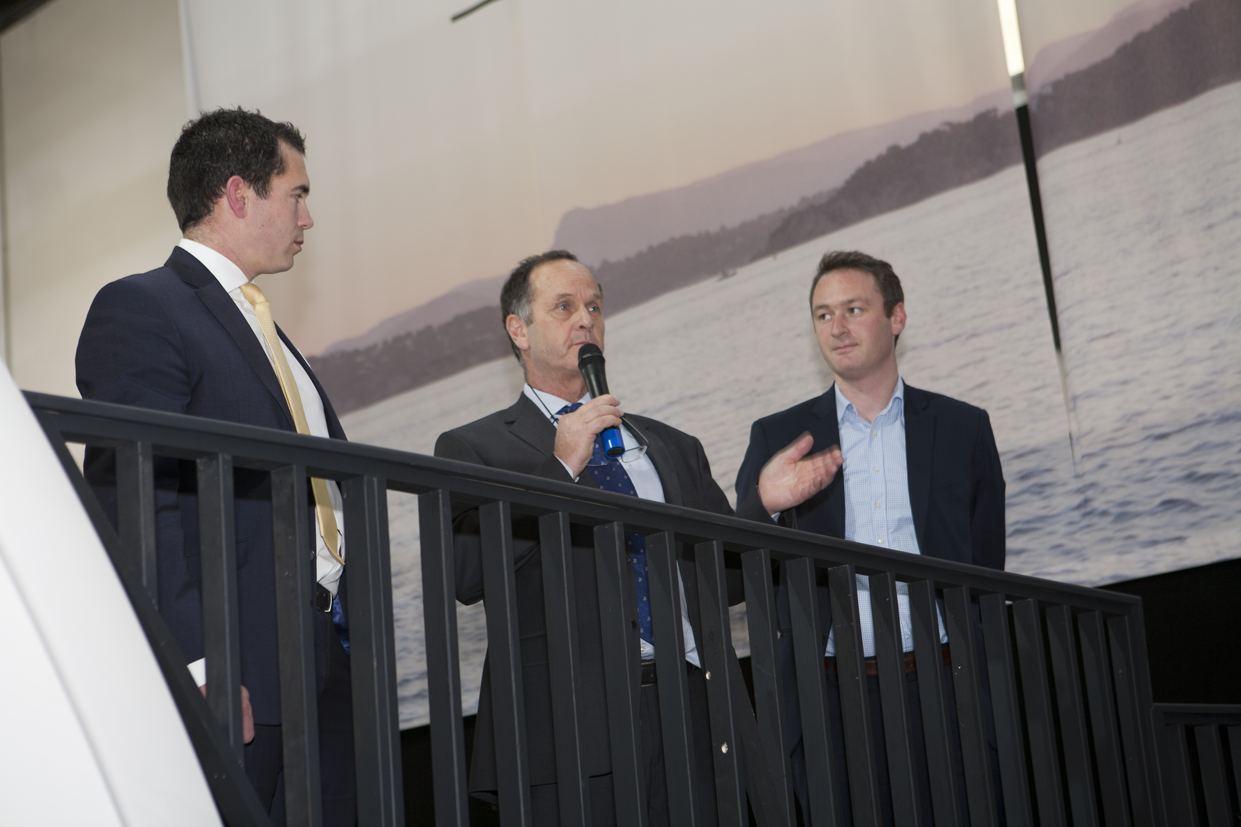

The importance of the UK launch was indicated by the presence of Jean-Francois de Premorel, Design Manager for Prestige Motor Yachts. De Premorel talked through the concept of the Prestige 680, which he came up with whilst recovering from a sporting accident, saying that the key was to offer “lots of technical innovations and a surprise inside… the 680 reflects all the key features of Prestige boats; a central galley, lots of light and a front forward ensuite master cabin”.

Nick Hatfield, Prestige Sales Manager at Ancasta, Jean-Francois de Premorel, and Antoine Chancelier from Prestige

De Premorel also talked about the brand’s position, he said “It is very emotional for Prestige to be here today at London Boat Show 2016 with a 68-footer… the market is changing and we are now one of the major players in Europe, Worldwide and in the US, becoming the world leader in 40ft-75ft luxury motor yachts.” He went on to talk about being part of the Beneteau Group, which allows Prestige to invest more than anyone.

The Prestige 680 has been incredibly well received since its world launch in September 2015 in Cannes. So far four new Prestige 680’s will be delivered to UK owners in 2016, an indication of how the Prestige 680 is set to be unrivalled in the 68 foot motorboat market.



Ancasta Prestige Sales Manager, Nick Hatfield, is delighted with the response to the new Prestige 680, he said “The 680 was launched to the world at Cannes in September and is already taking the motor yacht market by storm. When we look around the hall here in London, there is quite clearly a new “Big 3”.”

Guests were served Herbert Hall a ‘Traditional Method’ English sparkling wine, made from low-yield chardonnay, pinot noir and pinot meunier grapes grown organically at the Marden Vineyard in Kent. Nick Hall, owner of Herbert Hall, said “Our brand values echo those of Prestige so we are delighted to be involved in the launch; we represent quality, pleasure, adventure and individuality, and with English sparkling wine increasingly being associated with luxury, our association with Ancasta and Ancasta Yachts is the ideal mix of style and elegance.”

The 21m luxury flybridge cruiser boasts all the key features that have made the Prestige range so successful, including elements from the flagship Prestige 750.

Coming from the drawing board of Garroni Design and with a J&J Design hull the Prestige 680 reflects the stretched lines and layout of the other successful motor yachts in the Prestige range. Powered by Twin Volvo IPS 1200 engines, providing high economy and easy manoeuverability, the Prestige 680 is capable of a top speed of 30 Knots. The flybridge has a very large, private space linking to a lounge area with galley bar and a large forward sun terrace.

The interior of the Prestige 680 exudes calm and style. The living space is bathed in natural light from the large windows that offer panoramic views. The dining area and lounge boast exceptional views and plenty of specially designed storage space, and the aft galley is cleverly planned for cooking or entertaining. The Prestige 680 additionally offers separate side door access from the helm position to the starboard deck while the large glazed sliding doors extend the saloon area into the cockpit like a balcony.

The innovative layout of the Prestige 680, with a raised and forward owner’s cabin, gives an independent cabin on one level that is both private and very light due to its large windows. Guest cabins are on a separate level, with access via their own staircase, adding to the sense of privacy for the owner. The model is available with a 3 or 4-cabin layout, plus crew cabin.

With lines that are still daring and timeless, and a top quality finish and materials, the Prestige 680 maintains the historic technical attributes of the Prestige range whilst benefiting from the latest innovations.

The Prestige 680 is at London Boat Show until 17th January 2016, contact Ancasta now to make an appointment to view, email Nick Hatfield ([nickhatfield@ancasta.com](mailto:nickhatfield@ancasta.com)) or call +44 2380 450000.

For more information visit <http://www.ancasta.com/boats-for-sale/new-boats/prestige/prestige-yachts/680/>

**ENDS**

**Notes to editors**

* Ancasta International Boat Sales has 15 offices across Europe
* Ancasta is the UK’s largest Prestige Luxury Motor Yachts dealer, the UK’s largest Beneteau Power and the UK’s largest Beneteau Sail dealer
* Ancasta is exclusive UK dealer for Lagoon Catamarans
* In addition Ancasta is a new boat dealer for CNB Yacht Builders and McConaghy Yachts
* The Ancasta Group incorporates Hamble Yacht Services Refit & Repair and Advanced Rigging and Hydraulics, both operating from Port Hamble.
* For more information on Ancasta visit www.ancasta.com

Media enquiries via Marine Advertising Agency:

Alison Willis - [alison@marineadagency.com](mailto:alison@marineadagency.com) Tel: 023 9252 2044