News Release
26th January 2016

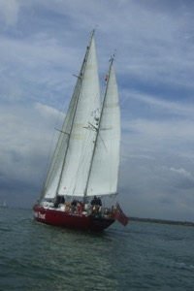
Ocean Youth Trust South wins Sail Training Vessel of the Year Award!

John Laing, the sailing vessel operated by Hampshire-based charity Ocean Youth Trust South (www.oytsouth.org/charity.asp), has been announced as the Sail Training Vessel of the Year by the Maritime and Coastguard Agency (MCA) and the Association of Sail Training Organisations (ASTO).

John Laing is used to offer personal development through adventure under sail to young people aged 12-25, building confidence, team working and the ability to take responsibility and cope with unfamiliar experiences.

The trophy was presented by Sir Alan Massey KCB, the Chief Executive of the MCA, who said: "John Laing receives the award today in recognition of 25 years of outstanding service to sail training, reflecting also the great care that Ocean Youth Trust South has taken over the years in ensuring the highest standards of safety and quality in what they do for sail training."

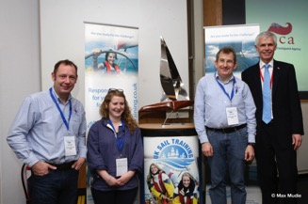
Mark Todd, Chief Executive of OYT South, said: "We are enormously proud to have received this award and it is a huge tribute to the work of all our volunteers, sponsors, donors and staff. Our sail training vessel John Laing has spent 25 years offering voyages to thousands of young people from all backgrounds - some of them very disadvantaged or vulnerable. The boat completed a voyage around the world in 1995-7 with young people as crew, and has since spent numerous seasons based in the Solent. It's wonderful that John Laing has achieved such recognition as she nears the end of her time with the charity and we move on to our new boat Prolific
(http://www.oytsouth.org/prolific.asp). The future for OYT South is very exciting and we look forward to offering safe, high-quality and fun voyages to thousands more young people in the years to come."
Pictured: Andy Viney (OYT South Staff Skipper), Mollie Crawford (OYT South Operations Assistant, Mark Todd (OYT South Chief Executive), Sir Alan Massey KCB (Chief Executive MCA)

See here for details of OYT South's charitable work: http://www.oytsouth.org/charity.asp.

//ENDS
For more information, contact Caroline White, caroline.white@oytsouth.org, 07986 354697

For downloadable images and MS Word/PDF versions of this release, please visit http://marineadagency.com/media-centre/

