Press Release
For Immediate Release
10th February 2016

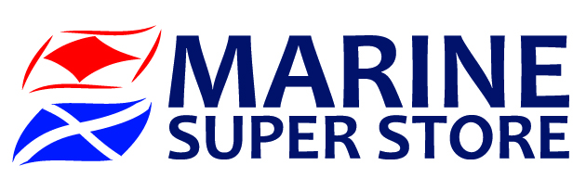
Marine Industry Regatta 2016 welcomes new sponsor, Marine Super Store

The Marine Industry Regatta team is delighted to announce that Marine Super Store has come on board as chandlery sponsor for the Marine Industry Regatta 2016.

Thanks to Marine Super Store’s sponsorship, competitors will be able to enjoy a wonderful jazz band when they come off the water. Marine Super Store is also sponsoring the prizes for the regatta and is offering competitors the chance to take advantage of some exclusive in store discounts.

‘We are delighted to be able to support the event. We attended the drinks reception which took place at London Boat Show this year and were instantly sold and keen to be involved’ Ben Ellis, Marine Super Store Sales and Marketing Director.

Mike Shepherd, Director of the Marine Advertising Agency, which is also involved with the regatta said “The Marine Industry Regatta team is delighted to have Marine Super Store on board as a sponsor. Their support will be a welcome addition to help ensure the success of the event.”

The Marine Industry Regatta takes place on Wednesday 1st June 2016, sailing out of Port Solent in Sunsail First 40’s. The regatta is a great way to get together with other marine professionals and to entertain clients and staff. Charitable donations from the event will raise funds for the John Merricks Sailing Trust and the Andrew Simpson Sailing Foundation, another great reason to get involved.

For more information on the Marine Industry Regatta 2016, to sign up and to find out who has already signed up, please call Alex Tredget at Sunsail on 02392 222 221 or visit www.marineindustryregatta.com

ENDS//

For media information & hi-res images please contact:

Alison Willis – Marine Advertising Agency Ltd
T +44 (0) 23 9252 2044
E Alison@marineadagency.com

Notes to Editors
Marine Superstore Marine Super Store Limited is a Portsmouth based chandlery, operating from a 10000 sq. ft. store. They stock a wide range of clothing, electronics and chandlery products. The company has been in business for over twenty years. In 2013 they introduced an additional 4000 sq. ft. store in Chichester Yacht Basin.
In addition to the shops and website, they are the largest retailer to exhibit at all major UK Boat Shows - London Excel Centre in January and Southampton Mayflower Park in September.
They operate a mail order department from their warehouse at the Port Solent Store, which gives good stock availability and allows them to display live stock levels on the website.
www.marinesuperstore.com

Marine Industry Regatta Is the day each year when the marine industry goes sailing. Originally conceived by Peter Nash (Boating Business, editor) this year the event welcomes the Survitec Group as title sponsor and open up to entries from the commercial sector of the industry. Sailed in Sunsail First 40’s from Port Solent the regatta is a great way to get together with other marine professionals and to entertain clients and staff. We look forward to seeing you all at the breakfast briefing 1st June 2016.

www.marineindustryregatta.com

