**Press release – Immediate release**
4th February 2016

Superyacht Tenders and Toys supplies world’s most luxurious cruise ship with water toys

Superyacht Tenders and Toys has outfitted Crystal Cruises newest most-luxurious ship, the Crystal Esprit, with water toys for the enjoyment of its guests. The Crystal Esprit debuted in December 2015 in the Seychelles and will be cruising worldwide. It is the latest luxury all-inclusive superyacht from Crystal Cruises and will welcome no more than 62 guests.
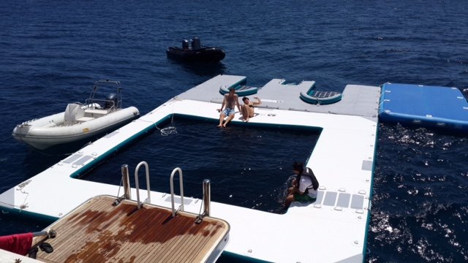
Superyacht Tenders and Toys has supplied the superyacht with an inflatable sea pool, custom design jet ski dock and all the watersports equipment onboard including water skis, wake boards, lifejackets and more. Crystal Esprit also has a submersible, allowing it to offer something quite unique to its guests.

Josh Richardson, Director of Superyacht Tenders and Toys, said “It’s exciting to be expanding our business to include the outfitting of luxury cruise ships as well as superyachts. We are proud to have worked with Crystal Cruises to ensure that its exclusive clientele will enjoy some of the best yacht toys available.”

To learn more about Superyacht Tenders and Toys, visit www.superyachttendersandtoys.com

ENDS

Media enquiries via Marine Advertising Agency:

Alison Willis, alison@marineadagency.com
Emma Stanbury, emma@marineadagency.com
T: 023 9252 2044

Continues over//

Or

Josh Richardson, Superyacht Tenders and Toys
T: UK +442380016363
T: France +33489733347
T: US +19643029066
E: info@superyachttendersandtoys.com

Notes to Editors:

Superyacht Tenders and Toys is the leading independent consultancy and management company specialising in all superyacht tender and toy needs and provides practical solutions for the World’s finest yachts.

