**Press release – Immediate release**
10th November 2015

New yacht toy gives Superyacht Tenders and Toys clients the chance to take off

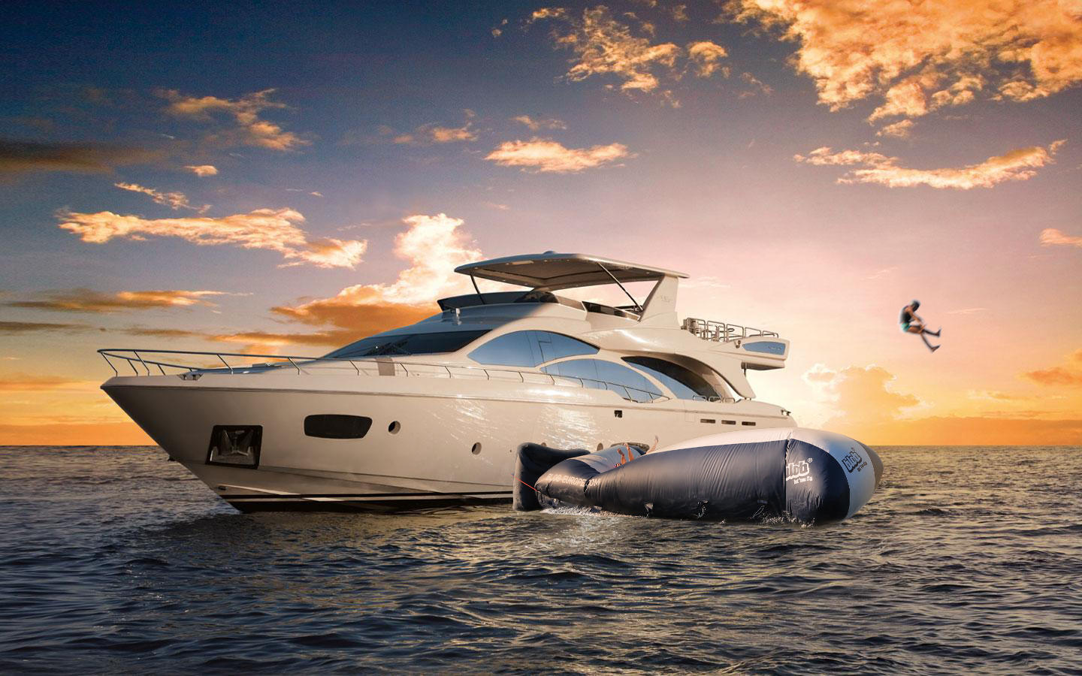

Superyacht Tenders and Toys latest addition to its yacht toy portfolio, the Blob, allows clients to launch themselves over 10m into the air. Adventurous clients could choose to try to beat the world record for being launched from the Blob, which currently stands at 17m! For comparison, 10m is the height of an Olympic diving platform.

The Blob is essentially an inflatable single skin PVC tube, the person being launched positions themselves on the far end of the Blob, while the person doing the launching jumps off the yacht onto the other end of the Blob, catapulting the other person into the air. The Blob takes only 8 minutes to inflate.

Best-seller, the All Round Blob, measures 7m x 4m and packs down to 70cm x 70cm x 40cm (60kg) meaning that it’s easy to stow away on board. All Round Blob’s can be made in any colour and customised with the yacht’s logo. Other size Blob’s can be built to clients’ specifications, Superyacht Tenders & Toys recently delivered the largest Blob ever sold, a 15m x 7m Blob, which was commissioned to go on a 124m yacht.

At €2845 ex. VAT, the All Round Blob is a relatively inexpensive yacht toy with plenty of play value. With a little practice Blob flights are controllable and there is even a freestyle sport – Blobbing Battles – where jumps and flights get scored on team performance, style and airtime.

The Blob can be purchased as a package including pump, bag, 10m rubber rope, two fasteners, guideline, manuals and a repair kit, prices on application. A protection mat is recommended, which goes between the yacht and the Blob. Superyacht Tenders & Toys can also provide landing area buoys to keep those launched safe when they land and are waiting to be picked up or to swim back to the yacht. Impact vests and helmets are recommended when using the Blob and these can also be supplied by Superyacht Tenders & Toys.

Superyacht Tenders & Toys has supplied Blobs to yachts such as Quatroelle, Septimius, Maryah and Revelry.

To learn more about Superyacht Tenders and Toys product range, visit www.superyachttendersandtoys.com

ENDS

Media enquiries via Marine Advertising Agency:

Alison Willis, alison@marineadagency.com
Emma Stanbury, emma@marineadagency.com
T: 023 9252 2044

or

Josh Richardson, Superyacht Tenders and Toys

T: UK +442380016363
T: France +33489733347
T: US +19643029066
E: info@superyachttendersandtoys.com

For high resolution images to accompany this release, please see:

http://superyachttendersandtoys.com/image-gallery/yacht-blob-2/

Notes to Editors:

Superyacht Tenders and Toys is the leading independent consultancy and management company specialising in all superyacht tender and toy needs and provides practical solutions for the World’s finest yachts.

