**News Release**

**For immediate release**

**31st March 2016**

**Portsmouth Harbour Multihull Show to take place 24th-26th June 2016**

The Portsmouth Harbour Multihull Show will be held at Haslar Marina in Gosport between the 24th and the 26th June 2016. The established show gives visitors the chance to see unique multihull designs from leading brands with 12 boats due to be exhibited in 2016. The show will be open from 10am to 5pm Friday and Saturday, and 10am to 4pm on Sunday, entry is FREE.

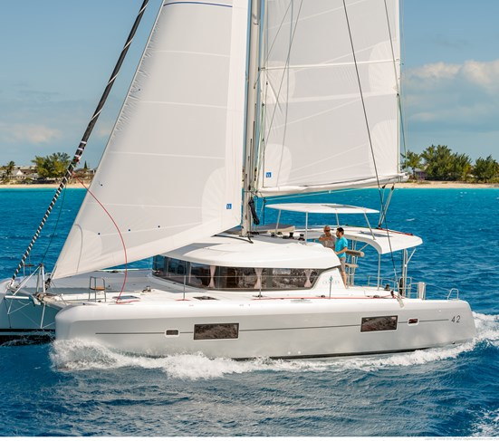

As exclusive UK dealer for Lagoon Catamarans, Ancasta will have a strong presence at the show. The company will be showcasing two of Lagoon’s popular catamarans at the event; the Lagoon 42 and Lagoon 450F flybridge catamaran. All the boats at the show will be open for public viewing, with selected exhibitors offering test sails strictly by prior arrangement.

Visitors will be able to see unique multihull designs from all the leading brands: Lagoon, Fountaine Pajot, Broadblue, Dragonfly, Gemini, Nautitech, Corsair and Seawind. This is a great opportunity to see a host of trimarans and catamarans, in one location, on the water and side-by-side.

Ancasta will present the Lagoon 42 at the Portsmouth Harbour Mulithull Show in June (photo credit: Nicolas Claris)

The show area is adjacent to the iconic green lightship, “Mary Mouse”, which is berthed at Haslar. Visitors will be able to enjoy food, refreshments and hospitality at Trinity’s At the Lightship, which enjoys an historic atmospheric setting overlooking Portsmouth Harbour.

For more information visit <https://www.ancasta.com/events/the-portsmouth-harbour-multihull-show-2016/> and [www.portsmouthmultihullshow.com](http://www.portsmouthmultihullshow.com)

Ancasta’s site for the multihull community ([www.ancastamultihulls.com](http://www.ancastamultihulls.com)), acts as a hub offering information to those interested in starting a multihull adventure, whether committed multihull sailors or occasional catamaran charterers. The site has frequently asked questions about sailing multihulls, news from the world of multihulls and also features stories from multihull owners. Owners are invited to share their own stories, creating a community feel to the site.

**ENDS**

**Notes to editors**

* Ancasta International Boat Sales has 15 offices across Europe
* Ancasta is the UK’s largest Prestige Luxury Motor Yachts dealer, the UK’s largest Beneteau Power and the UK’s largest Beneteau Sail dealer
* Ancasta is exclusive UK dealer for Lagoon Catamarans
* In addition Ancasta is a new boat dealer for CNB Yacht Builders and McConaghy Yachts
* The Ancasta Group incorporates Hamble Yacht Services Refit & Repair and Advanced Rigging and Hydraulics, both operating from Port Hamble.
* For more information on Ancasta visit www.ancasta.com

Media enquiries via Marine Advertising Agency: Alison Willis - [alison@marineadagency.com](mailto:alison@marineadagency.com) , Tel: 023 9252 2044